Geologic history of seawater: a MAGicapproach to carbon chemistry

Rolf S. Arvidson1, Michael W. Guidry2, and Fred T. Mackenzie3

1MARUM/Geowissenschaften FB5, University of Bremen, Germany

2Department of Oceanography, SOEST/University of Hawaii, Honolulu HI USA

I. Introduction

In his paper *Geologic history of sea water: An attempt to state the problem* (Rubey, 1951), W. W. Rubey presented one of the first quantitative efforts at obtaining an understanding of the paleochemistry of seawater and the atmosphere. Rubey concluded that throughout much of geologic time, seawater chemistry has been relatively uniform in composition. Dick Holland (Holland, 1972), to whom our paper in this volume is dedicated, employing a play of words on the title of Rubey’s article, in the paper *The geologic history of sea water—An attempt to solve the problem* reached a conclusion somewhat in agreement with Rubey. Based on the relative abundance of minerals in marine evaporites, their depositional sequence, and the absence of many minerals typical of non-marine evaporites, Holland concluded “that the concentration of the major constituents of seawater has rarely, if ever, been more than twice or less than half their present concentration during the past 700 million years.” Holland further stated that the “chemistry of seawater has been highly conservative” through geologic time. Garrels and Mackenzie (1971, 1972) based on the relative similarity of the mineralogy and chemistry of sedimentary rocks through geologic time, and accounting for diagenetic reactions and overprinting, had previously come to the same conclusion. However, in the latter part of the twentieth century and on into the twenty-first, these latter three authors and others using different methodologies (e.g., Mackenzie, 1975; Garrels and Perry, 1974; Berner et al., 1983; Veizer and Compston, 1974; Horita et al., 2002; Holland, 2004) concluded that Phanerozoic and also Precambrian seawater exhibited important compositional variations. Although both Rubey (Rubey, 1951) and Holland (Holland, 1972) discussed the role of carbon in the chemistry of seawater, neither author was able to resolve the geologic history of compositional variations in the seawater CO2-carbonic acid system [the system that includes CO2 (gas), CO2 (aq), H2CO3 (aq), HCO3− ion, CO32− ion, H+ ion, dissolved inorganic carbon (DIC), total alkalinity, and carbonate saturation state]. More recently there have been attempts to resolve Phanerozoic variations in this important seawater chemical system for at least part of the Phanerozoic using Earth system models (Zeebe, 2012; Arvidson et al., 2006, 2011, Kump et al. 2009, Ridgwell, 2005, Ridgwell and Zeebe, 2005; Locklair and Lerman, 2005; Hardie et al., 1996; Lowenstein et al. 2003; see also additional references in Arvidson et al. 2006).

As the quest for an understanding of the geologic history of seawater was developing, model calculations were leading to an increasingly robust understanding of paleoatmospheric CO2 variations during the Phanerozoic (e.g., Berner et al., 1983; Mora et al., 1996; Pearson and Palmer, 2000; Wallman, 2001; Nordt et al., 2002; Demicco et al., 2003; Edmond and Huh, 2003; Hansen and Wallman; 2003; Royer at al., 2004; Haworth et al., 2005; Guidry et al. 2007; Mackenzie et al., 2008; Arvidson et al., 2006, 2011; Berner, 2004, 2006; Royer, 2006). Proxy information for Phanerozoic CO2 variability was later derived from fossilized plant stomata, paleosols, phytoplankton, boron isotopes, and liverworts (e.g., Royer, 2006) confirming to some extent the CO2 modeling calculations. The ability to calculate paleoatmospheric CO2 places one constraint on the history of the CO2-carbonic acid system of seawater. However, unlike atmospheric CO2, there are no sedimentary proxies for the complete seawater CO2-carbonic acid system applicable on the time scale of the whole Phanerozoic: thus model estimates are mainly relied on. In this article we employ principally a modeling approach that is supported to some degree by sedimentological and paleontological data to investigate seawater carbon chemistry.

II. Methodology

We use primarily the numerical output from the Earth system model *MAGic* (Fig. **1**; *M*ackenzie, *A*rvidson, *G*uidry *i*nteractive *c*ycles, e.g., Arvidson et al., 2006, 2011; Guidry et al., 2007; Mackenzie et al., 2008) to explore the evolution of the trend in the Phanerozoic carbonic acid system of seawater. The data we present are for the standard runs of *MAGic* based on the original *MAGic* model (Arvidson et al., 2006) as revised in Arvidson et al. (2011). Briefly *MAGic* deals with the long-term, deep-time Phanerozoic evolution of 11 coupled biogeochemical element cycles, including atmospheric CO2 and O2, in the exogenic system of land-ocean-atmosphere-sediment and includes interactions with the deeper endogenic system. In addition and of importance to this paper, not only can the compositional changes in atmospheric CO2 and O2 be explored in *MAGic* but also those of the seawater CO2-carbonic acid system chemistry and carbonate sediment composition throughout the Phanerozoic Eon. To our knowledge this is the only coupled biogeochemical 11 element model that is capable of doing this.

In *MAGic,* the 11 element cycles are explicitly coupled to one another via a reaction network. This network incorporates the basic reactions controlling atmospheric CO2 and O2 concentrations, continental and seafloor weathering of silicate and carbonate rocks, net ecosystem productivity, basalt-seawater exchange reactions, precipitation and diagenesis of chemical sediments and authigenic silicates, oxidation–reduction reactions involving C, S, and Fe, and subduction-decarbonation reactions. Coupled reservoirs include shallow and deep cratonic silicate and carbonate rocks and sediments, seawater (as a single reservoir with no proviso for shallow and deep domains), atmosphere, oceanic sediments and basalts, and the shallow mantle (Fig. **1**). In addition, the model has parameterizations of the interactions between seawater and oceanic crust, the cycling and complex feedbacks between O2, iron (Fe), phosphorus (P), and organic matter, the complex feedback relationships between atmospheric CO2, global temperature, the terrestrial biosphere, and the rate of chemical weathering. *MAGic* is set up in an initial steady state condition that can be perturbed and the time course of changes in the atmosphere, ocean, and sediment composition followed through Phanerozoic time.

*MAGic* has been mainly employed to investigate the long-term millions to tens of million-year deep time compositional history of the Phanerozoic ocean-atmosphere-carbonate sediment system. Relatively short-term events like the changes accompanying mass extinctions have not been dealt with to date in any detail in the model. This should be kept in mind in the following discussion since these events, whatever their ultimate cause, be they meteorite impacts, volcanic eruptions, or rapid sea level changes, can reset the “compositional clock” and disturb the otherwise smoother changes in geochemical and environmental parameters calculated for the long time scale.

III. Calcium-Magnesium-Silicate-Carbonate-CO2 Subcycle of the Model MAGic

We begin our discussion of the CO2-carbonic acid system of seawater by first considering the reservoir domains and biogeochemical processes involving components that have a significant effect on the behavior of the system over geologic time (Fig. **2**). These include CO2, calcium (Ca), magnesium (Mg), dissolved inorganic carbon, silica, and carbonate.

Figure **2** illustrates in detail one subcycle of the model that has particular relevance to the seawater CO2-carbonic acid system (Arvidson et al., 2006, 2011).

With reference to Figure **2**, Ca and Mg are initially weathered from continental silicates and carbonates by carbonic and sulfuric acids. The Ca in river water is mainly derived from the weathering of calcite and dolomite and the dissolution of silicate minerals, particularly felsic plagioclase (Ca, Na aluminosilicate). Mg is derived from dolomite [CaMg(CO3)2] weathering and the weathering of mafic silicate minerals such as amphibole, pyroxene, and biotite (Fe- and Mg-rich silicate minerals). The dissolved inorganic carbon (mainly bicarbonate at the pH of river water) is derived from the weathering of carbonate and silicate rocks in the presence of CO2-charged soil and ground waters; the CO2 being mainly derived from terrestrial plant photosynthesis and subsequent degradation of organic carbon and root respiration in soils. Ca and Mg are also produced during weathering from the dissolution of evaporite minerals. The resultant dissolved constituents are transported to the oceans by rivers, and less importantly, by ground waters. Once present in seawater, these components are re-deposited in shelf environments as primary or secondary calcite (CaCO3), dolomite, and CaSO4 and MgSO4 salts in evaporite deposits.. Subsequent to deposition, these minerals either re-enter the weathering cycle through uplift and exposure or can be removed to deeper burial regimes.

In pelagic environments (slope, rise, and deep-sea), only calcium carbonate is deposited, and as far as we are aware in the present and past oceans, no dolomite; thus, the total carbonate flux is partitioned between shelf and pelagic regimes. Although other factors may play a role (Arvidson et al., 2011), the precipitation rate of shelf dolomite in *MAGic* is controlled by seawater saturation state and temperature (Arvidson and Mackenzie, 1999). In addition, the accumulation of dolomite is a function of the shelf area available for deposition of carbonate sediment. This function is estimated from Quaternary dolomite depositional fluxes in shallow water environments and the submerged shelf area as a function of time and is normalized to its Quaternary value. Dolomite is also formed in the shelf environment in locales where the oxidation of organic matter (so-called organogenic dolomitization) is tied to the rate of microbial sulfate reduction and production of dissolved inorganic carbon. After deposition, pelagic calcite is either subducted to the mantle or removed to a metamorphic regime, such as deep burial in sedimentary basins like the Gulf Coast, USA. Both of these pathways lead to decarbonation reactions that serve to return material to the weathering cycle. This is the classic Urey-Ebelmen reaction, written simply as:

CaCO3 + SiO2 = CaSiO3 + CO2,  [1]

leading to the release of CO2 to the atmosphere via volcanism and metamorphism in the subsurface of deep sedimentary basins. The latter process can be represented by the burial metamorphic reaction involving the reactants dolomite, kaolinite, quartz, and water and the products of chlorite, calcite, and CO2 (Hutcheon et al., 1980; Holser et al., 1988):

5CaMg(CO3)2 + Al2Si2O5(OH)4 + SiO2 + 2H2O =

Mg5Al2Si3O10(OH)8 + 5CaCO3 + 5CO2. [2]

The mantle itself does not constitute a reservoir *per se* in the *MAGic* modelbut simply represents a collection point for return fluxes to either the silicate (basaltic or continental crust) or atmospheric reservoirs. Basalt-seawater reactions result in the uptake of Mg and the release of Ca. Mg uptake is assumed to be first order with respect to the Mg2+ concentration in seawater and its uptake is modified by a time-dependent parameter reflecting the rate at which the seafloor spreads. The complementary release of Ca2+ from basalt during seawater–basalt reactions, although identical to the Mg uptake flux in the steady state (Quaternary) condition, is allowed to vary during time to balance with the uptake fluxes. This variation is related to the maintenance of the proton (i.e., CO2) balance between seawater and hydrothermal fluids within the basalt (see detailed explanation in Arvidson et al., 2006). In addition, some of the Ca derived from reactions with mafic silicate minerals in seafloor basalts during basalt-seawater reactions in the shallow seafloor is precipitated within the basalt and can be subducted to depth where its decarbonization leads to release of CO2 to the atmosphere via volcanism.

Diagenetic alteration of shelf and pelagic sediments also results in release of Ca to seawater that is first order with respect to sediment mass. Mg uptake by reverse weathering reactions in the sediment to form chlorite, a composition representative of a neoformed magnesium silicate clay mineral, is allowed to vary according to the mass of Mg2+ in the ocean. The Mg from the chlorite formed is transferred from the chlorite reservoir to react with buried calcite to form burial dolomite, an important process of secondary dolomite formation. The rate of burial dolomite formation is consequently limited by the size of the chlorite reservoir. This dolomite is eventually returned by uplift to the continental weathering regime, and burial calcite not consumed by dolomitization or uplift eventually returns CO2 to the atmosphere and Ca to the silicate reservoir by metamorphic decarbonation.

As has been known for some time now, the coupled cycle of Ca, Mg, carbonate, and CO2 is tied to that of the biogeochemical cycle of silica. Silica is released to river and ground waters during the chemical weathering of silicate minerals in rocks and in more recent geologic time, and less importantly, because of the dissolution of silica phytoliths in plants (see e.g., Katz et al., 2007). Since the appearance of organisms such as diatoms, radiolarians, dinoflagellates, and sponges that secrete siliceous opal-A skeletons, the dissolved silica entering the ocean from the weathering source, and from both low- and high-temperature basalt–seawater reactions, has been removed from the ocean primarily by the precipitation of the biogenic silica phase opal-A (SiO2 . 2H2O). During early diagenesis on the seafloor, some of this silica, upon dissolution in the pore waters of sediments, may precipitate in reverse weathering reactions, leading to the neoformation of silicate phases in the sediments (Mackenzie and Garrels, 1966a, b; Mackenzie et al., 1981; Michalopoulas and Aller, 1995). The net amount of opal-A buried in the sediments goes through a series of diagenetic reactions that convert it to quartz (SiO2) on the longer time scale. Some of the buried quartz reacts with calcium carbonate at the higher temperatures of the subducted slab of the seafloor or in deep sedimentary basins to form calcium silicate (CaSiO3) and release CO2 to the atmosphere via volcanism or seepage from the deep sedimentary basins (Mackenzie and Pigott, 1981; Berner et al., 1983; Berner and Kothavala, 2001; Berner, 2004; Milliken, 2004). However, most of the quartz silica is uplifted to the surface environment where it can be dissolved during weathering or recycled in the solid phase (Wollast and Mackenzie, 1983). Now with some appreciation of the scheme for the Ca-Mg-carbonate-CO2-Si subcycle of the *MAGic* model, we can consider some of the numerical results of the model and their accordance with proxy or other data for the evolution of the ocean-atmosphere-carbonate sediment system during the Phanerozoic Eon.

IV. Ca, Mg, and DIC Weathering and Basalt-Seawater Reaction Fluxes

Let us start with the weathering and basalt-seawater reaction fluxes. Figures **3** – **5** show the calculated Ca, Mg, and DIC weathering and basalt-seawater reaction fluxes during the Phaneozoic. Notice first the roughly long-term, multi-million year cyclic pattern in these fluxes. The Phanerozoic starts out with low values of the weathering fluxes, gradually increasing into the middle of the Paleozoic and then falling to the Carboniferous, at which time the fluxes began to increase into the Mesozoic and then fall dramatically into the Cenozoic. Despite some time lags, this general pattern is remarkably similar to the calculated long-term paleoatmospheric CO2 curves of the models *MAGic* and *GEOCARB* (e.g., Berner, 2004; Arvidson et al., 2006) and to proxy data for this atmospheric variable (e.g., Royer, 2006). As atmospheric CO2 concentrations rose, the radiative forcing due to this greenhouse gas increased and planetary temperatures rose leading to enhanced loading of the atmosphere with water vapor and hence increased precipitation (Kasting et al., 1988). The increase in temperature and precipitation rate led in turn to increasing weathering rates on land. The opposite combination of decreasing atmospheric CO2, radiative forcing, and precipitation appears to be responsible for falling weathering rates. The overall pattern of weathering fluxes is modified by sea level changes, a reflection at least in part of plate accretion rate, and the carbonate land area and carbonate rock type available for weathering, plus the location of the continents during Phanerozoic time. Notice that the cyclic weathering flux changes are somewhat muted for Mg. This probably reflects the more rapid dissolution rate of calcite than that of dolomite and the mass distribution of dolomite versus limestone, and hence surface exposure to weathering (Garrels et al., 1976), as a function of geologic age in the sedimentary rock column**.**

Figures **3** – **5** also show the Ca, Mg, and DIC combined low and high temperature exchange fluxes due to basalt-seawater reactions in the seafloor during the Phanerozoic. These fluxes only vary by about a factor of 1.5 to 2.5 in magnitude. The uptake-age trend of the DIC basalt uptake flux exhibits a distinct cyclic pattern with uptake fluxes low in the early Paleozoic climbing slightly into the Ordovician and then falling into the late-Paleozoic/early-Mesozoic minimum, followed by a rise into the Cretaceous and then falling again into the Cenozoic. To some extent this pattern roughly mimics that of the seafloor accretion rate (Fig. **7**), with lower fluxes at times of low accretion rate and higher fluxes at times of high accretion rates. This might be anticipated as more DIC (mainly HCO3−) is flushed through the global ridge system and precipitates as CaCO3 (the Ca being derived mainly from minerals like the Ca-rich anorthite component of plagioclase feldspar within the basalt) releasing CO2 as accretion rates increase; the converse is true for lower accretion rates. Calcite found in seafloor basalts as veins and other fillings of voids is recognized as an important sink of carbon (Alt and Teagle, 1999). This seafloor calcite on subduction acts as a CO2 source to the atmosphere owing to the Urey-Ebelmen reaction (eq. **1**).

The Ca basalt release and Mg uptake fluxes due to basalt-seawater exchange reactions in the seafloor show only moderate variations over Phanerozoic time. This is to be expected because of the strong buffering of these exchange fluxes controlled by the stoichiometry of basalt-seawater reactions (Arvidson et al., 2006). However, the temporal patterns of uptake of Mg and release of Ca due to basalt-seawater reactions are similar and their exchange is not simply one to one due to the complex nature of the processes giving rise to the basalt exchange fluxes (Arvidson et al., 2006).

V. Sinks of Ca, Mg, and DIC through the Phanerozoic Eon

The dissolved constituents delivered to the ocean by rivers and ground water discharges and those from other sources during Phanerozoic time must be removed from the oceans by various mechanisms and processes, otherwise the ocean would become much more saline that the present day ocean. Variations in the input and output fluxes of dissolved constituents involving the ocean determine seawater composition during geologic time. The *MAGic* model permits one to make calculations of the magnitude of these fluxes, and in addition, the changes in seawater and atmospheric CO2 and O2 composition deriving from changes in these fluxes. These variations in composition exert an influence on the evolution of life in the Phanerozoic that in turn through feedback mechanisms influence the composition of the ocean and atmosphere. In this section, we present a description and quantification of the sinks of Ca, Mg, and DIC, three major components related to carbonate biomineralization and production and to organic productivity through Phanerozoic time. The oceanic uptakes or sinks of Ca, Mg, and DIC into solid marine deposits are shown in Figures **8** – **10**. The strength of each sink is shown as a percentage of the total constituent flux into the solid phase. Let us first consider the nature of the sinks for Ca, Mg, and DIC.

The flux of dissolved Ca to the oceans from weathering on land of carbonate and silicate rocks and that released through reactions at the seafloor involving basalt and seawater at low and high temperatures (Thompson 1983; Wollast and Mackenzie, 1983; Mottl and Wheat, 1994; de Villiers and Nelson, 1999; Arvidson et al., 2006) is removed from the ocean in five sinks (Fig. **8**): accumulation of CaCO3 on the shelf and in deep sea sediments; accumulation of dolomite [CaMg(CO3)2] on the shelf; accumulation of CaCO3 in the pores, cracks, and fractures in submarine basalts; and accumulation as evaporite CaSO4. Until the onset and rapid expansion of the planktonic Coccolithophoridae and foraminiferal calcifiers in the mid Mesozoic, unless there were inorganic deposition of calcium carbonate in the deep sea (see previous discussion and Berner and Mackenzie, 2011), there was no accumulation of laterally extensive beds of carbonate sediments in the pre-Mesozoic deep sea.

Mg mainly derived from weathering reactions on land of carbonate and silicate rocks is primarily removed from the ocean during dolomite formation on the shelves (Morse and Mackenzie, 1990; Mackenzie and Morse, 1992); in low-temperature, diagenetic reverse weathering reactions in seafloor sediments (e.g., Mackenzie and Garrels, 1966a; Mackenzie et al., 1981; Michalopoulos and Aller, 1995; Holland, 2004); during reactions involving basalts and seawater (Thompson, 1983; Mottl and Wheat, 1994); and during formation of evaporite MgSO4 (Babel and Schreiber, 2013) (Fig. **9**).

The sinks for dissolved inorganic C released via weathering of carbonate and silicate rocks (in the latter the CO2 comes ultimately only from the atmosphere) and seafloor basalt-seawater reactions are the accumulation of inorganic carbon in shelf CaCO3 and dolomite, the accumulation of CaCO3 in seafloor basalts, and the accumulation of calcite and aragonite in the deep sea (Morse and Mackenzie, 1990) (Fig. **10**). Organic carbon sinks include shelf and pelagic storage of organic matter and the burial of organic matter in coal basins. Variations in the flux to the latter sink are especially important to the history of atmospheric oxygen (Berner and Canfield, 1989; Berner, 2004; Arvidson et al., 2006).

Now let us consider how these sinks of Ca, Mg, and DIC vary throughout Phanerozic time. First, we will consider the pattern of Ca and Mg flux variations as shown in Figures **8** and **9**. It can be seen from the figures that an important sink of Mg, and less so for Ca, through the Phanerozoic Eon is in the accumulation of dolomite on the shelf. Storage of these elements in dolomite is relatively high for much of the Mesozoic and mid-Paleozoic and low in the Cenozoic and Permo-Carboniferous. The downward trend from the high dolomite accumulation rate of the Cretaceous toward the present is well established by observational records of the distribution of dolomite through Phanerozoic time (Wilkinson and Walker, 1989; Wilkinson and Algeo, 1989; Morse and Mackenzie, 1990; Holland and Zimmermann, 2000). The high of the mid-Paleozoic and the subsequent low of the Permo-Carboniferous have been debated in the literature based on interpretations of observations of the dolomite mass-age distribution (Wilkinson and Algeo, 1989; Mackenzie and Morse, 1992; Holland and Zimmermann, 2000; Veizer and Mackenzie, 2004), but nevertheless, the results of the numerical simulations from *MAGic* suggest the possibility of a cyclic pattern in the dolomite accumulation flux-age distribution. This pattern is in accord with the distribution of preserved dolomite as a function of age in the Phanerozoic sedimentary rock column (e.g., Morse and Mackenzie, 2000)**.** This cyclic pattern also mimics to some extent the first-order sea level curves of Vail et al. (1977) and Hallam (1984), with high sea level stands being times of high dolomite accumulation rates. This would be anticipated since dolomite is a shallow-water deposit and is not deposited as vast extensive beds of dolomite in the deep sea. One can see from Figure **9** that as the sink for Mg in dolomite accumulation becomes more significant, the sink in submarine basalt uptake, the second most important sink of Mg, weakens as more of the Mg entering seawater is removed in the accumulation of dolomite.

For Ca, the most important sink through Phanerozoic time is in the accumulation of CaCO3 in shelf carbonate deposits (Fig. **8**). Until the advent of open ocean pelagic calcifying organisms, there probably was scant accumulation of biogenic CaCO3 in the deep sea (Boss and Wilkinson, 1991), and as mentioned previously, there may or may not have been inorganic deposition of CaCO3 in the deep sea. The accumulation of deep-sea biogenic carbonates only became significant in the early Mesozoic, resulting in the transfer of CaCO3 from the shallow water continental regime to the deep sea. Most, if not all, extant Paleozoic carbonates were deposited in cratonic, continental environments as mainly organo-detrital limestones and not in the deep sea, as evidenced by the sedimentologic characteristics of the carbonate rock record and the near-absence of deep-sea carbonate deposits associated with Paleozoic ophiolites (ancient sea floor metamorphosed basalt complexes; Boss and Wilkinson, 1991). The latter authors contend that some of the occurrences of dark limestone and rhythmically layered marble associated with the scant record of Paleozoic ophiolites may represent inorganic CaCO3 deposition on the deep seafloor. This observation would lend credence to the hypothesis of Berner and Mackenzie (2011) mentioned above that there was inorganic accumulation of carbonate in the Paleozoic deep sea. The accumulation of calcite in submarine basalts is of further importance to the record of Ca accumulation in the deep sea. In this case, the Ca is derived from the reaction of primary basaltic minerals with seawater mainly at hydrothermal temperatures and accumulates during the precipitation of CaCO3 in the pores, cracks, and fractures of submarine basalt. Arvidson et al. (2006) hypothesize that this sink can be an important source of CO2 to the atmosphere. Subduction of this CaCO3, along with pelagic calcareous oozes, results in decarbonation at higher temperatures and pressures and ultimate release of CO2 by volcanism to the Earth’s atmosphere. Evaporite minerals form an additional, albeit minor, sink for both Ca and Mg.

Ca and Mg also accumulate in evaporite deposits. The age distribution of extant evaporites in the sedimentary rock record is irregular, reflecting the infrequent coincidence of requisite tectonic, paleogeographic, and paleoclimatic conditions necessary for evaporite deposition. For example, vast quantities of evaporite salts accumulated in the Upper Permian that may actually have resulted in a lowering of the mean salinity of seawater at this time by 1% to 4% (Holser, 1984). The current version of the *MAGic* model does not incorporate these episodic evaporite depositional events and thus the modeled pattern of Ca and Mg accumulation reflects more the integrated strength

The Phanerozoic oceanic sinks of inorganic and organic C derived from land and organic C produced *in situ* by productivity in the ocean are shown in Figure **10.** Shelf accumulation of both C in organic matter and inorganic C in calcite and dolomite are very important sinks of C during the Phanerozoic. The trend in the rate of accumulation of inorganic C in dolomite, as might be expected, mimics the trend in accumulation of Mg in this phase. Pelagic calcite accumulation of inorganic C becomes important in the Mesozoic and inorganic accumulation of CaCO3 in submarine basalts occurs with only minor variation in magnitude through the past 500 million years. Accumulation of terrestrially derived organic C is particularly important in the Permo-Carboniferous, a time of vast coal deposits, whereas pelagic accumulation of organic C varies only slightly throughout Phanerozoic time (not shown).

Because to a significant extent, the ratio of the reduced carbon as organic C flux to the oxidized carbon as inorganic carbonate flux determines the δ13C ratio of seawater and hence that of sedimentary carbonates, it is possible to calculate using *MAGic* this ratio during Phanerozoic time and compare its trend with the carbon isotopic curve. It has been shown that the trend in calculated ratio agrees well with the isotopic curve with intervals of high organic C accumulation being periods of 13C-enriched carbonate deposits, and hence presumably seawater, at the time (Guidry et al., 2007). This finding lends some credence to the temporal distribution of carbon sinks shown in Figure **10**.

VI. Changes in Ca, Mg, DIC, pH, and Carbonate Saturation State of Seawater

The balance between the fluxes of dissolved constituents to seawater and their accumulation fluxes is the basic control on variations in seawater chemistry through geologic time. Several authors have tried to document variations in the CO2-carbonic acid system and carbonate saturation state of seawater for portions of the Phanerozoic (e.g., Lasaga *et al*., 1985; Tyrrell and Zeebe, 2004; Locklair and Lerman, 2005; Guidry et al., 2007; Arvidson *et al*., 2006, 2011). The changes in Ca, Mg, and DIC concentrations, pH, and seawater saturation state with respect to calcite in the ocean during Phanerozoic time calculated from the *MAGic* model are shown in Figure **11.** In addition, the sulfate concentration trend with age is also shown in Figure **11** since the concentration-age trend of this dissolved species is one that is recorded in the fluid inclusions of evaporites (Babel and Schreiber, 2013) and can be compared with model output.

In general there is a cyclic pattern of variation in the Ca, Mg, and DIC concentrations of seawater and hence the Mg/Ca and SO4/Ca ratios through Phanerozoic time. Times of slow plate accretion rates and low sea level are times of high Mg/Ca and SO4/Ca ratios; the converse is true for high plate accretion rates and high sea levels. The composition of fluid inclusions in evaporites in terms of Ca, Mg, and sulfate tracks the modeled compositional trends. As would be expected, the pH and carbonate mineral saturation state of seawater track each other closely, with a decrease in pH and saturation state with respect to calcite, and therefore aragonite and dolomite, at times of dolomite accumulation during first order high sea level stands and flooded continental freeboards. The cyclicity in seawater pH and calcite saturation state to some degree also tracks the paleoatmospheric CO2 curve with high CO2 levels correlating with lower seawater pH and calcite saturation state; the converse is true for lower pCO2 levels. The extended times of low seawater pH and likely carbonate saturation state are natural periods of ocean acidification.

With respect to DIC concentrations, the total inventory of DIC in the ocean reflects the sum of fluxes derived from continental weathering, basalt-seawater exchange, reverse weathering, and global deposition of carbonate. In the *MAGic* model, the pattern of DIC concentrations through the Phanerozoic is very sensitive to the dolomite accumulation rate, which acts to buffer the DIC concentration. Indeed varying the dolomite flux alone in the *MAGic* model can produce quite a different pattern of the DIC versus age trend (as cf. Arvidson et al., 2006; Arvidson et al., 2011). Thus, this trend still remains an important question for future investigation, although it is likely that DIC seawater concentrations were elevated during Hothouse intervals (Phanerozoic geologic periods of extended warmth).

VII. Atmospheric O2 and the Seawater CO2-Carbonic Acid System

VII.1. Introduction

Atmospheric O2 exhibits significantly major changes in its concentration-age distribution during the Phanerozoic Eon. The various model calculations for O2 are shown in Figure **12,** and although variable, appear robust in terms of the most important features: (1) atmospheric O2 concentrations started out at the beginning of the Phanerozoic similar to those of the more recent past; (2) from Cambrian to Devonian time, O2 concentrations were slightly higher or slightly lower than modern day; (3) in the Carboniferous and on into the Permian, O2 concentrations apparently rose dramatically to values reaching 1.5 to 2 times present day values; (4) following the relatively high O2 concentrations of the Permo-Carboniferous, O2 concentrations fell to values perhaps lower than today during the Triassic/early Jurassic and then rose once more into the late Mesozoic, falling then into the Cenozoic toward present day levels.

What caused this pattern in paleoatmospheric O2 concentrations during the Phanerozoic? The simplest explanation has been mainly tied to the development of the vast Permo-Carboniferous and Cretaceous/early Tertiary coal basins that stored large quantities of organic carbon recalcitrant to oxidation (Berner and Canfield, 1989). Oxygen on the geologic time scale is mainly controlled by two major processes: (1) the accumulation of organic carbon and pyrite (FeS2) in sediments leading to accumulation of O2 in the atmosphere, and (2) the weathering of uplifted sediments containing fossil organic matter (kerogen) and FeS2 by atmospheric O2 that removes O2 from the atmosphere (e.g.,Garrels et al., 1976; Berner and Canfield, 1989; more refs). During the Permo-Carboniferous and the Cretaceous/early Tertiary, with the large fluxes of organic carbon stored in coal basins, O2 weathering fluxes could not keep up and atmospheric O2 concentrations increased. Decreased coal basin development and carbon storage then led to O2 weathering fluxes being sufficient to drawdown atmospheric O2 levels.

Recently Ozaki et al. (2011) calculated secular changes in the state of ocean oxygenation during the Phanerozoic employing an oceanic biogeochemical cycle model and estimates from the literature of the variations in atmospheric concentrations of CO2 and O2 and continental shelf area. The results of the model demonstrated that although the first-order variations in the degree of oxygenation of the ocean are mainly regulated by the partial pressure of atmospheric O2, changes in continental shelf area also exert a crucial control on the long-term degree of oxygenation of the ocean. Although controversial it appears that well oxygenated open oceans could have prevailed in the Hothouse (Greenhouse) high CO2 and warm global climates of the early to middle Paleozoic and the Cretaceous Period. This would require the large epicontinental seas, resulting from continental flooding due to the high global sea levels characteristic of these times, acting as major repositories of nutrients derived via runoff from the land, thus enhancing marine productivity and the sequestration of important amounts of the organic carbon produced in shelf sediments.

VII.2. MAGic model parameterizations of the O2 cycle

In the standard run of *MAGic* applicable to the discussion in this paper of controls on the long-term evolution of atmospheric O2, marine productivity of organic matter in the ocean, which is the one of the first steps in the burial of organic carbon on the seafloor and the accumulation of O2 in the atmosphere, is strongly dependent on the flux of P from weathering of continental apatite. The net oxygen production is ultimately a power function of the mass of the reactive P pool. A degree of anoxia (DOA) function (Van Cappellen and Ingall, 1996) controls the C/P ratio of the buried organic matter and the fraction of the reactive iron pool in sediments involved in iron sulfide formation is inversely tied to atmospheric oxygen, and thus acts as a strong brake on the growth of this reservoir during periods of high marine productivity and carbon burial. This regulatory tie between sulfide formation and atmospheric O2 is a very similar approach to that of Garrels et al. (1976) in their study of the controls on atmospheric CO2 and O2 on a million-year time scale. In the current MAGic model, the description of oxidative weathering of organic matter on land involves only an exchange of CO2 for O2, and does not include any flux of terrestrial organic matter from land to ocean. In addition, the sedimentation of organic matter in the paralic or more open ocean environments is not directly tied to clastic sedimentation rate. However, MAGic employs an organic carbon and coal burial flux from a modification of the dataset of Budyko et al. (1987) (see Arvidson et al., 2006, for explanation), which is a Phanerozoic record of both *preserved* terrestrial and marine organic carbon burial in sediments and consequently should represent the *net* amount of O2 released to the ocean/atmosphere system involving the organic carbon biogeochemical cycle.

The major input of sulfate to seawater is via continental runoff and is derived through pyrite weathering on land, and less importantly, by weathering of sulfate-bearing evaporite deposits. Thus, at least part of this runoff sulfate-oxygen represents original atmospheric oxygen utilized in the oxidation of pyrite on land. The sulfate is reduced to sulfide in the pore waters of marine sediments by microbial processes. The reduced sulfur then reacts with ferrous iron and is stored in the sediments as pyrite. The pyrite buried represents oxygen accumulation in the atmosphere. During uplift this oxygen is removed from the atmosphere in the oxidation of the uplifted pyrite (see e.g., Garrels et al., 1976; Berner and Canfield, 1989; more refs). Free oxygen in the *MAGic* model is also returned to the atmosphere via the reduction of iron oxide (magnetite). This oxide formed originally as a product of an overall reaction involving ferrous silicate oxidation, sulfate reduction, and formation of pyrite in the basaltic crust of the ocean. The iron oxide, if subducted and sequestered in the mantle, represents oxygen that is not returned to the atmosphere. In the current *MAGic* model, this oxide is simply reduced to produce molecular oxygen. The details of how this reduction reaction occurs are problematic. The return was introduced in the model to balance the oxygen cycle and allow examination of the history of atmospheric O2 without the complication of a mantle sink. In addition, the O2 flux involved is small in comparison to the O2 flux deriving from the burial of pyrite in sediments.

In the *MAGic* model, the ultimate regulatory nutrient on the geologic time scale is taken as P because of its low solubility and tendency to be sequestered in solid phases such as iron oxyhydroxides, carbonate fluorapatite (CFA), and organic matter. The rate of uptake of P in organic matter is proportional to the mass of reactive P in the ocean:

FP = k1 × *v*mix × MP, [3]

where FP is the flux of P into organic matter fixation (bioproductivity), k1 is a rate constant calculated from the initial steady state of the model, *v*mix is a rate function that describes the ocean's ventilation rate, and MP is the mass of reactive P in the ocean. The latter includes both dissolved inorganic P and that portion of the organic P and other particulate P that is reactive in the ocean reservoir. The ventilation rate is the rate at which surface waters exposed to the atmosphere penetrate the interior portion of the ocean, that is enter or ventilate it. Bioproductivity is determined by the P fixation rate such that:

BP = C/PRedfield × FP [4]

BP is bioproductivity (gross organic production) and C/P is the Redfield C to P ratio of 106:16.

The degree of anoxicity of the ocean (DOA) is fundamentally a measure of the amount of O2 dissolved in the ocean; the less the O2 concentration, the more the ocean tends toward hypoxia or anoxia. DOA in *MAGic* is defined as:

DOA = (1 − k2) × *v*mix × MO2 [5]

where k2 is a rate constant and MO2 is the mass of oxygen in the atmosphere. DOA affects the burial C/P ratio and thus the total amount of P that gets buried or recycled, as well as the extent of sulfate reduction and these effects are all linear with respect to *v*mix. However, the organic carbon burial flux has a non-linear dependence on these variables such that:

FB = k3 × (Fp)n [6]

where FB is the burial flux of organic carbon and n = 2.5 (adapted from Van Cappellen and Ingall, 1996). This non-linear dependence is a strong negative feedback on atmospheric oxygen because Fp, despite its scaling to *v*mix, is dependent on the reactive P mass (Mp), and DOA and its dependence on *v*mix are modulated by their inverse proportionality to the mass of atmospheric O2.

As a summary of the discussion above, Figure **13** shows diagrammatically the coupling between the organic carbon subcycle of *MAGic* and its ties to atmospheric O2 in which net production of marine organic carbon is driven by phosphorus and net burial of *total* organic carbon is related to the Budyko et al. (1987) preserved rock record of accumulation of organic carbon (organic carbon survival or preservation rate: Gregor, 1985; Veizer and Mackenzie, 2004) with that of the biogeochemical cycles of iron and sulfur. The latter elements are related to the geologic history of atmospheric O2 concentrations primarily through the burial of sulfide, mainly as pyrite (FeS2), in sediments. This burial of pyrite along with that of organic carbon results in the accumulation of O2 in the atmosphere and later oxidation by atmospheric O2 of this sedimentary pyrite and organic carbon on uplift of host sediments removes O2 from the atmosphere and releases dissolved sulfate to rivers and CO2 to the atmosphere (see Arvidson et al., 2006 for details).

VII.3. Oceanic mixing and atmospheric oxygen

There is little doubt that the intensity of turbulent and diffusional mixing processes in the modern and paleoocean play a role in the bulk concentration and concentration gradient of O2 in the ocean (e.g., Wyrtki, 1961, 1962; Wilde and Berry, 1982; Wilde, 1987; Algeo and Ingall, 2007; Dahl et al., 2010; Ozaki et al., 2011). Even at a 100% present atmospheric level (PAL) of O2, Wilde (1987) suggested that global anoxic conditions could have prevailed on the continental shelf during the warm climates of the Early Paleozoic due to the lack of oxygen ventilation into deep water. As a means of exploring the long term coupling between atmospheric oxygen, the inorganic carbon system, and their manifold linkages to weathering and related redox-sensitive processes, we conducted a series of sensitivity runs in which we varied the ventilation rate (*v*mix, eq. **3**). To provide a reference picture for these results, we include detailed results from a baseline run in which *v*mix was fixed at a value of 3, for pH and saturation state (Fig. **14**A), atmospheric oxygen relative to present day (RO2, Fig. **14B**), major seawater electrolytes (Fig. **14C**), atmospheric CO2 (Fig. **14D**), Mg/Ca and SO4/Ca ratios together with the fluid inclusion data of Hardie et al. (1996) and Lowenstein et al. (2003), respectively (Fig. **14E**), and fluxes relevant to organic matter cycling (Fig. **14F**). [Discuss Figure 14 some more? Some results have been shown in previous figures, but some stuff is new, particularly in 14F. Fred/Michael?]

In the sensitivity runs, *v*mix was fixed and elevated (*v*mix = 4) or allowed to oscillate in a sinusoidal fashion between (3,4), with one pattern (arbitrarily labeled “normal”) being exactly out of phase with the other (“inverse”). Thus in the normal oscillation, *v*mix starts the run close to its maximum value (4), decreases to the minimum (3) at *t* ~ −350 Ma, climbs back its maximum (4) at *t* ~ −150 Ma, and decreases thereafter until the end of the run (a full cycle of 400 Ma). The inverse oscillation follows the opposite schedule, with minima at −545 and −150 Ma and a maximum at −350 Ma. The results of these runs, shown in Figures **15** and **16**, are expressed as the deviation (Δ) from those obtained from the run in which *v*mix = 3, i.e.,

Δ(*t*) = y(*t*) – y(*t*)|(*v*mix = 3). [7]

Figure **15B** clearly shows the effect on atmospheric oxygen. In comparison with the results obtained with *v*mix = 3, imposing an increased ventilation rate (*v*mix = 4) *decreases* oxygen mass (O2). The effect on oxygen from changes in ventilation rate is best shown when *v*mix is allowed vary between these limits (3,4) in antithetical fashion, producing results that show precisely contrasting minima and maxima (“normal” versus “inverse” curves of Fig. **15B**).

This result is anticipated, and shows the strong productivity-driven feedback effect of oxygen buffering described in eqs. 3 – 6. However, even higher ventilation rates at the close of the Paleozoic (fixed *v*mix = 4 and “inverse” curves) reduce but do not eliminate the O2 maximum over this interval, related to the burial of *terrestrial* organic matter accumulating in extensive coastal swamp and paludal environments. In contrast, marine organic matter burial rates are reduced during this period (Fig. **14F**). This latter effect is complex and cannot be explored in detail here, but reflects changes in marine productivity brought about by an overall decrease in the delivery of reactive phosphorous (Fig. **14F**) as CO2 and weathering rates decline during this interval, versus an increase, *relative to the weathering flux*, in the net flux of phosphorous that is buried (thus ultimately becoming sedimentary apatite), and not returned to the water column. In the model, this negative feedback in reactive phosphorous cycling is the primary cause of reduced marine productivity and carbon burial at a time when O2 concentrations are actually at a global maximum (Fig. **14B**).

In addition to the burial- and productivity-based controls on atmospheric O2, the model results also show significant but expected differences in the oxidation of both marine organic matter (i.e., carbon that is first buried and later exhumed to undergo oxic weathering) and pyrite. We should note for clarity that the latter includes both pyrite that is formed during microbial sulfate reduction (and thus for which marine organic matter is the electron donor) as well as that formed by hydrothermal sulfate reduction during seawater-basalt interaction (for which ferrous iron silicate, generically represented as Fe2SiO4 in the model, is the electron donor). This pyrite tied up in basalt will ultimately undergo subduction; in the model, the subsequent “return” of this phase to the continent is done in order maintain strict redox balance and prevent a long term “leak” of ferric iron into the mantle (see Fig. **13** and discussion in Arvidson et al., 2006). These fluxes are shown in Figure **16A** and **16C**, respectively, again expressed as the difference with the results of *v*mix = 3. The overall pattern shown by both these fluxes is similar. A constant, enhanced ventilation rate (*v*mix = 4, brown curve) and the resulting decrease in atmospheric O2 (Fig. **15B**) brings about an overall reduction in the oxidation flux of organic carbon (Fig. **16A**) and pyrite (Fig. **16C**) throughout the entire Phanerozoic model run. Comparison of cyclic variation in *v*mix is also, not surprisingly, consistent, with “normal” (green) and “inverse” (magnenta) curves closely resembling their O2 counterparts in Figure **15B**.

The responses of both pH and CO2 (Figs. **16B** and **16D**, respectively) are more complex, with identifiable but subtle differences in response to *v*mix – driven O2 shifts. Overall, a reduction in atmospheric O2 during constant enhanced mixing (brown curve, Fig. **15B**) results in a decrease in pH (brown curve, Fig. **16B**) over the entire run. The pH change seems to primarily reflect elevated CO2 (brown curve, Fig. **16D**). The results of the cyclic forcing runs (“normal” and “inverse” *v*mix variations) show similar results, with greater mixing (and lower atmospheric O2 concentrations) giving rise to a drop in pH and an increase in CO2. At first glance the *direction* of these changes seems inconsistent with the organic matter and pyrite oxidation fluxes expressed in Figures **16A** and **16C**, respectively. One might expect that increases in organic matter oxidation should result in an increase in CO2 (as CH2O + O2 = CO2 + H2O is driven to the right). Similarly, one might have a similar expectation for pH, for which increases in pyrite oxidation flux should decrease its value, as in acid mine drainage. The trends, at least in terms of CO2, are precisely the opposite. In the normal oscillation, CO2 is elevated at the beginning of the run when oxidation fluxes are relatively low, reaches a minimum around *t* ~ −350 Ma when oxidation fluxes are high, and increases to a second maximum at *t* ~ −150 Ma, when fluxes are again low. This can be understood by differentiating cause and effect, and recognizing the importance of productivity feedbacks as they appear in the model. Model changes in *v*mix control bioproductivity (Fig. **16E**) and marine organic matter burial (Fig. **16F**) fluxes through eqs. **3**–**6**. In addition, the sensitivity to changes in O2 concentration and *v*mix is brought about through DOA (eq. **5**), which influences the ratio of C/P in the organic matter undergoing burial and provides an essential negative feedback. Thus, although oxidation rates, which have a first order sensitivity to O2 concentrations in the model, increase during periods of suppressed mixing (O2 maxima), organic matter burial rates *also* increase (Fig. **15F**), sequestering greater amounts of organic carbon, and thus leaving relatively *more* oxygen (and thus less CO2) in the atmosphere [Fred please let me know if this makes sense].

The effect of coupled (*v*mix, O2) changes on CO2 (and thus pH) can be understood through evaluation of the results of DIC and SO4, shown in Figures **17A** and **17B**, respectively. As explained in detail in Arvidson etal. (2006), DIC and SO4 are both importantly involved in the basalt-seawater exchange reactions. Seawater SO4, together with Mg and alkalis (Na + K), all undergo uptake during these reactions, for which the following reaction network can be written:

(Na+,K+) + 1/2 Al2Si2O5(OH)4 + 2 SiO2 = (K,Na)AlSi3O8 + 1/2 H2O + H+ [9]

Mg2+ + 1/5 Al2Si2O5(OH)4 + 1/5 SiO2 + 7/5 H2O = 1/5 Mg5Al2Si3O10(OH)8 + 2 H+ [10]

Eqs. **9** and **10** show that alkali and Mg uptake effectively consumes a degraded silicate (shown here as normative kaolinite), to yield an acid. In the model, this acid is used to drive a reaction that results in the decomposition of calcic plagioclase in the basalt (represented in eq. **11** as normative anorthite):

CaAl2Si2O8 + 2 H+ + H2O = Ca2+ + Al2Si2O5(OH)4 [11]

In contrast, the hydrothermal reduction of SO4 can be written (consistent with the observations of Mottl and Holland, 1978) to consume ferrous silicate and produces pyrite and iron oxide (magnetite):

SO42− + 2 H+ + 11/2 Fe2SiO4 = 1/2 FeS2 + 7/2 Fe3O4 + 11/2 SiO2 + H2O [12]

Because the model does not maintain hydrogen as a component, the above reactions are written in terms of carbonic acid. These reactions thus describe the basic exchange of Mg for Ca during seawater-basalt reactions as a function of whether acid is released or consumed. The fluxes involving these reactions are given simple first order dependence with respect to dissolved concentrations of alkalis, Mg, and SO4 (eqs. **9**, **10**, and **12**, respectively), meaning that these fluxes can vary more or less independently, at least to the extent that they are involved in other processes. Lastly, the model represents the uptake of bicarbonate in order to account for the observation of basalt carbonate formation (vein calcite) observed by Alt and Teagle (1999),

Ca2+ + 2 HCO3− = CaCO3 + H2O + CO2 [13]

thus providing an additional sink (other than seawater) for the Ca liberated during eq. **11**.

The critical point we wish to make here is that the model thus links the concentrations of CO2, DIC and SO4 via their basalt-seawater exchange reactions, and provides a means of comparing the effect of O2-promoted changes in seawater and atmosphere composition in terms of the contribution high temperature inorganic (hydrothermal basalt-seawater exchanges), low temperature weathering, and organic matter burial. Evaluating the results of Fig. **17** in this light, we see that the inverse oscillation of *v*mix has relatively effect on SO4 concentration, and also corresponding little change in hydrothermal SR fluxes, reflecting the simple first order dependency. In contrast, both the normal mode oscillation and constant elevated run (*v*mix = 4) show a virtually identical pattern. This response suggests that it is the timing of the O2 peaks relative to the change in Mg/Ca ratio (Fig. **14E**) that determines the change in SO4. Note that the *all* sensitivity runs deliver the same Mg/Ca ratio curve results in terms of fidelity to the fluid inclusion constraint data. In this sense, the normal mode variation in O2 imposed by *v*mix is roughly synchronous with the Mg/Ca ratio curve. As discussed previously, the maxima and minima of the Mg/Ca ratio curve correspond in changes in spreading rate, which in turn drive changes in the uptake fluxes of Mg and SO4 (eqs. **10** and **12**). When MOR uptake is low (e.g., in the early Paleozoic just after the start of the run), shifts in O2 bring about only a muted response in SO4 (albeit the trend roughly follows the O2 curve), as seen by the similarity in the inverse (magenta) and baseline (blue, *v*mix = 3) curves. It is when the Mg/Ca ratio and O2 changes are roughly in phase that the greatest reduction in sulfate is observed, corresponding to the normal oscillation (green) and fixed, elevated mixing (brown, *v*mix = 4) curves in Figure **17C**. The pattern we see suggests that it is the *timing* of mixing and O2 variations, relative to corresponding changes in electrolyte uptake within the basalt, that strongly calibrates the system’s response.

Although the pattern is complex, the pattern of sulfate changes with respect to O2 appears to roughly oppose those we observe in DIC concentration (Fig. **17A**). The reasons for this are not immediately apparent, and will require further sensitivity analysis to resolve. One interesting observation is that the comparison of the various DIC curves shows that there are intervals over which the normal oscillation and fixed but elevated modes are in rough agreement (e.g., between *t* ~ −300 and −100 Ma); during other intervals (e.g., between *t* ~ −500 and −300, −100 to 0 Ma), they clearly diverge.

[Fred, I’m uncertain of how to finish this thread, or even if what I have thus far makes much sense. In hindsight, we could use a sensitivity run in which mixing is *less than* 3 to determine the system’s response (I can’t recall if I able to do this or not). Also in hindsight, we would have been better off using vmix = 3.5 as the baseline, and normalizing the (3, 4, variational) results to this marker, thus providing a “positive” and “negative” forcing. Anyway, enough of my griping: these results are more complex than even I first surmised, and I do need to take a break, get some feedback from you, and just think about this a bit more in order to say something intelligent to finish this section. Help!]

Notes on final points to make after the above section (tentative list):

1. strong fundamental coupling, most importantly with respect to inorganic and organic carbon, limits the system’s response (atmosphere and hydrosphere) to internal perturbation (i.e., changes in heat flow, volcanism, glacio-eustacy, paleogeographic redistribution and assembly, etc., etc.)

2. the sensitivity to changes involving physics, chemistry, and biology of the system: chemostatic nature enforces a strong return to a stable state after a perturbation (e.g., after resetting initial conditions, the system returns to a stable configuration that reflects the relative values of the matrix of flux coefficients governing basic exchange dynamics). The system is thus quasi-linear in behavior, i.e., reactions at the molecular level are non-linear, but competing and back reactions usually provide negative feedbacks that maintain the system within fairly close limits: this is particularly true for seawater and atmosphere. However biological evolution *does* provoke one-way, irreversible changes in the systems distribution of mass, and thus overprints the slow, long-legged cyclic pattern brought about by basic mass transfer and energy flow.

3. What have we learned?

VIII. Conclusions and Final Remarks

References

Agegian, C.R. (1985) The biogeochemical ecology of *Porolithon gardineri* (Foslie). Ph. D. Dissertation. University of Hawaii, Honolulu.

Algeo, T.J., Ingall, E. (2007) Sedimentary Corg: P ratios, paleocean ventilation, and Phanerozoic atmospheric pO2. *Palaeogeography Palaeoclimatology Palaeoecology* 256, 130-155.

Alt, J.C., Teagle, D.A.H. (1999) The uptake of carbon during alteration of ocean crust. *Geochimica et Cosmochimica Acta* 63, 1527-1535.

Andersson, A.J., Mackenzie, F.T. (2011) Ocean acidification: setting the record straight. *Biogeosciences Discussions* 8, 6161-6190.

Andersson, A.J., Mackenzie, F.T. (2012) Revisiting four scientific debates in ocean acidification research. *Biogeosciences* 9, 893-905.

Andersson, A.J., Mackenzie, F.T., Ver, L.M. (2003) Solution of shallow-water carbonates: an insignificant buffer against rising atmospheric CO2. *Geology* 31, 513-516.

Andersson, A.J., Mackenzie, F.T., Lerman, A. (2005) Coastal ocean and carbonate systems in the high CO2 world of the Anthropocene. *American Journal of Science* 305, 875-918.

Andersson, A.J., Mackenzie, F.T., Lerman, A. (2006) Coastal ocean CO2-carbonic acid-carbonate sediment system of the Anthropocene. *Global Biogeochemical Cycles* 20, GB4S09.

Andersson, A.J., Bates, N., Mackenzie, F.T. (2007) Dissolution of carbonate sediments under rising *p*CO2 and ocean acidification: observations from Devil's Hole, Bermuda. *Aquatic Geochemistry* 13, 237-264.

Andersson, A.J., Mackenzie, F.T., Bates, N.R. (2008) Life on the margin: implications of ocean acidification on Mg-calcite, high latitude and cold-water calcifiers. *Marine Ecology Progress Series* 373, 265-273.

Andersson, A.J., Kuffner, I.B., Mackenzie, F.T., Jokiel, P.L., Rodgers, K.S., Tan, A. (2009) Net loss of CaCO3 from a subtropical calcifying community due to seawater acidification: mesocosm-scale experimental evidence. *Biogeosciences* 6, 1811-1823.

Andersson, A.J., Mackenzie, F.T., Gattuso, J.-P. (2011). Effects of ocean acidification on benthic processes, organisms, and ecosystems. In: Gattuso, J.-P., Hansson, L. (Eds.) Ocean acidification*.* Oxford University Press, New York. 122-153.

Anthony, K.R.N., Kline, D.I., Diaz-Pulido, G., Dove, S., Hoegh-Guldberg, O. (2008) Ocean acidification causes bleaching and productivity loss in coral reef builders. *Proceedings of the National Academy of Sciences* 105, 17442-17446.

Anthony, K.R.N., Kleypas, J.A., Gattuso, J.-P. (2011) Coral reefs modify their seawater carbon chemistry: implications for impacts of ocean acidification. *Global Change Biology* 17, 3655-3666.

Archer, D., Maier-Reimer, E. (1994) Effect of deep-sea sedimentary calcite preservation on atmospheric CO2 concentration. *Nature* 367, 260-263.

Archer, D., Kheshgi, H., Maier-Reimer, E. (1998) Dynamics of fossil fuel CO2 neutralization by marine CaCO3. *Global Biogeochemical Cycles* 12, 259-276.

Arndt, S., Regnier, P., Goddéris, Y., Donnadieu, Y. (2010) GEOCLIM reloaded (v 1.0): a new coupled earth system model for past climate change. *Geoscientific Model Development Discussions* 3*,* 2109-2187.

Arvidson, R.S., Mackenzie, F.T. (1997) Tentative kinetic model for dolomite precipitation rate and its application to dolomite distribution. *Aquatic Geochemistry* 2, 273-298.

Arvidson, R.S., Mackenzie, F.T. (1999) The dolomite problem: control of precipitation kinetics by temperature and saturation state. *American Journal of Science* 299, 257-288.

Arvidson, R.S., Mackenzie, F.T., and Guidry, M. (2000) Ocean/atmosphere history and carbonate precipitation rates: a solution to the dolmite problem. In: Glenn, C.R., Prevot-Lucas, L., Lucas, J. (Eds.) Society of Economic Paleontologists and Mineralogists Special Publication No. 65, Tulsa, OK, pp. 1-5.

Arvidson, R.S., Ertan, I.E., Amonette, J.E., Luttge, A. (2003) Variation in calcite dissolution rates: a fundamental problem? *Geochimica et Cosmochimica Acta* 67, 1623-1634.

Arvidson, R.S., Guidry, M., Mackenzie, F.T. (2006) MAGic: a Phanerozoic model for the geochemical cycling of major rock-forming components. *American Journal of Science* 306, 135-190.

Arvidson, R.S., Guidry, M.W., Mackenzie, F.T. (2011) Dolomite controls on Phanerozoic seawater chemistry. *Aquatic Geochemistry* 17, 735-747.

Bacastow, R., Keeling, C.K. (1973) Atmospheric carbon dioxide and radiocarbon in the natural carbon cycle: II. changes from A. D. 1700 to 2070 as deduced from a geochemical model. *Brookhaven Symposia in Biology* 30, 86-135.

Baker, P.A., Kastner, M. (1981) Constraints on the formation of sedimentary dolomite. *Science* 213, 214-216.

Balthasar, U., Cusack, M., Faryma, L., Chung, P., Holmer, L.E., Jin, J., Percival, I., Popov, L. (2011) Relic aragonite from Ordovician-Silurian brachiopods: implications for the evolution of calcification. *Geology* 39, 967-970.

Bard, E., Hamelin, B., Fairbanks, R.G. (1990) U-Th ages obtained by mass-spectrometry in corals from Barbados: sea-level during the past 130,000 years. *Nature* 346, 456-458.

Bard, E., Hamelin, B., Fairbanks, R.G., Zindler, A. (1990) Calibration of the C-14 timescale over the past 30,000 years using mass-spectrometric U-Th ages from Barbados corals. *Nature* 345, 405-410.

Barnes, D.J., Cuff, C. (2000) Solution of reef rock buffers seawater against rising atmospheric CO2. In: Hopley, D., Hopley, M., Tamelander, J., Done, T. (Eds.) Proceedings of the 9th International Coral Reef Symposium, Abstracts. State Ministry for the Environment, Indonesia.

Bates, N.R. (2007) Interannual variability of the oceanic CO2 sink in the subtropical gyre of the North Atlantic Ocean over the last 2 decades. *Journal of Geophyical Research* 112, C09013.

Bates, N.R., Brand, U. (1990) Secular variation of calcium carbonate mineralogy: an evaluation of ooid and micrite chemistries. *Geologische Rundschau* 79, 27-46.

Bates, N.R., Amat, A., Andersson, A.J. (2010) Feedbacks and responses of coral calcification on the Bermuda reef system to seasonal changed in biological processes and ocean acidification. *Biogeosciences* 7, 2509-2530.

Bates, N.R., Best, M.H.P., Neely, K., Garley, R., Dickson, A.G., Johnson, R.J. (2012) Detecting anthropogenic carbon dioxide uptake and ocean acidification in the North Atlantic Ocean. *Biogeosciences* 9, 2509-2522.

Bathurst, R.G.C. (1974) Marine diagenesis of shallow water calcium carbonate sediments. *Annual Review of Earth and Planetary Sciences* 2, 257-274.

Bathurst, R.G.C. (1975) Carbonate sediments and their diagenesis.Elsevier Publishing Co., Amsterdam.

Beerling, D., Berner, R.A., Mackenzie, F.T., Harfoot, M.B., Pyle, J.A. (2009) Methane and the CH4 related greenhouse effect over the past 400 million years. *American Journal of Science* 309, 97-113.

Berger, W.H. (1982) Increase of carbon-dioxide in the atmosphere during deglaciation: the coral reef hypothesis. *Naturwissenschaften* 69, 87-88.

Bergman, N.M., Lenton, T.M., Watson, A.J. (2004) COPSE: a new model of biogeochemical cycling over Phanerozoic time. *American Journal of Science* 304, 397-437.

Berner, R.A. (1971) Principles of Chemical Sedimentology.McGraw-Hill, New York.

Berner, R. (1975) The role of magnesium in the crystal growth of calcite and aragonite from sea water. *Geochimica et Cosmochimica Acta* 39, 489-504.

Berner, R.A. (2001) Modeling atmospheric O2 over Phanerozoic time. *Geochimica et Cosmochimica Acta* 65, 685-694.

Berner, R.A. (2004) The Phanerozoic Carbon Cycle: CO2 and O2.Oxford University Press, Oxford.

Berner, R.A. (2006) GEOCARBSULF: a combined model for Phanerozoic atmospheric O2 and CO2. *Geochimica et Cosmochimica Acta* 70, 5653-5664.

Berner, R.A., Canfield, D.E. (1989) A new model for atmospheric oxygen over Phanerozoic time. *American Journal of Science* 289, 333-361.

Berner, R.A., Kothavala, Z. (2001) Geocarb III: A revised model of atmospheric CO2 over Phanerozoic time. *American Journal of Science* 301, 182-204.

Berner, R.A., Mackenzie, F.T. (2011) Burial and preservation of carbonate rocks over Phanerozoic time. *Aqueous Geochemistry* 17, 727-733.

Berner, R.A., Lasaga, A.C., Garrels, R.M. (1983) The carbonate-silicate geochemical cycle and its effect on atmospheric carbon dioxide over the past 100 million years. *American Journal of Science* 283, 641-683.

Bertram, M.A., Mackenzie, F.T., Bishop, F.C., Bischoff, W.D. (1991) Influence of temperature on the stability of magnesian calcite. *American Mineralogist* 76, 1889-1896.

Bischoff, J.L. (1968) Kinetics of calcite nucleation: magnesium ion inhibition and ionic strength catalysis. *Journal of Geophysical Research* 73, 3315-3322.

Bischoff, J.L., Fyfe, W.S. (1968) Catalysis, inhibition, and the calcite-aragonite problem: 1. The aragonite-calcite transformation. *American Journal of Science* 266, 65-79.

Bischoff, W.D., Mackenzie, F.T., Bishop, F.C. (1987) Stabilities of synthetic magnesian calcites in aqueous solution: Comparison with biogenic materials. *Geochimica et Cosmochimica Acta* 51, 1413-1423.

Bischoff, W.D., Bertram, M.A., Mackenzie, F.T., Bishop, F.C. (1993) Diagenetic stabilization pathways of magnesian calcites. *Carbonates and Evaporites* 8, 82-89.

Borges, A. (2005) Do we have enough pieces of the jigsaw to integrate CO2 fluxes in the coastal ocean? *Estuaries and Coasts* 28, 3-27.

Borges, A.V., Delille, B., Frankignoulle, M. (2005) Budgeting sinks and sources of CO2 in the coastal ocean: diversity of ecosystems counts. *Geophysical Research Letters* 32, L14601.

Borges, A.V., Schiettecatte, L.S., Abril, G., Delille, B., Gazeau, F. (2006) Carbon dioxide in European coastal waters. *Estuarine, Coastal and Shelf Science* 70, 375-387.

Borges, A., Abril, G. (2011) Carbon dioxide and methane dynamics in estuaries. In: Wolanski, E., McLusky, D.S. (Eds.) Treatise on Estuarine and Coastal Science, Vol. 5*.*Academic Press, Waltham, pp. 119-161.

Boss, S.K., Wilkinson, B.H. (1991) Planktogenic eustatic control on cratonic-oceanic carbonate accumulation. *Journal of Geology* 99, 497-513.

Bots, P., Benning, L.G., Rickaby, R.E.M., Shaw, S. (2011) The role of SO4 in the switch from calcite to aragonite seas. *Geology* 39, 331-334.

Brady, P.V., Krumhansl, J.L., Papenguth, H.W. (1996) Surface complexation clues to dolomite growth. *Geochimica et Cosmochimica Acta* 60, 727-731.

Brennan, S.T., Lowenstein, T.K. (2002) The major-ion composition of Silurian seawater. *Geochimica et Cosmochimica Acta* 66, 2683-2700.

Broecker, W.S. (1971) Calcite accumulation rates and glacial to interglacial changes in ocean mixing. In: Turekian, K.K. (Ed.) The Late Cenozoic Glacial Ages*.* Yale University Press, New Haven, CT, pp. 239- 265.

Broecker, W.S. (1995) The glacial world according to Wally.Lamont-Doherty Geological Observatory, Columbia University, Palisades, NY.

Broecker, W.S. (2002) Constraints on the glacial operation of the Atlantic Ocean's conveyor circulation. *Israel Journal of Chemistry* 42, 1-14.

Broecker, W.S. (2003) The oceanic CaCO3 cycle. In: Turekian, K.K., Holland, H.D. (Eds.) Treatise on Geochemistry*.* Elsevier, Palisades, NY, pp. 529-549.

Broecker, W.S., Takahashi, T. (1966) Calcium carbonate precipitation on the Bahama Banks. *Journal of Geophysical Research* 71, 1575-1602.

Broecker, W.S., Li, Y.H., Peng, T.H. (1971). Carbon dioxide: man's unseen artifact. In: Hood, D.H. (Ed.) Impingement of Man on the Oceans*.* John Wiley and Sons, Inc., New York, pp. 287-324.

Budd, A. (2000) Diversity and extinction in the Cenozoic history of Caribbean reefs. *Coral Reefs* 19, 25-35.

Buddemeier, R.W., Hopley, D. (1988). Turn-ons and turn-offs: causes and mechanisms of the initiation and termination of coral reef growth. In: Proceedings of the Sixth International Coral Reef Symposium. Townsville, Australia. 8th-12th August 1988*.* pp. 253-261.

Burton, E.A., Walter, L.M. (1987) Relative precipitation rates of aragonite and Mg calcite from seawater: temperature or carbonate ion control? *Geology* 15, 111-114.

Cai, W.-J., Dai, M., Wang, Y. (2006) Air-sea exchange of carbon dioxide in ocean margins: a province-based synthesis. *Geophysical Research Letters* 33, L12603.

Caldeira, K., Wickett, M.E. (2003) Oceanography: Anthropogenic carbon and ocean pH. *Nature* 425, 365-365.

Caraco, N.F. (1995) Influence of human populations on P transfers to aquatic aquatic systems: a regional scale study using large rivers. In: Tiessen, H. (Ed.) Phosphorus in the Global Environment: Transfers, Cycles, and Management*.* John Wiley, New York.

Chave, K.E. (1954) Aspects of the biogeochemistry of magnesium: 2. Calcareous sediments and rocks. *The Journal of Geology* 62, 587-599.

Chave, K.E., Suess, E. (1967) Suspended minerals in seawater. *Transactions of the New York Academy of Sciences* 29, 991-1000.

Chavez, F.P., Toggweiler, J.R. (1995) Physical estimates of global new production: the upwelling contribution. In: Summerhayes, C.P., Emeis, C.-L., Angel, M.V., Smith, R.L., Zeitzschel, B. (Eds.) Upwelling in the Ocean: Modern Processes and Ancient Records*.* Wiley, New York, pp. 313-320.

Chave, K.E., Garrels, R.M., Thompson, M.E., Deffeyes, K.S., Weyl, P.K. (1962) Observations on solubility of skeletal carbonates in aqueous solutions. *Science* 137, 33-34.

Chen, C.-T.A., Liu, K.-K., Macdonald, R. (2003) Continental margin exchanges. In: Fasham, M.J.R. (Ed.) Ocean Biogeochemistry: The Role of the Ocean Carbon Cycle in Global Change*.* Springer-Verlag, Berlin, pp. 53-97.

Chen, C.-T.A., Wang, S.L., Lu, X.X., Zhang, S.R., Lui, H.K., Tseng, H.C., Wang, B.J., Huang, H.I. (2008) Hydrogeochemistry and greenhouse gases of the Pearl River, its estuary and beyond. *Quaternary International* 186, 79-90.

Cicero, A.D., Lohmann, K.C. (2001) Sr/Mg variation during rock-water interaction: implications for secular changes in the elemental chemistry of ancient seawater. *Geochimica et Cosmochimica Acta* 65, 741-761.

Cloud, P.E.J. (1962) Environment of calcium carbonate deposition west of Andros Island, Bahamas *U.S. Geology Survey Professional Papers* 350, 1-138.

Cohen, J.E., Small, C., Mellinger, A., Gallup, J., Sachs, J. (1997) Estimates of coastal populations. *Science* 278, 1209-1213.

Cole, J.J., Pace, M.L., Caraco, N.F., Steinhart, G.S. (1993) Bacterial biomass and cell-size distributions in lakes: more and larger cells in anoxic waters. *Limnology and Oceanography* 38, 1627-1632.

Crowley, T.J., Berner, R.A. (2001) CO2 and climate change. *Science* 292, 870-872.

Davis, K.J., Dove, P.M., De Yoreo, J.J. (2000) The role of Mg2+ as an impurity in calcite growth. *Science* 290, 1134-1137.

de Villiers, S., Nelson, B.K. (1999) Detection of low-temperature hydrothermal fluxes by seawater Mg and Ca anomalies. *Science* 285, 721-723.

De'ath, G., Fabricius, K.E., Sweatman, H., Puotinen, M. (2012) The 27-year decline of coral cover on the Great Barrier Reef and its causes. *Proceedings of the National Academy of Sciences of the United States of America* 109, 17995-17999.

Demicco, R.V. (2004) Modeling seafloor-spreading rates through time. *Geology* 32, 485-488.

Demicco, R.V., Lowenstein, T.K., Hardie, L.A. (2003) Atmospheric *p*CO2 since 60 Ma from records of seawater pH, calcium, and primary carbonate mineralogy. *Geology* 31, 793-796.

Demicco, R.V., Lowenstein, T.K., Hardie, L.A., Spencer, R.J. (2005) Model of seawater composition for the Phanerozoic. *Geology* 33, 877-880.

Dickson, J.A.D. (1995) Paleozoic Mg calcite preserved: implications for the Carboniferous ocean. *Geology* 23, 535-538.

Dickson, J.A.D. (2002) Fossil echinoderms as monitor of the Mg/Ca ratio of Phanerozoic oceans. *Science* 298, 1222-1224.

Dickson, J.A.D. (2004) Echinoderm skeletal preservation: calcite-aragonite seas and the Mg/Ca ratio of Phanerozoic oceans. *Journal of Sedimentary Research* 74, 355-365.

Doney, S.C., Fabry, V.J., Feely, R.A., Kleypas, J.A. (2009) Ocean Acidification: The Other CO2 Problem. *Annual Review of Marine Science* 1, 169-192.

Dore, J.E., Letelier, R.M., Church, M.J., Lukas, R., Karl, D.M. (2008) Summer phytoplankton blooms in the oligotrophic North Pacific Subtropical Gyre: historical perspective and recent observations. *Progress In Oceanography* 76, 2-38.

Drupp, P., De Carlo, E.H., Mackenzie, F.T., Bienfang, P., Sabine, C.L. (2011) Nutrient inputs, phytoplankton response, and CO2 variations in a semi-enclosed subtropical embayment, Kaneohe Bay, Hawaii. *Aquatic Geochemistry* 17, 473-498.

Durack, P.J., Wijffels, S.E. (2010) Fifty-year trends in global ocean salinities and their relationship to broad-scale warming. *Journal of Climate* 23, 4342-4362.

Eakin, C.M. (1996) Where have all the carbonates gone? A model comparison of calcium carbonate budgets before and after the 1982-1983 El Nino at Uva Island in the eastern Pacific. *Coral Reefs* 15, 109-119.

Ebelmen, J.J. (1845) Sur les produits de la décomposition des espèces minérales de la famille des silicates. *Annales des Mines* 7, 3-66.

Edmond, J.M., Huh, Y. (2003) Non-steady state carbonate recycling and implications for the evolution of atmospheric *p*CO2. *Earth and Planetary Science Letters* 216, 125-139.

Fagan, K.E., Mackenzie, F.T. (2007) Air-sea CO2 exchange in a subtropical estuarine-coral reef system, Kaneohe Bay, Oahu, Hawaii. *Marine Chemistry* 106, 174-191.

Fairbanks, R.G. (1989) A 17,000-year glacio-eustatic sea-level record: influence of glacial melting rates on the younger dryas event and deep-ocean circulation. *Nature* 342, 637-642.

Folk, R.L., Land, L.S. (1975) Mg/Ca ratio and salinity: two controls over crystallization of dolomite. *AAPG Bulletin* 59, 60-68.

Foster, G.L. (2008) Seawater pH, *p*CO2 and [CO2-3] variations in the Caribbean Sea over the last 130 kyr: a boron isotope and B/Ca study of planktic foraminifera. *Earth and Planetary Science Letters* 271, 254-266.

Frakes, L.A., Francis, J.E., Syktus, J.I. (1992) Climate Modes of the Phanerozoic.Cambridge University Press, Cambridge.

Fyfe, W.S., Bischoff, J.L. (1965). The calcite-aragonite problem. In: Dolomitization and Limestone Diagenesis, Vol. 13*.* Society for Economic Paleontologists and Mineralogists Special Publication, pp. 3-13.

Gardner, T.A., Côté, I.M., Gill, J.A., Grant, A., Watkinson, A.R. (2003) Long-term region-wide declines in Caribbean corals. *Science* 301, 958-960.

Garrels, R.M., Mackenzie, F.T. (1971) Evolution of Sedimentary Rocks.W.W. Norton and Company, New York.

Garrels, R.M., MacKenzie, F.T. (1972) A quantitative model for the sedimentary rock cycle. *Marine Chemistry* 1, 27-41.

Garrels, R., Wollast, R. (1978) Equilibrium criteria for two-component solids reacting with fixed composition in an aqueous phase: example- the magnesian calcites; discussion. *American Journal of Science* 278, 1469-1474.

Garrels, R.M., Mackenzie, F.T. (1980) Some aspects of the role of the shallow ocean in global carbon dioxide uptake. Workshop Report, United States Department of Energy, Carbon Dioxide Effects Research and Assessment Program.

Garrels, R.M., Perry, E.A., Mackenzie, F.T. (1973) Genesis of Precambrian iron-formations and the development of atmospheric oxygen. *Economic Geology* 68, 1173-1179.

Garrels, R.M., Mackenzie, F.T., Hunt, C. (1975) Chemical Cycles and the Global Environment- Assessing Human Influences.W. Kaufman, Inc., Los Altos, CA.

Garrels, R.M., Lerman, A., Mackenzie, F.T. (1976) Controls of atmospheric O2 and CO2: past, present, and future: geochemical models of the earth's surface environment, focusing on O2 and CO2 cycles, suggest that a dynamic steady-state system exists, maintained over time by effective feedback mechanisms. *American Scientist* 64, 306-315.

Gattuso, J.-P., Hansson, L. (2011) Ocean Acidification.Oxford University Press, New York.

Gattuso, J.P., Frankignoulle, M., Bourge, I., Romaine, S., Buddemeier, R.W. (1998) Effect of calcium carbonate saturation of seawater on coral calcification. *Global and Planetary Change* 18, 37-46.

Gattuso, J.-P., Allemand, D., Frankignoulle, M. (1999) Photosynthesis and calcification at cellular, organismal and community levels in coral reefs: a review on interactions and control by carbonate chemistry. *American Zoologist* 39, 160-183.

Goldsmith, J.R. (1953) A "simplexity principle" and its relation to "ease" of crystallization. *Journal of Geology* 61, 439-451.

González-Dávila, M., Santana-Casiano, J.M., Rueda, M.J., Llinás, O. (2010) The water column distribution of carbonate system variables at the ESTOC site from 1995 to 2004. *Biogeosciences* 7, 3067-3081.

Gradstein, F.M., Ogg, J.C., Smith, A.G. (2004) A Geologic Time Scale 2004.Cambridge University Press, New York.

Guidry, M.W., Mackenzie, F.T. (2003) Experimental study of igneous and sedimentary apatite dissolution: control of pH, distance from equilibrium, and temperature on dissolution rates. *Geochimica et Cosmochimica Acta* 67, 2949-2963.

Guidry, M.W., Arvidson, R.S., Mackenzie, F.T. (2007). Biological and geochemical forcings to Phanerozoic change in seawater, atmosphere, and carbonate precipitate composition. In: Falkowski, P.G., Knoll, A.H. (Eds.) Evolution of Primary Producers in the Sea*.* Elsevier, Amsterdam, pp. 377-403.

Hall-Spencer, J.M., Rodolfo-Metalpa, R., Martin, S., Ransome, E., Fine, M., Turner, S.M., Rowley, S.J., Tedesco, D., Buia, M.-C. (2008) Volcanic carbon dioxide vents show ecosystem effects of ocean acidification. *Nature* 454, 96-99.

Hallam, A. (1984) Pre-Quaternary sea-level changes. *Annual Review of Earth and Planetary Sciences* 12, 205-243.

Halley, E. (1715) A short account of the cause of the saltness of the ocean, and of the several lakes that emit no rivers; with a proposal, by help thereof, to discover the age of the world. *Philosophical Transactions of the Royal London Society* 29, 296-300.

Halley, R.B., Yates, K.K. (2000) Will reef sediments buffer corals from increased global CO2? In: Hopley, D., Hopley, M., Tamelander, J., Done, T. (Eds.) Proceedings of the 9th International Coral Reef Symposium, 248. State Ministry for the Environment, Bali, Indonesia.

Hansen, K.W., Wallmann, K. (2003) Cretaceous and Cenozoic evolution of seawater composition, atmospheric O2 and CO2: a model perspective. *American Journal of Science* 303, 94-148.

Hardie, L.A. (1991) On the significance of evaporites. *Annual Review of Earth and Planetary Sciences* 19, 131-168.

Hardie, L.A. (1996) Secular variation in seawater chemistry: an explanation for the coupled secular variation in the mineralogies of marine limestones and potash evaporites over the past 600 m.y. *Geology* 24, 279-283.

Harvie, C.E., Weare, J.H. (1980) The prediction of mineral solubilities in natural waters: the Na-K-Mg-Ca-Cl-SO4-H2O system from zero to high concentration at 25°C. *Geochimica et Cosmochimica Acta* 44, 981-997.

Harvie, C.E., Eugster, H.P., Weare, J.H. (1982) Mineral equilibria in the six-component seawater system, Na-K-Mg-Ca-SO4-Cl-H2O at 25°C. 2. Compositions of the saturated solutions. *Geochimica et Cosmochimica Acta* 46, 1603-1618.

Haworth, M., Hesselbo, S.P., McElwain, J.C., Robinson, S.A., Brunt, J.W. (2005) Mid-Cretaceous *p*CO2 based on stomata of the extinct conifer *Pseudofrenelopsis* (Cheirolepidiaceae). *Geology* 33, 749-752.

Hay, W.W. (1985) Potential errors in estimates of carbonate rock accumulating through geologic time. In: Sundquist, E. T., Broecker, W.S. (Eds.) The Carbon Cycle and Atmospheric CO2: Natural Variations Archean to Present*.* AGU, Washington, DC, pp. 573-583.

Helgeson, H.C., Mackenzie, F.T. (1970) Silicate-sea water equilibria in the ocean system. *Deep Sea Research and Oceanographic Abstracts* 17, 877-892.

Hoegh-Guldberg, O. (2005) Low coral cover in a high-CO2 world. *Journal of Geophysical Research* 110, C09S06.

Hoegh-Guldberg, O., Mumby, P.J., Hooten, A.J., Steneck, R.S., Greenfield, P., Gomez, E., Harvell, C.D., Sale, P.F., Edwards, A.J., Caldeira, K., Knowlton, N., Eakin, C.M., Iglesias-Prieto, R., Muthiga, N., Bradbury, R.H., Dubi, A., Hatziolos, M.E. (2007) Coral reefs under rapid climate change and ocean acidification. *Science* 318, 1737-1742.

Hoffman, J.S., Carlson, A.E., Winsor, K., Klinkhammer, G.P., LeGrande, A.N., Andrews, J.T., Strasser, J.C. (2012) Linking the 8.2 ka event and its freshwater forcing in the Labrador Sea. *Geophysical Research Letters* 39, L18703.

Holland, H.D. (1972) Geologic history of sea-water- attempt to solve problem. *Geochimica et Cosmochimica Acta* 36, 637-651.

Holland, H.D. (1978) The Chemical Evolution of the Atmosphere and Oceans.Princeton University Press, Princeton, New Jersey.

Holland, H.D. (1984) The Chemical Evolution of the Atmosphere and Oceans.Princeton University Press, Princeton.

Holland, H.D. (2004). The geologic history of seawater. In: Elderfield, H. (Ed.) The Oceans and Marine Chemistry*.* Elsevier, Amsterdam, pp. 583-625.

Holland, H.D. (2005) Sea level, sediments and the composition of seawater. *American Journal of Science* 305, 220-239.

Holland, H.D., Zimmerman, H. (2000) The dolomite problem revisited. *International Geology Review* 42, 481-490.

Holland, H.D., Horita, J., Seyfried, W.E. (1996) On the secular variations in the composition of Phanerozoic marine potash evaporites. *Geology* 24, 993-996.

Holser, W.T. (1963) Chemistry of brine inclusions in Permian salt from Hutchinson, Kansas. *Symposium on Salt 1*, Northern Ohio Geological Society, 86-95.

Holser, W.T. (1984) Gradual and abrupt shifts in ocean chemistry during Phanerozoic time. In: Holland, H.D., Trendall, A.F. (Eds.) Patterns of Change in Earth Evolution*.* Springer-Verlag, Berlin, pp. 123-144.

Holser, W., Schidlowski, M., Mackenzie, F., Maynard, J. (1988) Geochemical cycles of carbon and sulfur. *Chemical Cycles in the Evolution of the Earth*, 105-173.

Hönisch, B., Hemming, N.G. (2005) Surface ocean pH response to variations in *p*CO2 through two full glacial cycles. *Earth and Planetary Science Letters* 236, 305-314.

Hönisch, B., Ridgwell, A., Schmidt, D.N., Thomas, E., Gibbs, S.J., Sluijs, A., Zeebe, R., Kump, L., Martindale, R.C., Greene, S.E., Kiessling, W., Ries, J., Zachos, J.C., Royer, D.L., Barker, S., Marchitto, T.M., Moyer, R., Pelejero, C., Ziveri, P., Foster, G.L., Williams, B. (2012) The geological record of ocean acidification. *Science* 335, 1058-1063.

Horita, J., Friedman, T.J., Lazar, B., Holland, H.D. (1991) The composition of Permian seawater. *Geochimica et Cosmochimica Acta* 55, 417-432.

Horita, J., Zimmermann, H., Holland, H.D. (2002) Chemical evolution of seawater during the Phanerozoic: implications from the record of marine evaporites. *Geochimica et Cosmochimica Acta* 66, 3733-3756.

Houghton, R.A. (1995) Land-use change and the carbon-cycle. *Global Change Biology* 1, 275-287.

Hutcheon, I., Oldershaw, A., Ghent, E.D. (1980) Diagenesis of Cretaceous sandstones of the Kootenay Formation at Elk Valley (southeastern British Columbia) and Mt Allan (southwestern Alberta). *Geochimica et Cosmochimica Acta* 44, 1425-1435.

Imbrie, J., Hays, J., Martinson, D., McIntyre, A., Mix, A., Morley, J., Pisias, N., Prell, W., Shackleton, N. (1984) The orbital theory of Pleistocene climate: support from a revised chronology of the marine δ18O record. In: Berger, A., Schneider, S., Duplessy, J.C. (Eds.) Climate and Geosciences. Kluwer Academic Publishers, Dordrecht, Holland, pp. 121-164.

Indermühle, A., Stocker, T.F., Joos, F., Fischer, H., Smith, H.J., Wahlen, M., Deck, B., Mastroianni, D., Tschumi, J., Blunier, T., Meyer, R., Stauffer, B. (1999) Holocene carbon-cycle dynamics based on CO2 trapped in ice at Taylor Dome, Antarctica. *Nature* 398, 121-126.

IPCC (2001) Climate change 2001: the scientific basis, Contribution of Working Group I to the Third Assessment Report of the Inter-governmental Panel on Climate Change.Cambridge University Press, New York.

IPCC (2007) Climate change 2007: the scientific basis. Contribution of Working Group I to the Fourth Assessment Report of the Intergovernmental Panel on Climate Change.Cambridge University Press, New York.

Ishii, M., Kimoto, M., Sakamoto, K., Iwasaki, S.I. (2006) Steric sea level changes estimated from historical ocean subsurface temperature and salinity analyses. *Journal of Oceanography* 62, 155-170.

Jahnke, R.A. (2010) Global synthesis. In: Liu, K.-K., Atkinson, L., Quiñones, R., Talaue-McManus, L. (Eds.) Carbon and Nutrient Fluxes in Continental Margins*.* Springer, Berlin, pp. 597-615.

Jokiel, P., Rodgers, K., Kuffner, I., Andersson, A., Cox, E., Mackenzie, F. (2008) Ocean acidification and calcifying reef organisms: a mesocosm investigation. *Coral Reefs* 27, 473-483.

Joly, J. (1899) An estimate of the geological age of the Earth. *The Scientific Transactions of the Royal Dublin Society* 7, 23-66.

Kampschulte, A. (2001) Schwefelisotopenuntersuchungen an strukturell substituierten Sulfaten in marinen Karbonaten des Phanerozoikums: Implikationen für die geochemische Evolution des Meerwassers und die Korrelation verschiedener Stoffkreisläufe. Fakultät für Geowissenschaften, Ruhr-Universität Bochum.

Kampschulte, A., Strauss, H. (1998) The isotopic composition of trace sulphates in Paleozoic biogenic carbonates: implications for coeval seawater and geochemical cycles. *Mineralogy Magazine* 62, 744-745.

Kasting, J.F., Toon, O.B., Pollack, J.B. (1988) How climate evolved on the terrestrial planets. *Scientific American* 258, 90-97.

Katz, M.E., Wright, J.D., Miller, K.G., Cramer, B.S., Fennel, K., Falkowski, P.G. (2005) Biological overprint of the geological carbon cycle. *Marine Geology* 217, 323-338.

Katz, M.E., Fennel, K., Falkowski, P.G. (2007) Geochemical and biological consequences of phytoplankton evolution. *Evolution of Primary Producers in the Sea*, 405-430.

Keir, R.S. (1980) The dissolution kinetics of biogenic calcium carbonates in seawater. *Geochimica et Cosmochimica Acta* 44, 241-252.

Keir, R.S. (1983) Variation in the carbonate reactivity of deep-sea sediments: determination from flux experiments. *Deep-Sea Research Part A: Oceanographic Research Papers* 30, 279-296.

Kerr, R.A. (2002) Deep life in the slow, slow lane. *Science* 296, 1056-1058.

Kiessling, W. (2002) Secular variations in Phanerozoic reef ecosystem. In: Kiessling, W., Flügel, E., Golonka, J.A.N. (Eds.) Phanerozoic Reef Patterns*.* Society of Economic Paleontologists and Mineralogists Special Publication, Tulsa, OK. pp. 625-690.

Kiessling, W. (2009) Geologic and biologic controls on the evolution of reefs. *Annual Review of Ecology, Evolution, and Systematics* 40, 173-192.

Kiessling, W., Flügel, E., Golonka, J. (2003) Patterns of Phanerozoic carbonate platform sedimentation. *Lethaia* 36, 195-225.

Kleypas, J.A. (1997) Modeled estimates of global reef habitat and carbonate production since the last glacial maximum. *Paleoceanography* 12, 533-545.

Kleypas, J.A., Buddemeier, R.W., Archer, D., Gattuso, J.-P., Langdon, C., Opdyke, B.N. (1999) Geochemical consequences of increased atmospheric carbon dioxide on coral reefs. *Science* 284, 118-120.

Kleypas, J.A., Anthony, K.R.N., Gattuso, J.-P. (2011) Coral reefs modify their seawater carbon chemistry – case study from a barrier reef (Moorea, French Polynesia). *Global Change Biology* 17, 3667-3678.

Kline, D.I., Teneva, L., Schneider, K., Miard, T., Chai, A., Marker, M., Headley, K., Opdyke, B., Nash, M., Valetich, M., Caves, J.K., Russell, B.D., Connell, S.D., Kirkwood, B.J., Brewer, P., Peltzer, E., Silverman, J., Caldeira, K., Dunbar, R.B., Koseff, J.R., Monismith, S.G., Mitchell, B.G., Dove, S., Hoegh-Guldberg, O. (2012) A short-term in situ CO2 enrichment experiment on Heron Island (GBR). *Scientific Reports* 2, 1-9.

Köhler, P., Fischer, H., Munhoven, G., Zeebe, R.E. (2005) Quantitative interpretation of atmospheric carbon records over the last glacial termination. *Global Biogeochemical Cycles* 19, GB4020.

Kroeker, K.J., Kordas, R.L., Crim, R.N., Singh, G.G. (2010) Meta-analysis reveals negative yet variable effects of ocean acidification on marine organisms. *Ecology Letters* 13, 1419-1434.

Kroopnick, P.M. (1980) The distribution of 13C in the Atlantic-Ocean. *Earth and Planetary Science Letters* 49, 469-484.

Ku, T.C.W., Walter, L.M., Coleman, M.L., Blake, R.E., Martini, A.M. (1999) Coupling between sulfur recycling and syndepositional carbonate dissolution: evidence from oxygen and sulfur isotope composition of pore water sulfate, South Florida Platform, U.S.A. *Geochimica et Cosmochimica Acta* 63, 2529-2546.

Kuffner, I.B., Andersson, A.J., Jokiel, P.L., Rodgers, K.u.S., Mackenzie, F.T. (2008) Decreased abundance of crustose coralline algae due to ocean acidification. *Nature Geosci* 1, 114-117.

Kump, L.R. (1989) Alternative modeling approaches to the geochemical cycles of carbon, sulfur, and strontium isotopes. *American Journal of Science* 289, 390-410.

Kump, L.R., Bralower, T.J., Ridgwell, A. (2009) Ocean acidification in deep time. *Oceanography* 22, 94-107.

Land, L.S. (1967) Diagenesis of skeletal carbonates. *Journal of Sedimentary Research* 37, 914-930.

Land, L.S. (1985) The origin of massive dolomite. *Journal of Geological Education* 33, 112-125.

Land, L.S. (1989). The carbon and oxygen isotopic chemistry of surficial Holocene shallow marine carbonate sediment and Quaternary limestone and dolomite. In: Fritz, P., Fontes, J.C. (Eds.) The Marine Environment*.* Elsevier, Amsterdam, pp. 191-218.

Land, L.S. (1995) Comment on "Oxygen and carbon isotopic composition of Ordovician brachiopods: Implications for coeval seawater" by H. Qing and J. Veizer. *Geochimica et Cosmochimica Acta* 59, 2843-2844.

Land, L.S., Mackenzie, F.T., Gould, S.J. (1967) Pleistocene history of Bermuda. *Geological Society of America Bulletin* 78, 993-1006.

Langdon, C., Broecker, W.S., Hammond, D.E., Glenn, E., Fitzsimmons, K., Nelson, S.G., Peng, T.-H., Hajdas, I., Bonani, G. (2003) Effect of elevated CO2 on the community metabolism of an experimental coral reef. *Global Biogeochemical Cycles* 17, 1011.

Lasaga, A.C., Berner, R.A., Garrels, R.M. (1985) An improved geochemical model of atmospheric CO2 fluctuations over the past 100 million years. *Geophysical Monograph Series* 32, 397-411.

Lazar, B., Holland, H.D. (1988) The analysis of fluid inclusions in halite. *Geochimica et Cosmochimica Acta* 52, 485-490.

Le Quéré, C., Andres, R.J., Boden, T., Conway, T., Houghton, R.A., House, J.I., Marland, G., Peters, G.P., van der Werf, G., Ahlström, A., Andrew, R.M., Bopp, L., Canadell, J.G., Ciais, P., Doney, S.C., Enright, C., Friedlingstein, P., Huntingford, C., Jain, A.K., Jourdain, C., Kato, E., Keeling, R.F., Klein Goldewijk, K., Levis, S., Levy, P., Lomas, M., Poulter, B., Raupach, M.R., Schwinger, J., Sitch, S., Stocker, B.D., Viovy, N., Zaehle, S., Zeng, N. (2012) The global carbon budget 1959-2011. *Earth System Science Data Discussion* 5, 1107-1157.

Leclercq, N., Gattuso, J.-P., Jaubert, J. (2000) CO2 partial pressure controls the calcification rate of a coral community. *Global Change Biology* 6, 329-334.

Leclercq, N., Gattuso, J.-P., Jaubert, J. (2002) Primary production, respiration, and calcification of a coral reef mesocosm under increased CO2 partial pressure. *Limnology and Oceanography* 47, 558-564.

Lee, J., Morse, J.W. (2010) Influences of alkalinity and *p*CO2 on CaCO3 nucleation from estimated Cretaceous composition seawater representative of "calcite seas". *Geology* 38, 115-118.

Lees, A., Buller, A.T. (1972) Modern temperate-water and warm-water shelf carbonate sediments contrasted. *Marine Geology* 13, M67-M73.

Leitmeier, H. (1909) Die Absätze des Mineralwassers von Rohitsch-Sauerbrunn in Steiermark. *Zeitschrift Krystallographie Mineralogie* 47, 104-123.

Lerman, A., Clauer, N. (2004). Stable isotopes in the sedimentary record. In: Holland, H.D., Turekian, K.K. (Ed.) Treatise on Geochemistry: Sediments, Diagenesis, and Sedimentary Rocks*.* Elsevier, pp. 1-55.

Lerman, A., Mackenzie, F. (2005) CO2 air–sea exchange due to calcium carbonate and organic matter storage, and its implications for the global carbon cycle. *Aquatic Geochemistry* 12, 389-390.

Lerman, A., Guidry, M., Andersson, A., Mackenzie, F. (2011) Coastal ocean last glacial maximum to 2100 CO2-carbonic acid-carbonate system: a modeling approach. *Aquatic Geochemistry* 17, 749-773.

Levitus, S., Antonov, J., Boyer, T. (2005) Warming of the world ocean, 1955-2003. *Geophysical Research Letters* 32, L02604.

Li, G., Elderfield, H. (2013) Evolution of carbon cycle over the past 100 million years. *Geochimica et Cosmochimica Acta* 103, 11-25.

Lippmann, F. (1960) Versuche zur Aufklarung der Bildungsbedingungen von Calcit und Aragonit. *Fortschritte der Mineralogie* 38, 156-161.

Lippmann, F. (1973) Sedimentary Carbonate Minerals.Springer-Verlag, New York.

Locklair, R.E., Lerman, A. (2005) A model of Phanerozoic cycles of carbon and calcium in the global ocean: evaluation and constraints on ocean chemistry and input fluxes. *Chemical Geology* 217, 113-126.

Lowenstam, H.A., Weiner, S. (1989). On biomineralization. Oxford University Press, Oxford.

Lowenstein, T.K., Hardie, L.A., Timofeeff, M.N., Demicco, R.V. (2003) Secular variation in seawater chemistry and the origin of calcium chloride basinal brines. *Geology* 31, 857-860.

Lowenstein, T.K., Timofeeff, M.N., Kovalevych, V.M., Horita, J. (2005) The major-ion composition of Permian seawater. *Geochimica et Cosmochimica Acta* 69, 1701-1719.

Lüthi, D., Le Floch, M., Bereiter, B., Blunier, T., Barnola, J.M., Siegenthaler, U., Raynaud, D., Jouzel, J., Fischer, H., Kawamura, K. (2008) High-resolution carbon dioxide concentration record 650,000-800,000 years before present. *Nature* 453, 379-382.

Mackenzie, F.T. (1975) Sedimentary cycling and the evolution of seawater. In: Riley, J.P., Skirrow, G. (Eds.) Chemical Oceanography, Volume 1. Second edition, Academic Press, London, pp. 309-364.

Mackenzie, F.T. (2011) Our Changing Planet: An Introduction to Earth System Science and Global Environmental Change. Fourth edition, Prentice Hall, Upper Saddle River, NJ.

Mackenzie, F.T., Garrels, R.M. (1966a) Chemical mass balance between rivers and oceans. *American Journal of Science* 264, 507-525.

Mackenzie, F.T., Garrels, R.M. (1966b) Silica-bicarbonate balance in the ocean and early diagenesis. *Journal of Sedimentary Research* 36, 1075-1084.

Mackenzie, F.T., Pigott, J.D. (1981) Tectonic controls of Phanerozoic sedimentary rock cycling. *Journal of the Geological Society* 138, 183-196.

Mackenzie, F.T., Agegian, C.R. (1989) Biomineralization and tentative links to plate tectonics. In: Crick, R.E. (Ed.) Origin, Evolution, and Modern Aspects of Biomineralization in Plants and Animals*.* Plenum Press, New York, pp. 11-28.

Mackenzie, F.T., Morse, J.W. (1992) Sedimentary carbonates through Phanerozoic time. *Geochimica et Cosmochimica Acta* 56, 3281-3295.

Mackenzie, F.T., Lerman, A. (2006) Carbon in the Geobiosphere: Earth's Outer Shell.Springer, Dordreeht, Netherlands.

Mackenzie, F.T., Ristvet, B., Thorstenson, D., Lerman, A., Leeper, R. (1981) Reverse weathering and chemical mass balance in a coastal environment. In: Marten, J.M., Burton, J.D., Eisma, D. (Eds.) River Inputs to Ocean Systems. UNEP and UNESCO, Switzerland, pp. 152-187.

Mackenzie, F.T., Bischoff, W.D., Bishop, F.C., Loijens, M., Schoonmaker, J., Wollast, R. (1983) Magnesian calcites: low-temperature occurrence, solubility and solid-solution behavior. *Reviews in Mineralogy and Geochemistry* 11, 97-144.

Mackenzie, F.T., Ver, L.M., Lerman, A. (2002) Century-scale nitrogen and phosphorus controls of the carbon cycle. *Chemical Geology* 190, 13-32.

Mackenzie, F.T., Andersson, A.J., Lerman, A., Ver, L.M. (2005) Boundary exchanges in the global coastal margin: implications for the organic and inorganic carbon cycles. In: Robinson, A.R., Brink, K.H. (Eds.) The Sea: Ideas and Observations on Progress in the Study of the Seas*.* Harvard University Press, Cambridge, MA, pp. 193-225.

Mackenzie, F.T., Arvidson, R.S., Guidry, M. (2008) Chemostatic modes of the ocean-atmosphere-sediment system through Phanerozoic time. *Mineralogical Magazine* 72, 329-332.

Mackenzie, F.T., Andersson, A.J., Arvidson, R.S., Guidry, M.W., Lerman, A. (2011) Land-sea carbon and nutrient fluxes and coastal ocean CO2 exchange and acidification: past, present, and future. *Applied Geochemistry* 26, S298-S302.

Macqueen, R.W., Ghent, E.D. (1970) Electron microprobe study of magnesium distribution in some mississippian echinoderm limestones from western Canada, *Canadian Journal of Earth Sciences* 7, 1308-1316.

Macqueen, R.W., Ghent, E.D., Davies, G.R. (1974) Magnesium distribution in living and fossil specimens of the echinoid Peronella lesueuri Agassiz, Shark Bay, Western Australia. *Journal of Sedimentary Research* 44, 60-69.

Manzello, D.P., Enochs, I.C., Melo, N., Gledhill, D.K., Johns, E.M. (2012) Ocean acidification refugia of the Florida reef tract. *PLoS ONE* 7, e41715.

Martin, S., Rodolfo-Metalpa, R., Ransome, E., Rowley, S., Buia, M.-C., Gattuso, J.-P., Hall-Spencer, J. (2008) Effects of naturally acidified seawater on seagrass calcareous epibionts. *Biology Letters* 4, 689-692.

McCulloch, M., Falter, J., Trotter, J., Montagna, P. (2012) Coral resilience to ocean acidification and global warming through pH up-regulation. *Nature Climate Change* 2, 623-633.

Meybeck, M. (1979) Concentrations des eaux fluviales en éléments majeurs et apports en solution aux océans. *Revue de Géologie Dynamique et de Géographie Physique* 21, 215-246.

Meybeck, M. (1982) Carbon, nitrogen, and phosphorus transport by world rivers. *American Journal of Science* 282, 401-450.

Meybeck, M., Ragu, A. (1995) River Discharges to Oceans: An Assessment of Suspended Solids, Major Ions and Nutrients. United Nations Environment Programme, Nairobi.

Michalopoulos, P., Aller, R.C. (1995) Rapid clay mineral formation in Amazon delta sediments: reverse weathering and oceanic elemental cycles. *Science* 270, 614-614.

Milankovitch, M. (1941) Kanon der Erdbestrahlung und seine Anwendung auf das Eiszeitenproblem (Canon of Insolation and the Ice Age Problem). *Royal Serbian Sciences, Special Publications 132* Section of Mathematical and Natural Sciences 33, Belgrade. Translated by Israel Program for Scientific Translations, Jerusalem, available from U. S. Department of Commerce, Clearinghouse for Scientific and Technical Information, Springfield, Va.

Milliken, K.L. (2004) Elemental transfer in sandstone-shale sequences: Chapter 5. In: Mackenzie, F.T. (Ed.) Sediments, Diagenesis, and Sedimentary Rocks, Vol. 7, Treatise on Geochemistry,Elsevier, pp. 159-190.

Milliman, J.D. (1993) Production and accumulation of calcium carbonate in the ocean: budget of a nonsteady state. *Global Biogeochemical Cycles* 7, 927-957.

Milliman, J.D. (1997) Blessed dams or damned dams? *Nature* 386, 325-327.

Milliman, J.D. (2001) Delivery and fate of fluvial water and sediment to the sea: a marine geologist's view of European rivers. *Scientia Marina* 65, 121-131.

Milliman, J., Droxler, A. (1996) Neritic and pelagic carbonate sedimentation in the marine environment: ignorance is not bliss. *Geologische Rundschau* 85, 496-504.

Moberly, R. (1968) Composition of magnesian calcites of algae and pelecypods by electron microprobe analysis. *Sedimentology* 11, 61-82.

Monaghan, P.H., Lytle, M.L. (1956) The origin of calcareous ooliths. *Journal of Sedimentary Research* 26, 111-118.

Montaggioni, L. (2000) Postglacial reef growth. *Comptes Rendus de l'Académie des Sciences-Series IIA-Earth and Planetary Science* 331, 319-330.

Montañez, I.P. (2002) Biological skeletal carbonate records changes in major-ion chemistry of paleo-oceans. *Proceedings of the National Academy of Sciences* 99, 15852-15854.

Mora, C.I., Driese, S.G., Colarusso, L.A. (1996) Middle to Late Paleozoic atmospheric CO2 levels from soil carbonate and organic-matter. *Science* 271, 1105-1107.

Morrow, D.W. (1982) Diagenesis 1. Dolomite- Part 1. The chemistry of dolomitization and dolomite precipitation. *Geoscience Canada* 9, 5-13.

Morse, A.N.C., Iwao, K., Baba, M., Shimoike, K., Hayashibara, T., Omori, M. (1996) An ancient chemosensory mechanism brings new life to coral reefs. *The Biological Bulletin* 191, 149-154.

Morse, D.E., Morse, A.N.C. (1991) Enzymatic characterization of the morphogen recognized by *Agaricia humilis* (scleractinian coral) larvae. *The Biological Bulletin* 181, 104-122.

Morse, J.W. (1983) The kinetics of calcium carbonate dissolution and precipitation. *Reviews in Mineralogy and Geochemistry* 11, 227-264.

Moser, H., Stichler, W. (1980). Environmental isotopes in ice and snow. In: Fritz, P., Fontes, J.C. (Eds.) The Terrestrial Environment, A*.* Elsevier, Amsterdam. pp. 141-178.

Morse, J.W., Mackenzie, F.T. (1990) Geochemistry of Sedimentary Carbonates.Elsevier, New York.

Morse, J.W., Wang, Q., Tsio, M.Y. (1997) Influences of temperature and Mg:Ca ratio on CaCO3 precipitates from seawater. *Geology* 25, 85-87.

Morse, J.W., Andersson, A.J., Mackenzie, F.T. (2006) Initial responses of carbonate-rich shelf sediments to rising atmospheric *p*CO2 and "ocean acidification": role of high Mg-calcites. *Geochimica et Cosmochimica Acta* 70, 5814-5830.

Morse, J.W., Arvidson, R.S., Lüttge, A. (2007) Calcium carbonate formation and dissolution. *Chemical Reviews* 107, 342-381.

Mottl, M.J., Wheat, C.G. (1994) Hydrothermal circulation through mid-ocean ridge flanks: fluxes of heat and magnesium. *Geochimica et Cosmochimica Acta* 58, 2225-2237.

Mucci, A., Morse, J.W. (1983) The incorporation of Mg2+ and Sr2+ into calcite overgrowths: influences of growth rate and solution composition. *Geochimica et Cosmochimica Acta* 47, 217-233.

Munhoven, G. (2007) Glacial-interglacial rain ratio changes: implications for atmospheric CO2 and ocean-sediment interaction. *Deep-Sea Research Part II-Topical Studies in Oceanography* 54, 722-746.

Nelson, C.S. (1988) An introductory perspective on non-tropical shelf carbonates. *Sedimentary Geology* 60, 3-12.

Neumann, A.C. (1965) Processes of recent carbonate sedimentation in Harrington Sound, Bermuda. *Bulletin of Marine Science* 15, 987-1035.

Nordt, L., Atchley, S., Dworkin, S. (2002) Paleosol barometer indicates extreme fluctuations in atmospheric CO2 across the Cretaceous-Tertiary boundary. *Geology* 30, 703-706.

Opdyke, B.N., Wilkinson, B.H. (1990) Paleolatitude distribution of Phanerozoic marine ooids and cements. *Palaeogeography, Palaeoclimatology, Palaeoecology* 78, 135-148.

Opdyke, B.N., Walker, J.C.G. (1992) Return of the coral reef hypothesis: basin to shelf partitioning of CaCO3 and its effect on atmospheric CO2. *Geology* 20, 733-736.

Paytan, A., Kastner, M., Campbell, D., Thiemens, M.H. (1998) Sulfur isotopic composition of Cenozoic seawater sulfate. *Science* 282, 1459-1462.

Paytan, A., Kastner, M., Campbell, D., Thiemens, M.H. (2004) Seawater sulfur isotope fluctuations in the cretaceous. *Science* 304, 1663-1665.

Pearson, P.N., Palmer, M.R. (2000) Atmospheric carbon dioxide concentrations over the past 60 million years. *Nature* 406, 695-699.

Perrin, C. (2002) Tertiary: the emergence of modern reef ecosystems. In: Kiessling, W., Flügel, Golonka, J. (Eds.) Phanerozoic Reef Patterns. SEPM Special Publication 72, pp. 587-624.

Petit, J.R., Jouzel, J., Raynaud, D., Barkov, N.I., Barnola, J.M., Basile, I., Bender, M., Chappellaz, J., Davis, M., Delaygue, G., Delmotte, M., Kotlyakov, V.M., Legrand, M., Lipenkov, V.Y., Lorius, C., Pepin, L., Ritz, C., Saltzman, E., Stievenard, M. (1999) Climate and atmospheric history of the past 420,000 years from the Vostok ice core, Antarctica. *Nature* 399, 429-436.

Pitzer, K.S. (1973) Thermodynamics of electrolytes. I. Theoretical basis and general equations. *The Journal of Physical Chemistry* 77, 268-277.

Pitzer, K.S. (1975) Thermodynamics of electrolytes. V. Effects of higher-order electrostatic terms. *Journal of Solution Chemistry* 4, 249-265.

Plummer, L.N., Mackenzie, F.T. (1974) Predicting mineral solubility from rate data; application to the dissolution of magnesian calcites. *American Journal of Science* 274, 61-83.

Pytkowicz, R.M. (1965) Rates of inorganic calcium carbonate nucleation. *The Journal of Geology*, 196-199.

Pytkowicz, R. (1973) Calcium carbonate retention in supersaturated seawater. *American Journal of Science* 273, 515-522.

Railsback, L.B. (1993) Stability of carbonate minerals: a thermodynamic perspective and its implications for carbonate petrology. *Journal of Geological Education* 41, 12-14.

Railsback, L.B., Anderson, T.F. (1987) Control of Triassic seawater chemistry and temperature on the evolution of post-Paleozoic aragonite-secreting faunas. *Geology* 15, 1002-1005.

Raiswell, R., Canfield, D.E. (2012) The iron biogeochemical cycle past and present. *Geochemical Perspectives* 1, 1-220.

Rao, C.P., Jayawardane, M.P.J. (1994) Major minerals, elemental and isotopic composition in modern temperate shelf carbonates, eastern Tasmania, Australia - implications for the occurrence of extensive ancient nontropical carbonates. *Palaeogeography Palaeoclimatology Palaeoecology* 107, 49-63.

Raymo, M., Ruddiman, W.F. (1992) Tectonic forcing of late Cenozoic climate. *Nature* 359, 117-122.

Raymo, M.E., Ruddiman, W.F., Froelich, P.N. (1988) Influence of late Cenozoic mountain building on ocean geochemical cycles. *Geology* 16, 649-653.

Reddy, M.M., Plummer, L.N., Busenberg, E. (1981) Crystal growth of calcite from calcium bicarbonate solutions at constant *p*CO2 and 25°C: a test of a calcite dissolution model. *Geochimica et Cosmochimica Acta* 45, 1281-1289.

Retallack, G.J. (2001) A 300-million-year record of atmospheric carbon dioxide from fossil plant cuticles. *Nature* 411, 287-290.

Ridgwell, A.J. (2003) Implications of the glacial CO2 "iron hypothesis" for Quaternary climate change. *Geochemistry Geophysics Geosystems* 4, 1076.

Ridgwell, A.J. (2005) Changes in the mode of carbonate deposition: implications for Phanerozoic ocean chemistry. *Marine Geology* 217, 339-357.

Ridgwell, A.J., Zeebe, R.E. (2005) The role of the global carbonate cycle in the regulation and evolution of the Earth system. *Earth and Planetary Science Letters* 234, 299-315.

Ridgwell, A.J., Watson, A.J., Maslin, M.A., Kaplan, J.O. (2003) Implications of coral reef buildup for the controls on atmospheric CO2 since the Last Glacial Maximum. *Paleoceanography* 18, 1083.

Riding, R., Liang, L. (2005a) Geobiology of microbial carbonates: metazoan and seawater saturation state influences on secular trends during the Phanerozoic. *Palaeogeography, Palaeoclimatology, Palaeoecology* 219, 101-115.

Riding, R., Liang, L. (2005b) Seawater chemistry control of marine limestone accumulation over the past 550 million years. *Revista Española de Micropaleontología* 37, 1-11.

Riebesell, U., Tortell, P.D. (2011) Effects of ocean acidification on pelagic organisms and ecosystems. In: Gattuso, J.-P., Hansson, L. (Eds.) Ocean acidification*.* Oxford University Press, New York, pp. 99-121.

Ries, J.B. (2004) Effect of ambient Mg/Ca ratio on Mg fractionation in calcareous marine invertebrates: A record of the oceanic Mg/Ca ratio over the Phanerozoic. *Geology* 32, 981-984.

Ries, J.B. (2009) Review: the effects of secular variation in seawater Mg/Ca on marine biocalcification. *Biogeosciences Discussion* 6, 7325-7452.

Ries, J.B. (2011) Skeletal mineralogy in a high-CO2 world. *Journal of Experimental Marine Biology and Ecology* 403, 54-64.

Ries, J.B., Stanley, S.M., Hardie, L.A. (2006) Scleractinian corals produce calcite, and grow more slowly, in artificial Cretaceous seawater. *Geology* 34, 525-528.

Ries, J.B., Cohen, A.L., McCorkle, D.C. (2009) Marine calcifiers exhibit mixed responses to CO2-induced ocean acidification. *Geology* 37, 1131-1134.

Roberts, J.A., Bennett, P.C., Gonzalez, L.A., Macpherson, G.L., Milliken, K.L. (2004) Microbial precipitation of dolomite in methanogenic groundwater. *Geology* 32, 277-280.

Ronov, A.B. (1980) Sedimentary Cover of the Earth.Nauka, Moscow.

Royer, D.L. (2006) CO2-forced climate thresholds during the Phanerozoic. *Geochimica et Cosmochimica Acta* 70, 5665-5675.

Royer, D.L., Berner, R.A., Beerling, D.J. (2001) Phanerozoic atmospheric CO2 change: evaluating geochemical and paleobiological approaches. *Earth-Science Reviews* 54, 349-392.

Royer, D.L., Berner, R.A., Montanez, I.P., Tabor, N.J., Beerling, D.J. (2004) CO2 as a primary driver of Phanerozoic climate. *GSA Today* 14, 4-10.

Rubey, W.W. (1951) Geologic history of sea water: an attempt to state the problem. *Geological Society of America Bulletin* 62, 1111-1148.

Ruddiman, W.F. (2003) The anthropogenic greenhouse era began thousands of years ago. *Climatic Change* 61, 261-293.

Sandberg, P.A. (1983) An oscillating trend in Phanerozoic non-skeletal carbonate mineralogy. *Nature* 305, 19-22.

Sandberg, P.A. (1985a) Aragonite cements and their occurrence in ancient limestones. In: Schneidermann, N., Harris, P.M. (Eds.) Society of Economic Paleontologists and Mineralogists Special Publication 36, pp. 33-57.

Sandberg, P.A. (1985b). Nonskeletal aragonite and *p*CO2 in the Phanerozoic and Proterozoic. In: Sunquist, E.T., Broecker, W.S. (Eds.) The Carbon Cycle and Atmospheric CO2: Natural Variations Archean to Present*.* AGU Monograph 32, Washington, DC., pp. 585-594.

Schlager, W., James, N. (1978) Low-magnesian calcite limestones forming at the deep-sea floor, Tongue of the Ocean, Bahamas. *Sedimentology* 25, 675-702.

Schmalz, R.F. (1967) Kinetics and diagenesis of carbonate sediments. *Journal of Sedimentary Petrology* 37, 60-67.

Semesi, I.S., Beer, S., Björk, M. (2009) Seagrass photosynthesis controls rates of calcification and photosynthesis of calcareous macroalgae in a tropical seagrass meadow. *Marine Ecology Progress Series* 382, 41-47.

Shields, G., Veizer, J. (2002) Precambrian marine carbonate isotope database: Version 1.1. *Geochemistry, Geophysics, Geosystems* 3, 1-12.

Siegenthaler, U., Stocker, T.F., Monnin, E., Lüthi, D., Schwander, J., Stauffer, B., Raynaud, D., Barnola, J.-M., Fischer, H., Masson-Delmotte, V., Jouzel, J. (2005) Stable carbon cycle-climate relationship during the Late Pleistocene. *Science* 310, 1313-1317.

Sigman, D.M., Boyle, E.A. (2000) Glacial/interglacial variations in atmospheric carbon dioxide. *Nature* 407, 859-869.

Sillén, L.G. (1967). Gibbs phase rule and marine sediments. In: Gould, R.F. (Ed.) Equilibrium Concepts in Natural Water Systems*.* American Chemical Society, Washington, D.C., pp. 57-69.

Silverman, J., Lazar, B., Cao, L., Caldeira, K., Erez, J. (2009) Coral reefs may start dissolving when atmospheric CO2 doubles. *Geophysical Research Letters* 36, L05606.

Simkiss, K. (1964) Variation in the crystallization form of calcium carbonate from artificial sea water. *Nature* 201, 492-493.

Smith, S.V., Kinsey, D.W. (1976) Calcium-carbonate production, coral-reef growth, and sea-level change. *Science* 194, 937-939.

Smith, S.V., Buddemeier, R.W. (1992) Global change and coral reef ecosystems. *Annual Review of Ecology and Systematics* 23, 89-118.

Smith, S.V., Veeh, H.H. (1989) Mass balance of biogeochemically active materials (C,N,P) in a hypersaline gulf. *Estuarine Coastal and Shelf Science* 29, 195-215.

Smith, T.M., Peterson, T.C., Lawrimore, J.H., Reynolds, R.W. (2005) New surface temperature analyses for climate monitoring. *Geophysical Research Letters* 32.

Sorby, H.C. (1879) The structure and origin of limestone. *Proceedings of the Geological Society of London* 35, 56-59.

Spencer, R., Hardie, L. (1990) Control of seawater composition by mixing of river waters and mid-ocean ridge hydrothermal brines. *Fluid-mineral interactions: A tribute to HP Eugster: Geochemical Society Special Publication* 19, 409-419.

Stanley, S.M. (2006) Influence of seawater chemistry on biomineralization throughout Phanerozoic time: paleontological and experimental evidence. *Palaeogeography, Palaeoclimatology, Palaeoecology* 232, 214-236.

Stanley, S.M., Hardie, L.A. (1998) Secular oscillations in the carbonate mineralogy of reef-building and sediment-producing organisms driven by tectonically forced shifts in seawater chemistry. *Palaeogeography, Palaeoclimatology, Palaeoecology* 144, 3-19.

Stanley, S.M., Hardie, L.A. (1999) Hypercalcification: paleontology links plate tectonics and geochemistry to sedimentology. *GSA Today* 9, 1-7.

Stanley, S.M., Ries, J.B., Hardie, L.A. (2002) Low-magnesium calcite produced by coralline algae in seawater of Late Cretaceous composition. *Proceedings of the National Academy of Sciences* 99, 15323-15326.

Stanley, S.M., Ries, J.B., Hardie, L.A. (2005) Seawater chemistry, coccolithophore population growth, and the origin of Cretaceous chalk. *Geology* 33, 593-596.

Stein, C.L., Krumhansl, J.L. (1988) A model for the evolution of brines in salt from the lower Salado Formation, southeastern New Mexico. *Geochimica et Cosmochimica Acta* 52, 1037-1046.

Steuber, T., Veizer, J. (2002) Phanerozoic record of plate tectonic control of seawater chemistry and carbonate sedimentation. *Geology* 30, 1123-1126.

Stolarski, J., Meibom, A., Przeniosło, R., Mazur, M. (2007) A Cretaceous Scleractinian coral with a calcitic skeleton. *Science* 318, 92-94.

Suzuki, A., Nakamori, T., Kayanne, H. (1995) The mechanism of production enhancement in coral-reef carbonate systems: model and empirical results. *Sedimentary Geology* 99, 259-280.

Taft, W.H., Harbaugh, J.W. (1964) Modern Carbonate Sediments of Southern Florida, Bahamas, and Espíritu Santo Island, Baja California: A Comparison of Their Mineralogy and Chemistry, Volume 8.Stanford University Press, Palo Alto, CA.

Tan, F.C. (1988) Stable carbon isotopes in dissolved inorganic carbon in marine and estuarine environments. In: Fritz, P., Fontes, J. C. (Eds.) Handbook of Environmental Isotope Geochemistry, volume 3, The Marine Environment. Elsevier, Amsterdam, pp. 171-190.

Thompson, G. (1983) Basalt-seawater interaction. In: Rona, P.A., Bostrom, K., Laubjer, L., Smith, K.L. (Eds.) Hydrothermal Processes at Seafloor Spreading Centers*.* Plenum Press, New York, pp. 225-278.

Thorstenson, D.C., Plummer, L.N. (1977) Equilibrium criteria for two-component solids reacting with fixed composition in an aqueous phase- Example: the magnesian calcites. *American Journal of Science* 277, 1203-1223.

Thorstenson, D.C., Plummer, L.N. (1978) Equilibrium criteria for two-component solids reacting with fixed composition in an aqueous phase- Example: the magnesian calcites; reply. *American Journal of Science* 278, 1478-1488.

Timofeeff, M.N., Lowenstein, T.K., Da Silva, M.A.M., Harris, N.B. (2006) Secular variation in the major-ion chemistry of seawater: evidence from fluid inclusions in Cretaceous halites. *Geochimica et Cosmochimica Acta* 70, 1977-1994.

Tribble, J.S., Mackenzie, F.T. (1998) Recrystallization of magnesian calcite overgrowths on calcite seeds suspended in seawater. *Aquatic Geochemistry* 4, 337-360.

Tribble, J.S., Arvidson, R.S., Lane III, M., Mackenzie, F.T. (1995) Crystal chemistry, and thermodynamic and kinetic properties of calcite, dolomite, apatite, and biogenic silica: applications to petrologic problems. *Sedimentary Geology* 95, 11-37.

Tribollet, A., Godinot, C., Atkinson, M., Langdon, C. (2009) Effects of elevated *p*CO2 on dissolution of coral carbonates by microbial euendoliths. *Global Biogeochemical Cycles* 23, GB3008.

Tynan, S., Opdyke, B.N. (2011) Effects of lower surface ocean pH upon the stability of shallow water carbonate sediments. *Science of The Total Environment* 409, 1082-1086.

Tyrrell, T., Zeebe, R.E. (2004) History of carbonate ion concentration over the last 100 million years. *Geochimica et Cosmochimica Acta* 68, 3521-3530.

Vail, P.R., Mitchum, R.W., Thompson, S. (1977). Seismic stratigraphy and global changes of sea level, part 3: relative changes of sea level from coastal onlap. In: Payton, C. E. (Ed.) Seismic Stratigraphy Applications to Hydrocarbon Exploration*.* AAPG Memoir 26, pp. 63-82.

Vasconcelos, C., McKenzie, J.A. (1997) Microbial mediation of modern dolomite precipitation and diagenesis under anoxic conditions (Lagoa Vermelha, Rio de Janeiro, Brazil). *Journal of Sedimentary Research* 67, 378-390.

Vecsei, A., Berger, W.H. (2004) Increase of atmospheric CO2 during deglaciation: constraints on the coral reef hypothesis from patterns of deposition. *Global Biogeochemical Cycles* 18, GB1035.

Veizer, J. (1995) Reply to the Comment by L. S. Land on "Oxygen and carbon isotopic composition of Ordovician brachiopods: implications for coeval seawater". *Geochimica et Cosmochimica Acta* 59, 2845-2846.

Veizer, J., Mackenzie, F.T. (2004). Evolution of sedimentary rocks. In: Mackenzie, F.T. (Ed.) Sediments, Diagenesis and Sedimentary Rocks*.* Elsevier-Pergamon, Oxford, pp. 369-407.

Veizer, J., Ala, D., Azmy, K., Bruckschen, P., Buhl, D., Bruhn, F., Carden, G.A.F., Diener, A., Ebneth, S., Godderis, Y., Jasper, T., Korte, C., Pawellek, F., Podlaha, O.G., Strauss, H. (1999) 87Sr/86Sr, δ13C and δ18O evolution of Phanerozoic seawater. *Chemical Geology* 161, 59-88.

Ver, L.M.B., Mackenzie, F.T., Lerman, A. (1999) Biogeochemical responses of the carbon cycle to natural and human perturbations: past, present, and future. *American Journal of Science* 299, 762-801.

Videtich, P.E. (1985) Electron microprobe study of Mg distribution in recent Mg calcites and recrystallized equivalents from the Pleistocene and Tertiary. *Journal of Sedimentary Research* 55, 421-429.

Vörösmarty, C., Lettenmaier, D., Leveque, C., Meybeck, M., Pahl-Wostl, C., Alcamo, J., Cosgrove, W., Grassl, H., Hoff, H., Kabat, P., Lansigan, F., Lawford, R., Naiman, R. (2004) Humans transforming the global water system. *Eos Transactions AGU* 85, 509-514.

Wallmann, K. (2001) The geological water cycle and the evolution of marine δ18O values. *Geochimica et Cosmochimica Acta* 65, 2469-2485.

Walsh, J.J. (1991) Importance of continental margins in the marine biogeochemical cycling of carbon and nitrogen. *Nature* 350, 53-55.

Walter, L.M. (1985) Relative reactivity of skeletal carbonates during dissolution: implications for diagenesis. In: Schneidermann, N., Harris, P.M. (Eds.) Carbonate Sediments*.* Society of Economic Paleontologists and Mineralogists, Tulsa, OK, pp. 3-16.

Walter, L.M. (1986) Relative efficiency of carbonate dissolution and precipitation during diagenesis: a progress report on the role of solution chemistry. In: Gautier, D.L. (Ed) Roles of Organic Matter in Mineral Diagenesis. SEPM Special Publication 38, pp. 1-12.

Walter, L.M., Morse, J.W. (1984) Reactive surface area of skeletal carbonates during dissolution: effect of grain size. *Journal of Sedimentary Research* 54, 1081-1090.

Walter, L.M., Morse, J.W. (1985) The dissolution kinetics of shallow marine carbonates in seawater: a laboratory study. *Geochimica et Cosmochimica Acta* 49, 1503-1513.

Walter, L.M., Burton, E.A. (1990) Dissolution of recent platform carbonate sediments in marine pore fluids. *American Journal of Science* 290, 601-643.

Walter, L.M., Bischof, S.A., Patterson, W.P., Lyons, T.W., O'Nions, R.K., Gruszczynski, M., Sellwood, B.W., Coleman, M.L. (1993) Dissolution and recrystallization in modern shelf carbonates: evidence from pore water and solid phase chemistry [and discussion]. *Philosophical Transactions of the Royal Society of London. Series A: Physical and Engineering Sciences* 344, 27-36.

Walter, L.M., Ku, T.C.W., Muehlenbachs, K., Patterson, W.P., Bonnell, L. (2007) Controls on the δ13C of dissolved inorganic carbon in marine pore waters: an integrated case study of isotope exchange during syndepositional recrystallization of biogenic carbonate sediments (South Florida Platform, USA). *Deep Sea Research Part II: Topical Studies in Oceanography* 54, 1163-1200.

Warthmann, R., van Lith, Y., Vasconcelos, C., McKenzie, J.A., Karpoff, A.M. (2000) Bacterially induced dolomite precipitation in anoxic culture experiments. *Geology* 28, 1091-1094.

Weyl, P.K. (1965) The solution behavior of carbonate minerals in sea water. *EPR Publication* 428, 1-59.

Wilkinson, B.H. (1979) Biomineralization, paleoceanography, and the evolution of calcareous marine organisms. *Geology* 7, 524-527.

Wilkinson, B.H., Given, R.K. (1986) Secular variation in abiotic marine carbonates: constraints on Phanerozoic atmospheric carbon dioxide contents and oceanic Mg/Ca ratios. *The Journal of Geology* 94, 321-333.

Wilkinson, B.H., Algeo, T.J. (1989) Sedimentary carbonate record of calcium-magnesium cycling. *American Journal of Science* 289, 1158-1194.

Wilkinson, B.H., Walker, J.C.G. (1989) Phanerozoic cycling of sedimentary carbonate. *American Journal of Science* 289, 525-548.

Wilkinson, B.H., Buczynski, C., Owen, R.M. (1984) Chemical control of carbonate phases: implications from Upper Pennsylvanian calcite-aragonite ooids of southeastern Kansas. *Journal of Sedimentary Research* 54, 932-947.

Wilkinson, B.H., Owen, R.M., Carroll, A.R. (1985) Submarine hydrothermal weathering, global eustasy, and carbonate polymorphism in Phanerozoic marine oolites. *Journal of Sedimentary Research* 55, 171-183.

Wilkinson, C. (2008) Status of Coral Reefs of the World: 2008.Global Coral Reef Monitoring Network & Reef and Rainforest Research Centre, Townsville.

Willis, J.K., Roemmich, D., Cornuelle, B. (2004) Interannual variability in upper ocean heat content, temperature, and thermosteric expansion on global scales. *Journal of Geophysical Research-Oceans* 109, C12036.

Wilson, P.A., Dickson, J.A.D. (1996) Radiaxial calcite: alteration product of and petrographic proxy for magnesian calcite marine cement. *Geology* 24, 945-948.

Wisshak, M., Schoenberg, C.H.L., Form, A., Freiwald, A. (2012) Ocean acidification accelerates reef bioerosion. *PLoS ONE* 7, E45124.

Wollast, R. (1971) Kinetic aspects of the nucleation and growth of calcite from aqueous solutions. In: Bricker, O.P. (Ed.) Carbonate Cements*.* John Hopkins University Press, Baltimore, MD, pp. 264-273.

Wollast, R. (1998) Evaluation and comparison of the global carbon cycle in the coastal zone and in the open ocean. In: Brink, K., Robinson, A.R. (Eds.) The Sea: Ideas and Observations on Progress in the Study of the Seas*.* Wiley & Sons, New York, pp. 213-252.

Wollast, R., Mackenzie, F.T. (1983) Global cycle of silica. In: Aston, S.R. (Ed.) Silicon Geochemistry and Biogeochemistry*.* Academic Press, pp. 39-76.

Yamamoto, S., Kayanne, H., Terai, M., Watanabe, A., Kato, K., Negishi, A., Nozaki, K. (2012) Threshold of carbonate saturation state determined by CO2 control experiment. *Biogeosciences* 9, 1441-1450.

Yapp, C.J., Poths, H. (1992) Ancient atmospheric CO2 pressures inferred from natural goethites. *Nature* 355, 342-344.

Yates, K.K., Halley, R.B. (2006) CO2-3 concentration and *p*CO2 thresholds for calcification and dissolution on the Molokai reef flat, Hawaii. *Biogeosciences Discussions* 3, 123-154.

Yates, K.K., Halley, R.B. (2006) Diurnal variation in rates of calcification and carbonate sediment dissolution in Florida Bay. *Estuaries and Coasts* 29, 24-39.

Zeebe, R.E. (1999) An explanation of the effect of seawater carbonate concentration on foraminiferal oxygen isotopes. *Geochimica et Cosmochimica Acta* 63, 2001-2007.

Zeebe, R.E. (2001) Seawater pH and isotopic paleotemperatures of Cretaceous oceans. *Palaeogeography, Palaeoclimatology, Palaeoecology* 170, 49-57.

Zeebe, R. (2012) LOSCAR: Long-term ocean-atmosphere-sediment carbon cycle reservoir model v2. 0.4. *Geoscientific Model Development* 5, 149-166.

Zeebe, R.E., Ridgwell, A. (2011) Past changes of ocean carbonate chemistry. In: Gattuso, J.-P., Hansson, L. (Eds.) Ocean Acidification*.* Oxford University Press, New York, pp. 21-40.

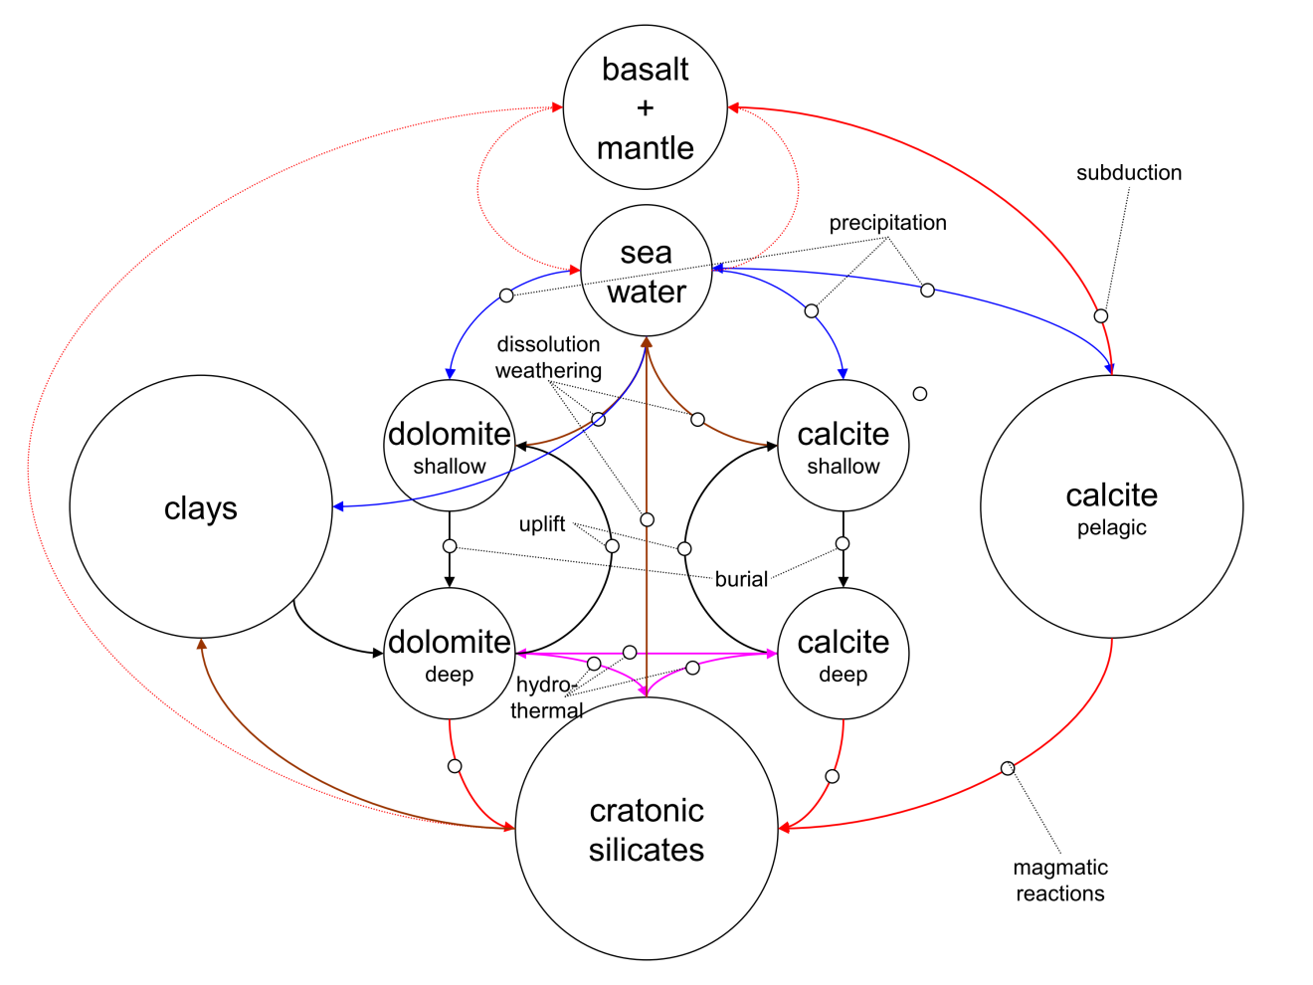**Figure 1**. Schematic diagram of the Earth system model MAGic (Mackenzie, Arvidson, Guidry interactive cycles) showing the major reservoirs and the coupling network among the reservoirs. Size of reservoirs is not proportional, and many fluxes are generalized. Precipitation fluxes are indicated by blue arrows, weathering or (diagenetic) dissolution by brown, hydrothermal interactions by magenta arrows, and magmatic or metamorphic transfers by red. Virtually all reservoirs contain links to the atmospheric (CO2 and O2), and thus these are omitted for clarity.

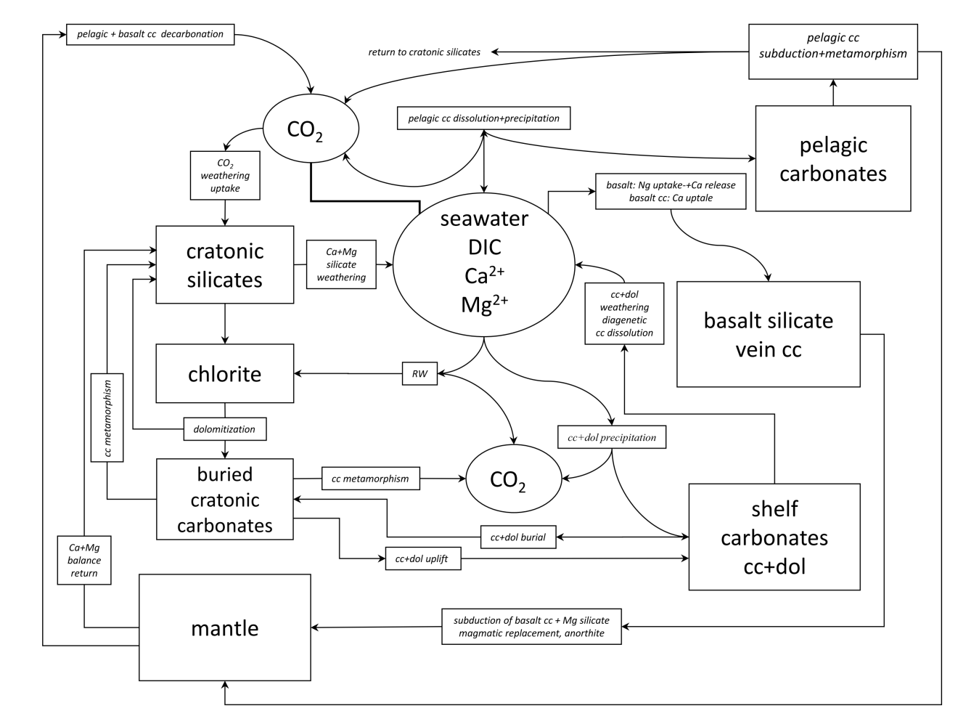

**Figure 2**. The calcium-magnesium-silicate-carbonate-CO2 subcycle of the model MAGic showing reservoirs and processes moving constituents from reservoir to reservoir. This subcycle is coupled to several others in the reaction network of MAGic and is important in terms of controls on atmospheric CO2 and ocean carbon chemistry on the geologic deep time scale (adapted from Arvidson et al., 2006).

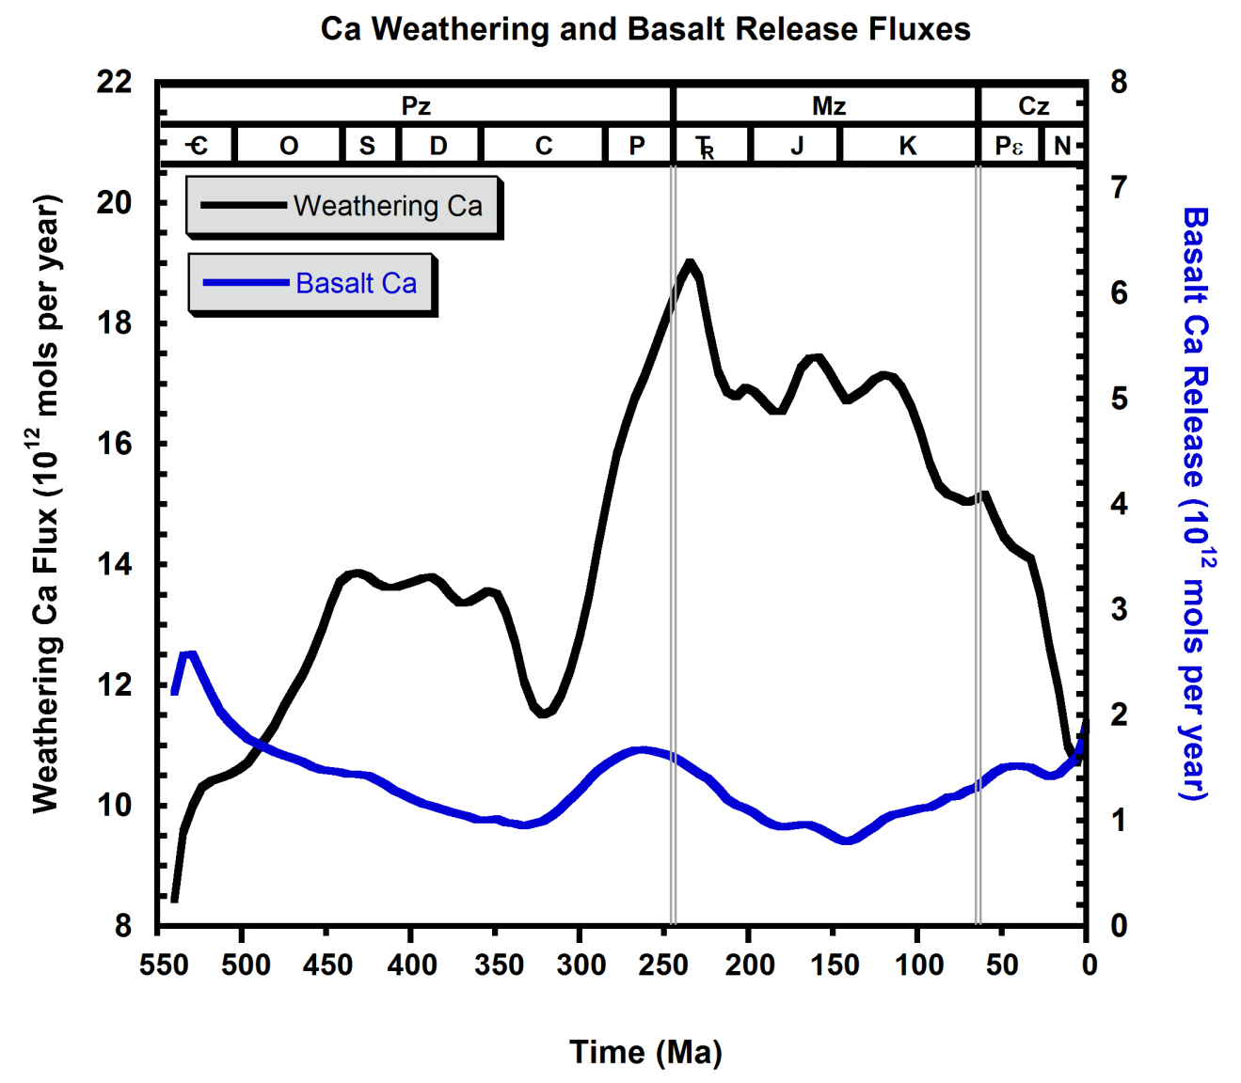

**Figure 3**. The results of numerical calculations from MAGic showing the calcium flux to the ocean via rivers and groundwaters from weathering reactions on land and the calcium released to the ocean due to basalt-seawater reactions in the seafloor in 1012 mol y−1. Notice in particular the rough cyclic pattern of higher weathering fluxes of the mid-Paleozoic and much of the Mesozoic and the lower fluxes of the early Phanerozoic, late Paleozoic, and Cenozoic. The basalt calcium release fluxes vary by about a factor of two and appear slightly higher at times of low plate accretion rates and lower at times of higher plate accretion rates [data from numerical model output of MAGic (Arvidson et al., 2006)] as modified in Arvidson et al. (2011).

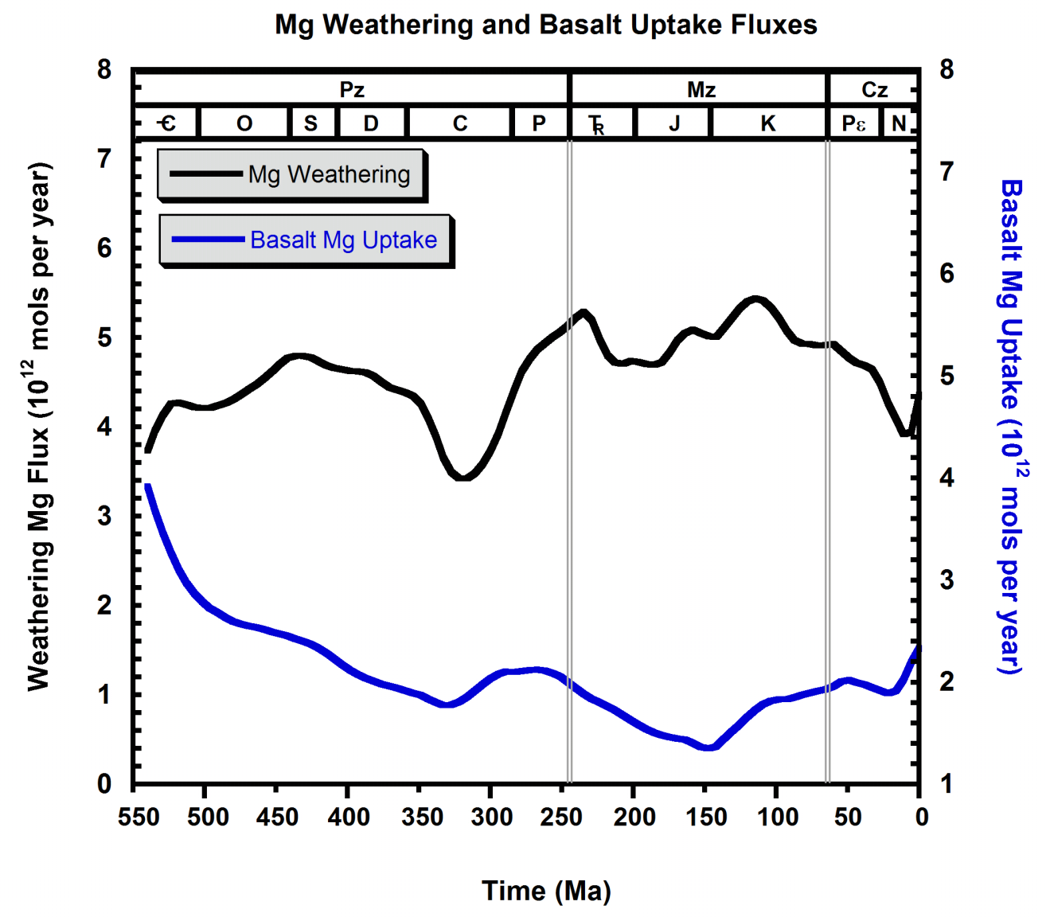

**Figure 4**. The results of numerical calculations from MAGic showing the magnesium flux to the ocean via rivers and groundwaters from weathering reactions on land and the magnesium taken up from seawater due to basalt-seawater reactions in the seafloor in 1012 mol y−1. Similar to the calcium fluxes in Figure 3 but not as pronounced, notice in particular the rough cyclic pattern of higher weathering fluxes of the mid-Paleozoic and much of the Mesozoic and the lower fluxes of the early Phanerozoic, late Paleozoic, and Cenozoic. The basalt magnesium uptake fluxes vary by about a factor of 2.5 and appear slightly higher at times of low plate accretion rates and lower at times of higher plate accretion rates (*ibid*).

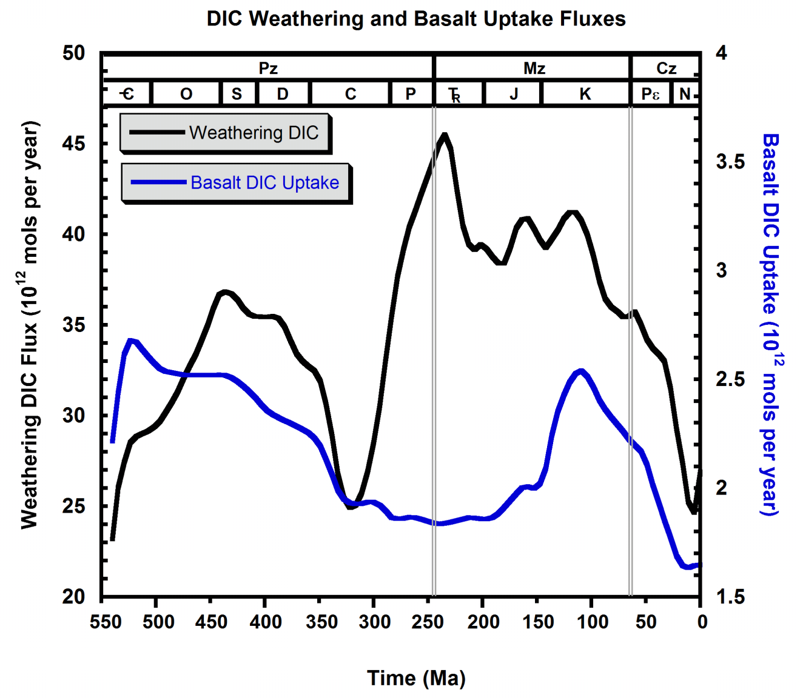

**Figure 5**. The results of numerical calculations from MAGic showing the dissolved inorganic carbon (DIC, mainly bicarbonate) flux to the ocean via rivers and groundwaters from weathering reactions on land and the DIC taken up from seawater due to basalt-seawater reactions in the seafloor in 1012 mol y−1. Similar to the calcium fluxes in **Figure 3**, notice in particular the pronounced cyclic pattern of higher weathering fluxes of the mid-Paleozoic and much of the Mesozoic and the lower fluxes of the early Phanerozoic, late Paleozoic, and Cenozoic. The basalt DIC uptake fluxes also exhibit a cyclic pattern and vary by about a factor of 1.5, appearing higher at times of high plate accretion rates and lower at times of lower plate accretion rates (*ibid*).

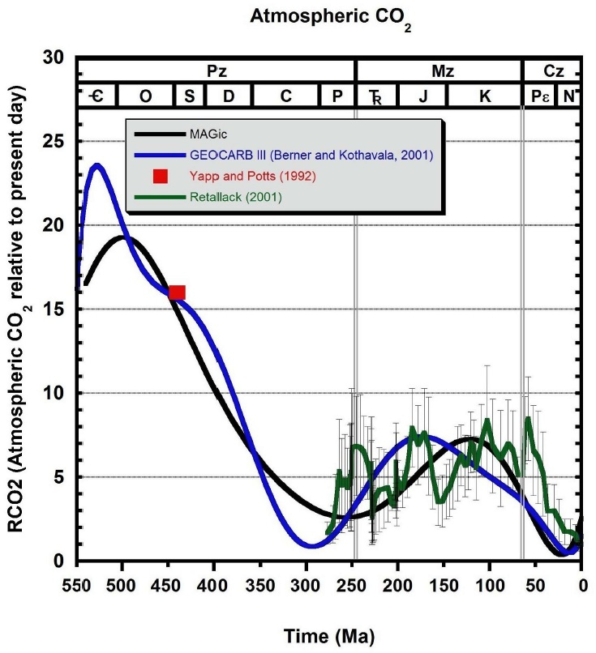

**Figure 6**. Phanerozoic long-term deep time generalized paleoatmospheric CO2 concentrations relative to the pre-Anthropocene value of ~300 ppmv. Model calculations from MAGic (Arvidson et al., 2006, 2011) and GEOCARB III (Berner and Kothavala (2001) are shown for comparison. The green line is a trend line through the ranges (bars) in proxy fossil plant stomatal data for atmospheric CO2 of Retallack (2001). The red square is Yapp and Potts (1992) data point of paleoatmospheric CO2 derived from paleosols. Notice the overall cyclic pattern in Phanerozoic atmospheric CO2 levels with concentration values increasing from the beginning of the Cambrian into the mid-Paleozoic and then falling toward the end of the Paleozoic and rising once more into the mid-Mesozoic and then falling into the Cenozoic.

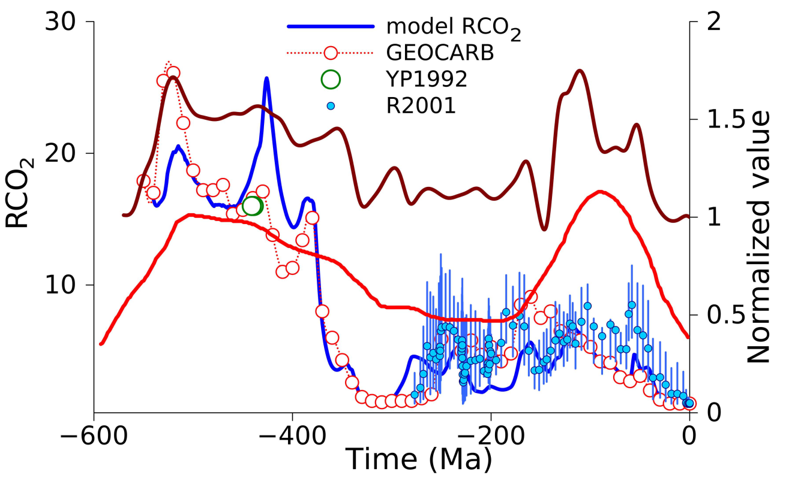

**Figure 7**. First order sea level changes, accretion rate, and paleoatmospheric CO2 through the Phanerozoic Eon. The brown curve is a normalized forcing function used in the GEOCARB and MAGic models to simulate sea floor accretion rate (e.g., Berner and Kothavala, 2001); the red curve is an estimate of relative eustatic sea level variation, based on data from Vail et al. (1977) modified by Arvidson and Mackenzie (1997). Atmospheric CO2 is shown as plotted relative to present day concentration (RCO2). The proxy CO2 data from Yapp and Potts (1992) obtained from paleosols and from the fossil plant stomata of Retallack (2001) are also shown (after Mackenzie et al., 2011).

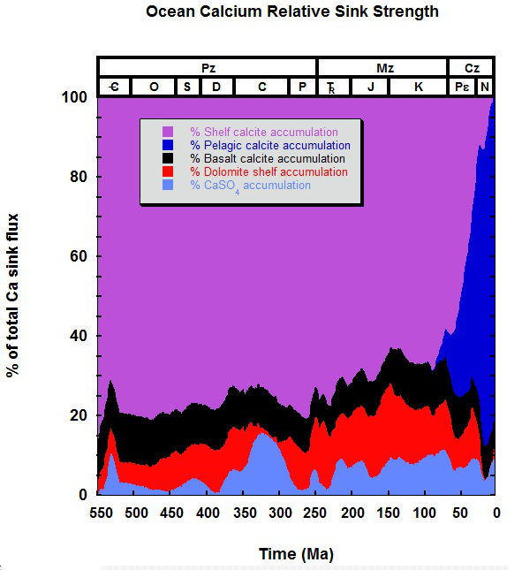

**Figure 8**. The relative sink strengths of various solid phase marine reservoirs of calcium in percent of total calcium flux to the reservoirs through Phanerozoic time [data from numerical model output of MAGic (Arvidson et al., 2006)], as modified in Arvidson et al. (2011).

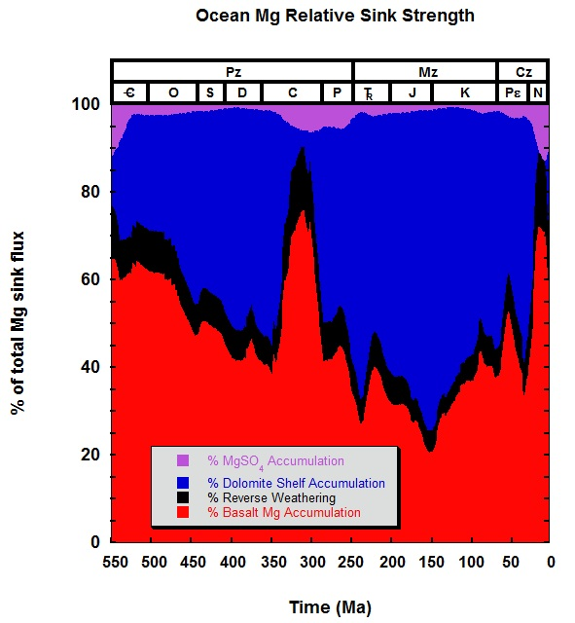

**Figure 9**. The relative sink strengths of various solid phase marine reservoirs of magnesium in percent of total magnesium flux to the reservoirs through Phanerozoic time (*ibid*).

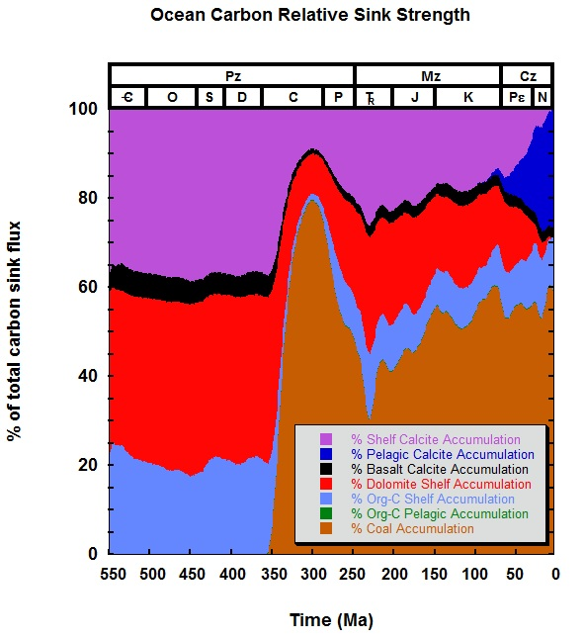

**Figure 10**. The relative sink strengths of various solid phase marine reservoirs of carbon in percent of total carbon flux to the reservoirs through Phanerozoic time (*ibid*).

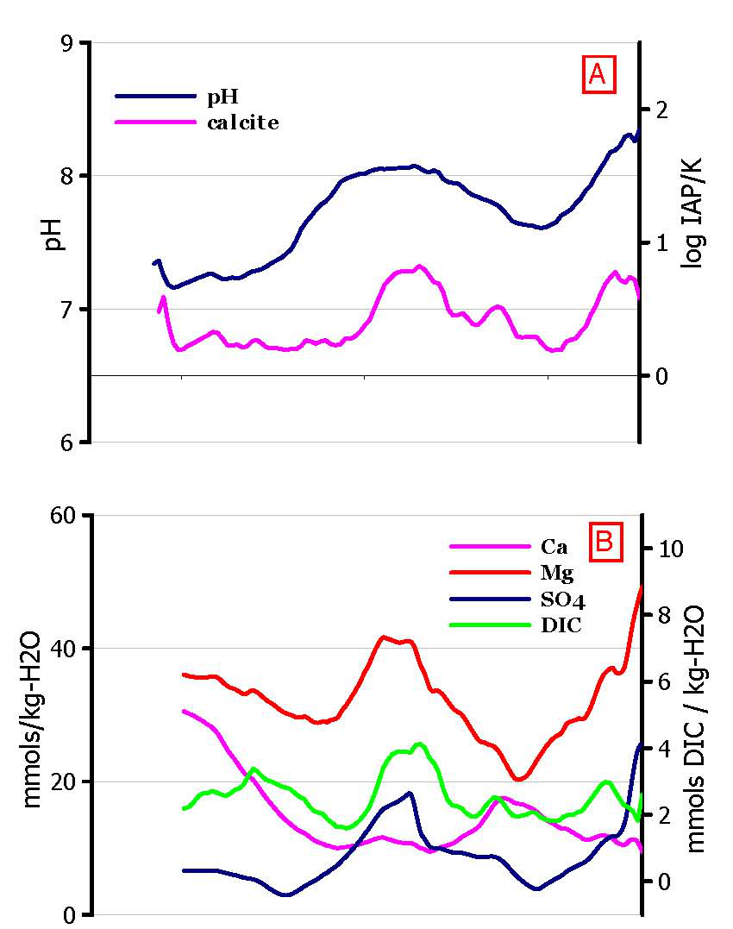

**Figure 11**. MAGic seawater concentration-age trends through the Phanerozoic. (A) pH and seawater saturation state with respect to calcite, computed from Pitzer equations; (B) Seawater dissolved Ca, Mg, DIC, and sulfate concentrations. There is a general cyclic variation in Mg/Ca and SO4/Ca ratios (Fig. **14E**), thus times of slow plate accretion rates, low sea levels, and low CO2 are times of high Mg/Ca and SO4/Ca ratios; conversely, low ratios are associated with high plate accretion rates, sea levels, and CO2 (*cf*. Fig. **7**). The cyclicity in calcite saturation state and pH also tracks the paleoatmospheric CO2 curve (Figs. 6, 7, 12, and 14), with high CO2 levels correlating with lower seawater pH and calcite saturation state, and lower pCO2 levels with higher pH and saturation state. Extended periods of low seawater pH are natural periods of ocean acidification (OA) [data from Arvidson et al. (2006) as modified in Arvidson et al. (2011)].

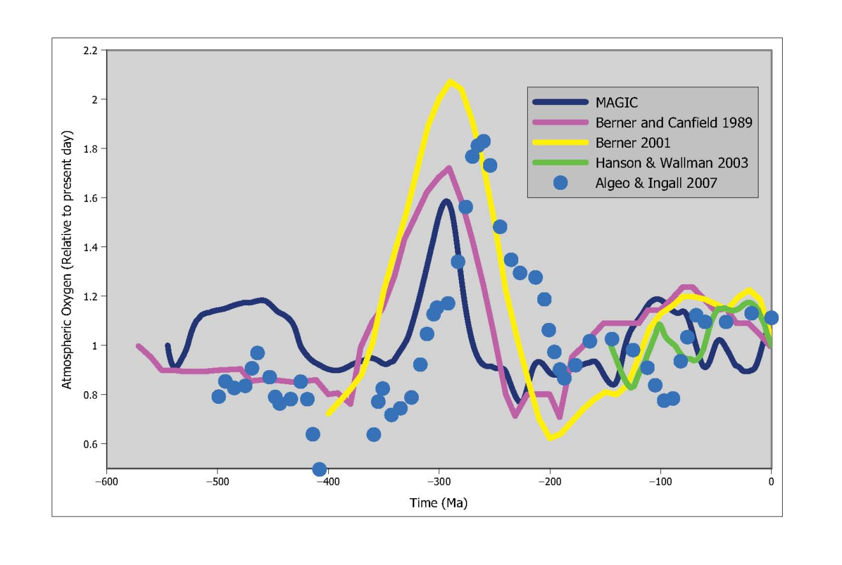

**Figure 12**. Comparison of atmospheric oxygen estimates. [Describe MAGic (yellow), Berner and Canfield (1989), Berner (2001), Hanson and Wallmann (2003; figure legend shows “Wallman”, needs correction), and Algeo and Ingall (2007).]

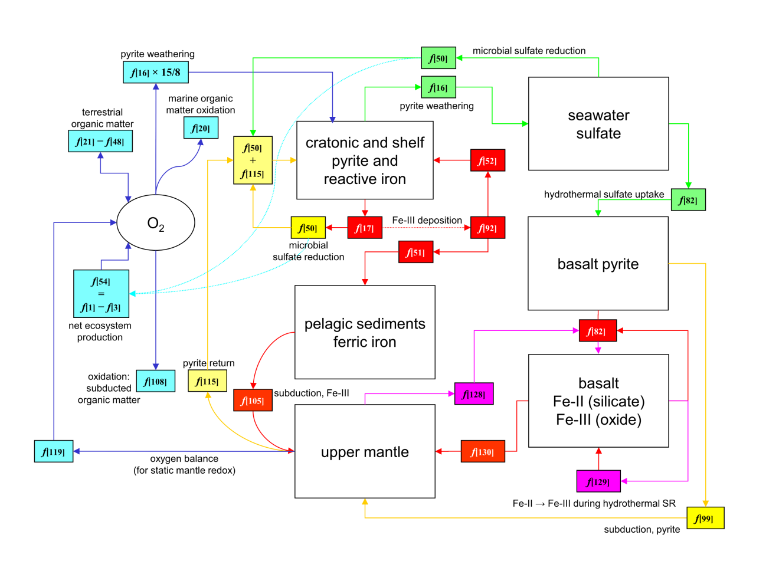

**Figure 13**. Interactions of organic carbon, iron, and sulfur biogeochemical cycles and their role in regulating atmospheric oxygen through the Phanerozoic Eon. The numbered labels refer to either reservoirs identified by bold italic font, or flux indices ( *f* [i] ) in the MAGic model (see Table A1, Arvidson et al., 2006). The flows related to oxygen are shown in blue, sulfate in green, ferric iron in gold, and reduced iron silicate as magenta. In addition to terrestrial organic matter cycling (burial – oxidation, *f* [21] – *f* [48]), oxidation of marine-derived organic matter on land (*f* [20]), and oxidation of pelagic organic matter, atmospheric oxygen is also controlled by the partitioning of iron between reduced and oxidized phases of sulfur and iron. Pyrite is produced both by microbial sulfate reduction (*f* [50]) in sediments and by hydrothermal sulfate reduction within seafloor basalt (*f* [82]). Pyrite oxidation (*f* [16]) consumes oxygen, as does hydrothermal pyrite formation, which involves production of ferric iron (*f* [129]). Although its flux is small, for purposes of the steady state maintenance of O2, the oxygen bound within this phase is ultimately returned to the atmosphere in the model (*f* [119]). The precise mechanism for this return flux is problematic and not well understood (after Arvidson et al., 2006).

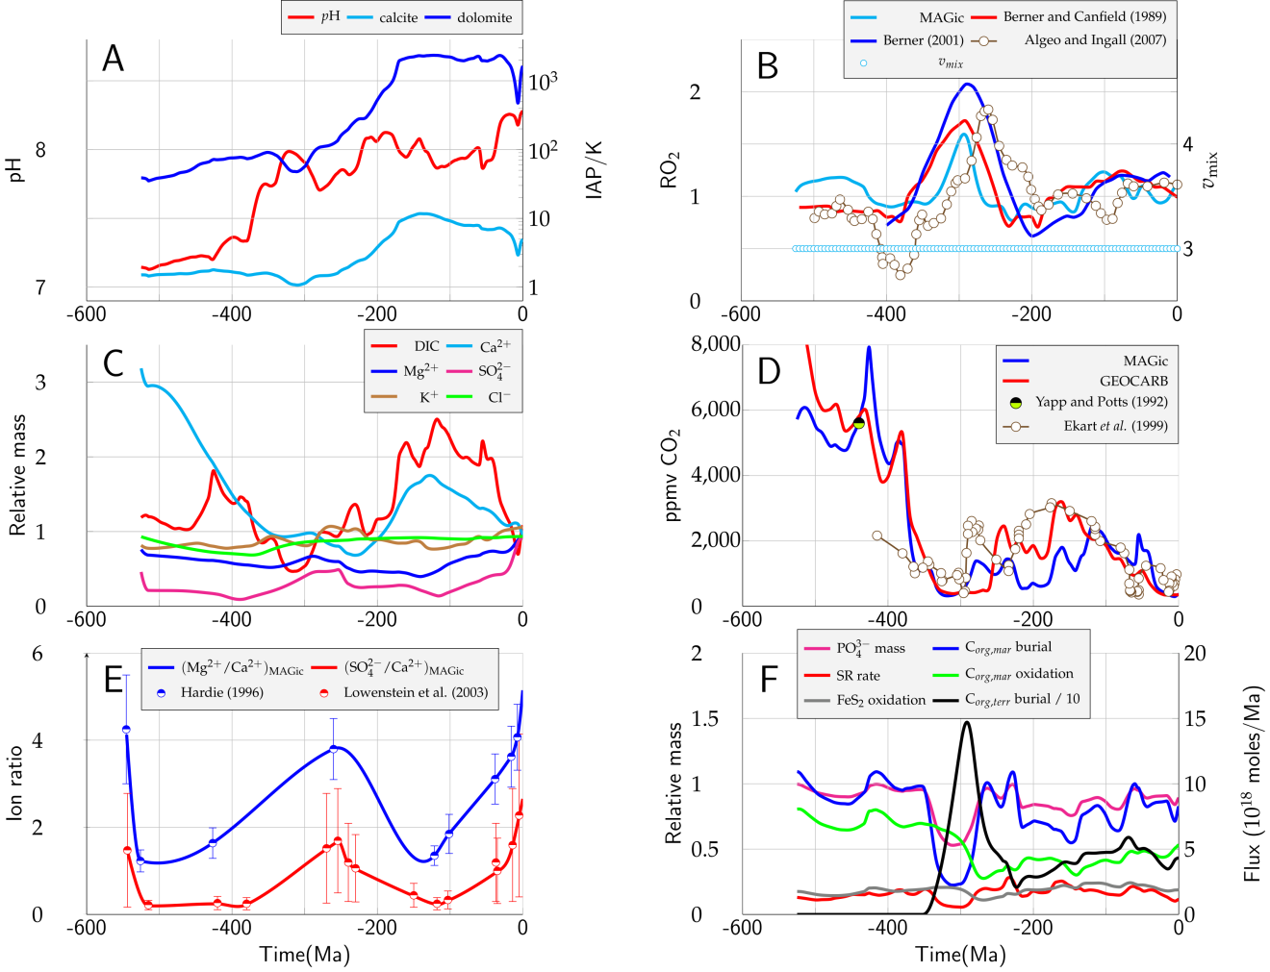

**Figure 14**. Summary figure of MAGic baseline run (fixed *v*mix = 3). [To do]

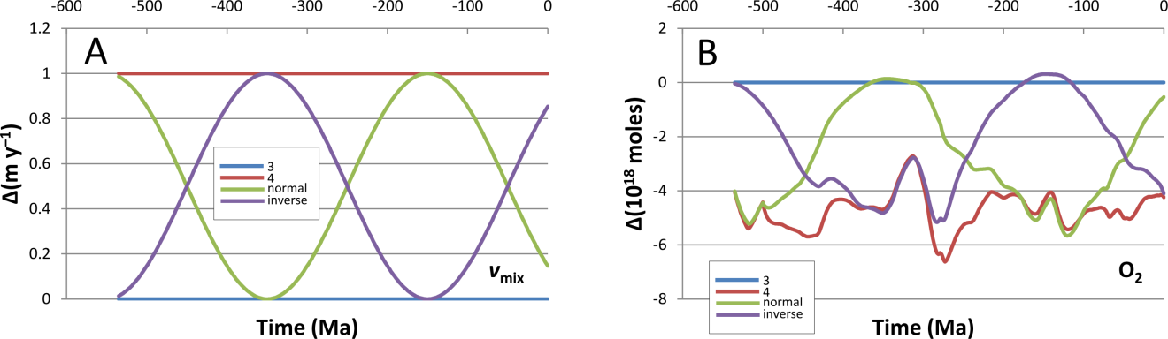

**Figure 15**. Sensitivity of atmospheric oxygen to simple variations in mixing rate (*v*mix) over the Phanerozoic. (A) Four runs were made, in which the value of *v*mix was fixed at 3 (blue curve) or 4 (brown curve), or cycled between these fixed values; the cyclic runs are arbitrarily differentiated as “normal” (green curve) and “inverse” (magenta curve). (B) The resulting variation in the total mass of atmospheric oxygen, expressed as an absolute deviation, Δ(O2), from the *v*mix = 3 (blue line at Δ = 0) results; colors for other curves as in (A). In general, an *increase* in the mixing rate brings about a *decrease* in atmospheric O2, as more oxygen is consumed in the aerobic decomposition of organic matter, oxic weathering of pyrite, and related processes. See Figures **16**, **17** and supporting text for discussion.

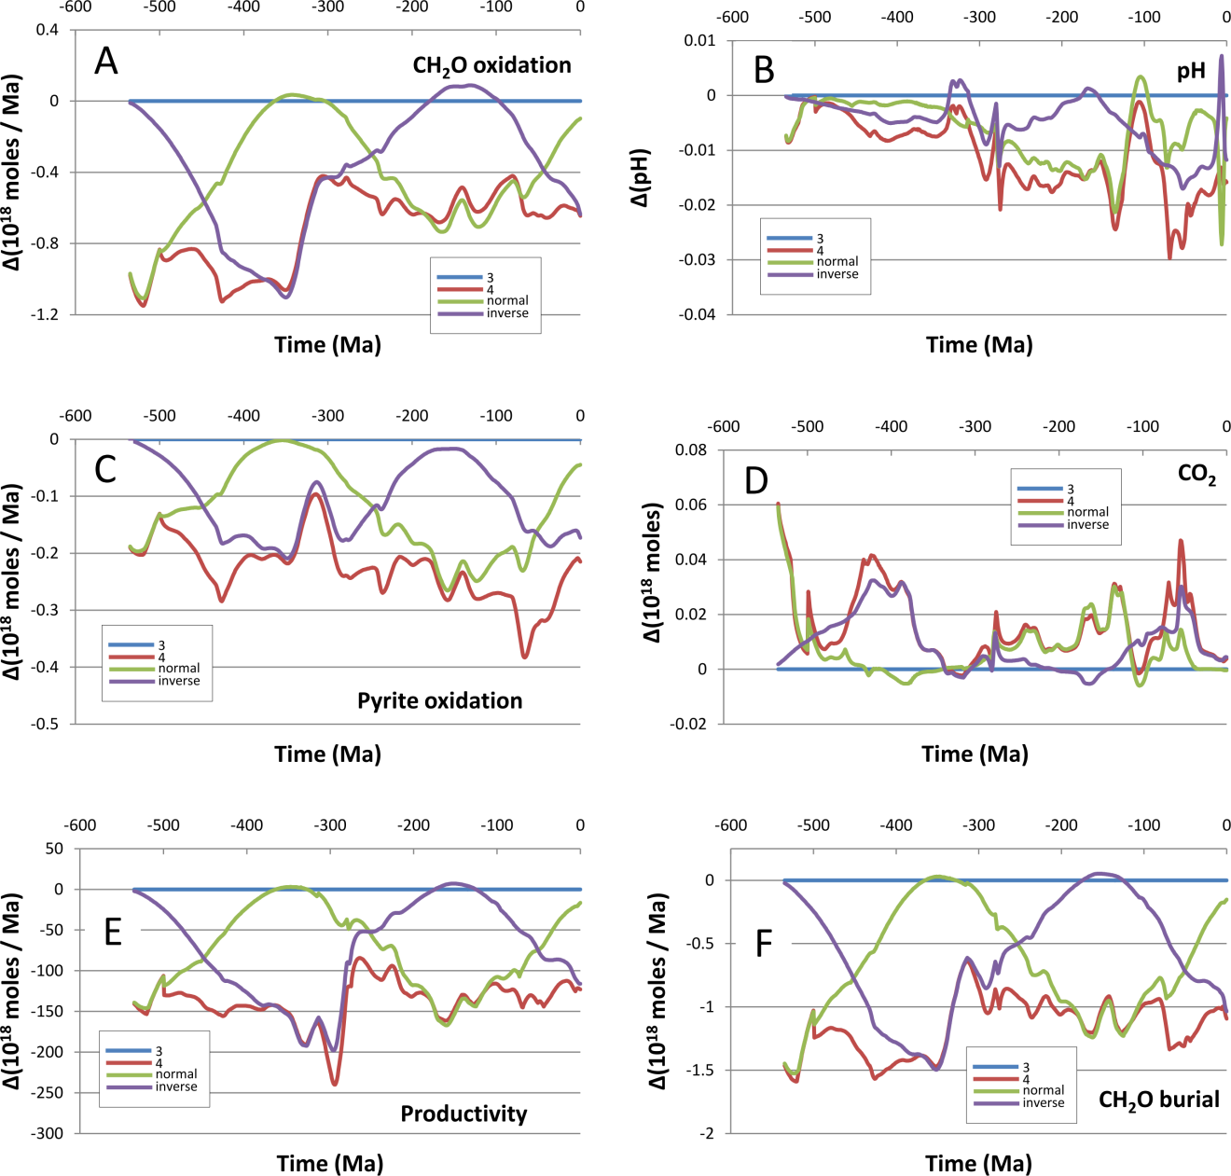

**Figure 16**. Variations in oxidation fluxes of marine organic matter (A) and pyrite (C), compared to changes in pH (B) and CO2 (D), as well as bioproductivity (E; BP term of eq. **4**), and marine organic matter burial (F; FB term of eq. **6**) brought about by *v*mix-forced changes in O2 concentration (Fig. **15B**), expressed as Δ values relative to *v*mix = 3 (color scheme identical to Fig. **15**). See text for discussion.

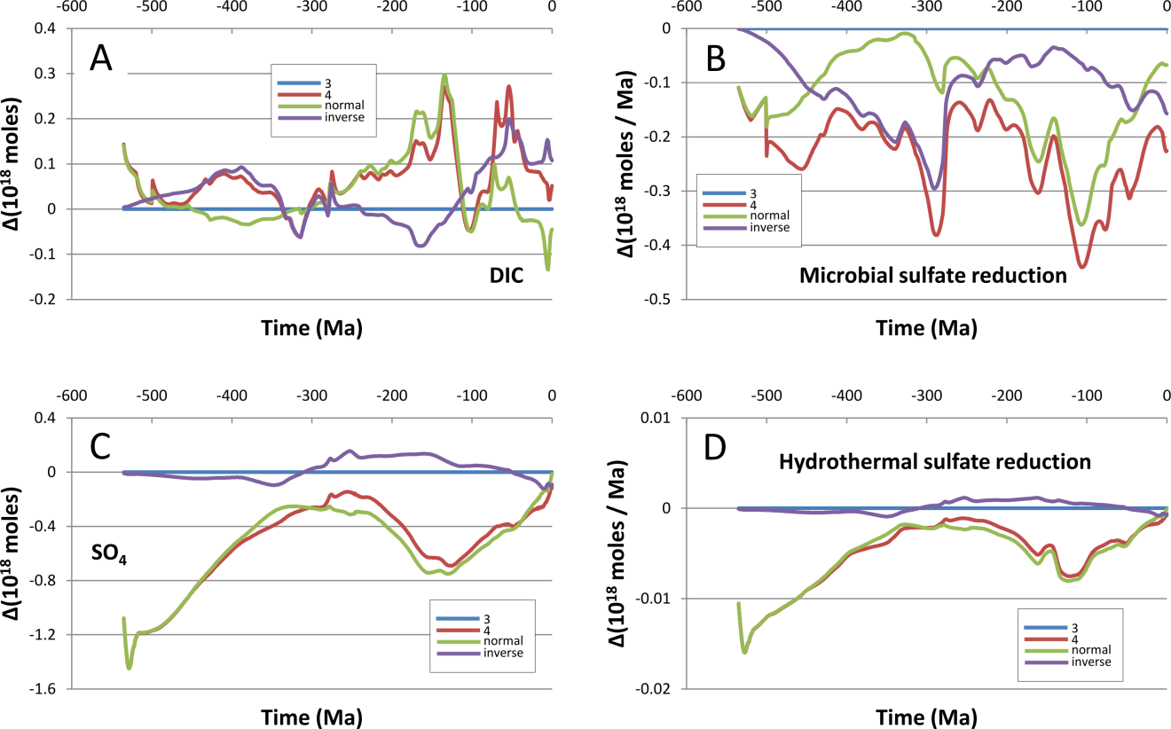

**Figure 17**. Variations in the seawater masses of DIC (A) and SO4 (C), and sulfur fluxes of arising from sulfate reduction during anaerobic oxidation of organic matter (B) and basalt-seawater interaction (D). See text for discussion.