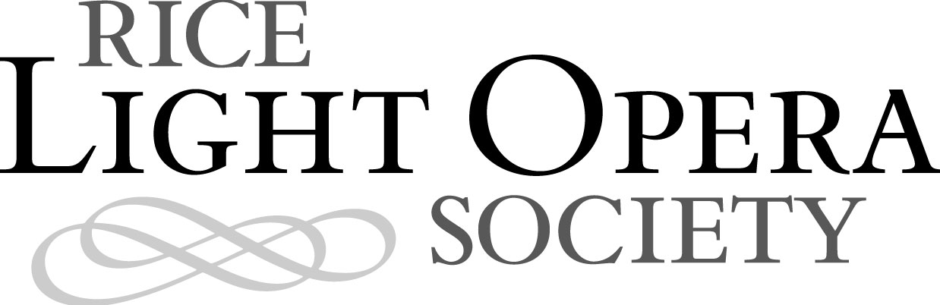
FOR IMMEDIATE RELEASE
March 2, 2006

CONTACT: Jen Frazer
Website: http://www.hailpoetry.com
E-mail: publicity@hailpoetry.com
Phone: 713-348-4586

EVIL ISN’T WHAT IT SEEMS IN Gilbert and Sullivan’s “RUDDIGORE” at Rice

The Rice Light Opera Society will present Gilbert and Sullivan’s comic light opera “Ruddigore” in seven performances March 23 through April 1.

The bad baronets of Ruddigore aren't really evil, but are compelled by a curse to perform daily crimes on pain of death. It's enough to drive a man mad. And when long-dead ancestors get involved, things get really scary. “Ruddigore” gathers evil aristocrats, innocent maids, fawning suitors, and a gang of very frustrated bridesmaids in a collision that questions the nature of evil and the virtues of, well, virtue. The opera is Victorian melodrama amplified and set to music, in a delightful parody of all things horrific and pure.

“Ruddigore” will be performed on the Rice University campus at Hanszen College. All shows are on Thursdays, Fridays, and Saturdays at 8 p.m., except for Friday, March 24, which will be at 10 p.m. There will also be a 2:30 p.m. matinee performance Sunday, March 26. Tickets are $10 for the general public (including parking) and $5 for the Rice community. For directions and ticket reservations, please visit http://www.hailpoetry.com or call 832-553-3251.

The Rice Light Opera Society has staged annual productions since 2002, most recently performing “Patience” in March 2005. The mission of the society is to increase awareness and appreciation of light opera in the Rice community.

“Ruddigore, or The Witch’s Curse” was the 10th collaboration between W.S. Gilbert and Arthur Sullivan. The opera opened on January 21, 1887, at the Savoy Theatre in London and ran for 288 performances. Gilbert and Sullivan wrote 14 operas together between 1871 and 1896, most of which were produced by the D’Oyly Carte Opera Company. Gilbert, the duo’s librettist, was an accomplished satirist known for a series of illustrated verses written under the pen name Bab. Sullivan, the composer, was often called the “English Mendelssohn,” but his genius was most evident in the lighter comic songs he wrote with Gilbert. Sullivan’s solo works include the opera Ivanhoe and the hymn “Onward Christian Soldiers.” Gilbert and Sullivan’s operas were wildly popular in their time and are still performed regularly today.

###

Editors: High-resolution press photos are available at http://www.hailpoetry.com/shows/ruddigore/press

