Seeing "Whitefellas": Contact-era Images in Rock-art
Patty Bass

Contact art and contact experience
David Lewis-Williams’s Believing and Seeing (1981) tangentially raised epistemological issues in our way of interpreting rock-art when he focused on explicating the 'meaning' behind the product labeled rock-art. It is perhaps not surprising that his efforts also eventually forced examination of those interpretations of the production itself to acknowledge the social and cultural complexity underlying the art’s production. One corpus of rock-art that would seem to illuminate this complexity including issues of identity and social adjustment are those images depicting ‘contact art.' The present project, of which this paper is a beginning effort, presents the issues of agency, change, resistance to colonial ideology and the presence of a native historiography in rock-art depictions.
The focus is on ‘contact art’ and on the assumption that it is readily identifiable; pictures of men on horses with rifles or of wheeled wagons are often assumed to be depictions of colonists and their relationship to the colonized. So the 'norm' for colonial or European contact art is:
• viewers, with different research interests in rock-art, around the world, think they can identify European figures in their rock-art corpora.
The iconic features that are used to make this identification are, typically,
• figures with hats
• figures with a distinctive posture variously described as aggressive, wide-legged, hands-on-hips, or hands in the pockets
• the figures are often associated with horses, wagons, guns and big-skirted women, assumed to be white.
While these images seem representational or narrative, research has shown that a great deal of rock-art is symbolic and cannot be treated as simple narrative. I explore if it is possible to use the art to describe a reductive imagery of the European (Alloula 1986:129) and to ‘interpret the intrusive coming of Europeans in ways consistent with the people’s own cosmological schemes’ (Sahlins 1995: 179).

Figure 1
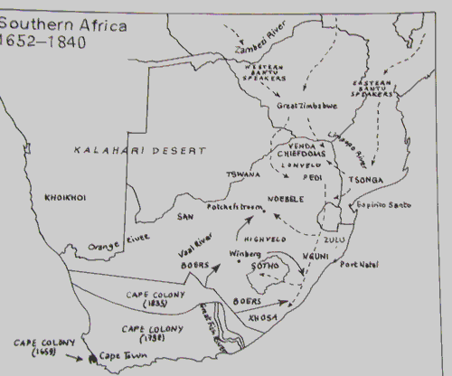

Into the field – South Africa
Southern Africa was well if sparsely inhabited when the Portuguese first investigated its southernmost tip in the late 15th century. But European settlement did not commence in earnest until Dutch settlers followed Dutch explorers into the Cape region in 1652 (Figure 1) followed by the beginning of the frontier wars in the late 1700s (Penn 1999:2). The eighteenth century saw the settlement expand from the Cape into a colonial presence in conflict with the varied indigenous groups of the Western Cape, Eastern Cape and Free State. The advancing settlers not only introduced hitherto unknown diseases to earlier inhabitants but annihilated the herds of game that had supported the Bushmen life-style (Lewis-Williams 1986: 36). The colonialists not only encountered the remnants of the hunting-foraging Bushmen but pastoralists who had been observed by the earlier explorers using coastal lands in annual seasonal rounds for their herds of cattle (Vogel 1997: 210). Kraals or villages were made up of related men with their wives. Outsiders were supposed to make gestures of gifts to the chief for permission to enter the kraal lands. Yet the only individually owned property was the livestock (Vogel 1997: 212). The large herds of cattle belonging to the indigenous groups were the main attraction for the Dutch to set up their trading station at Table Bay eventually becoming Cape Town. The difficult interactions with the Europeans eventually led, through a combination of warfare and acculturation, to the disappearance of the Bushmen except in Namibia and Botswana (Vogel 1997:346).
Rock-art, which has survived at the very least for centuries, is found throughout southern Africa. In South Africa’s ‘treasure trove of rock-art’, some contact art has been produced by non-Bushmen such as the Sotho. Indeed the 'distinctive posture' of Europeans in rock-art was first pointed out in this non-Bushmen art by a fellow rock-art researcher but as those corpora of art are being examined by others (e.g. Smith, pers. com.; in press) it was not the focus of this project.
Many Bushmen paintings seem to be narrative. A scene from Cathcart in the Eastern Cape depicts a uniformed line of twelve soldiers. The figures wear white pants and blue coats along with crossed belts; one figure at the end of the line wears a fur hat. None of the soldiers is drawn with the ‘typical’ stance noted above (Figure 2; contact the author); yet their dress enables them to be recognized as Europeans. In another example, European soldiers, identified by their uniforms, without a typical stance, are on horseback and hunting the context-laden eland. This scene at Bellevue would seem to be narrative and it has no shaman figures (Figure 3; contact the author), yet it shows shamanistic symbols - the eland. The eland plays a large symbolic role for the San that is difficult to summarize: ‘it is a symbol of, among other things, the power that shamans harnessed to enter the spirit world. Each [eland] proclaims all the values Bushmen held dear’ (Lewis-Williams & Dowson 1992: 41). Here eland are being pursued by the uniformed European on horseback: are they more than large antelope? In the San world they are. Thus an assumption that they are merely representational images ignores the presence of an indigenous cosmology and some use of the reductive imagery of European uniforms and weapons (Lips 1937: 73-77).
Another San scene that seems to have depicted an iconic animal alongside Europeans is one housed in the Museum Africa, originally from the Rouxville district, Free State, illustrating an elaborately attired and hatted couple, the male with shoes, plus an ostrich and other images (Figure 4; contact the author). The costumed couple, drawn with their hands on their hips, are therefore viewed as European. In addition the skirt is present, the feature that labels the white woman (Lips 1937: 151). The ostrich posture is interpreted as a display or aggressive posture because of the raised wing and tail feathers (Campbell 1987: 120; The Big Picture, Jeremy Hollmann, pers. com.). In earlier research, Vinnicombe associated the ostrich with the wildebeest, regarded by the Bushmen as an ‘animal which resorted to subterfuge; it lived among animals under false pretences’. The wildebeest was therefore subject to rules of avoidance, as was the ostrich its frequent consort (1976: 209–210).
An image from the Free State paints figures in hats and European-style breeches, with hands on hips. Associated with the human figures are feline figures, a pair of yellow and white lions, and a baboon (Figure 5; contact the author). To explain the images of baboons, Patricia Vinnicombe after studying the stories of Wilhelm Bleek’s Bushman informants, suggested ‘the delineation of this animal on the rocks may in some way have immobilized the evil that would otherwise afflict the [Bushman] hunter' (1976: 225). As for the feline images, Vinnicombe reported long ago in People of the eland how the lion was viewed by the Bushman as a symbol of aggression and associated with harm and destruction. In addition sorcerers could adopt the guise of lions (1976: 215–218). David Lewis-Williams, explaining the role of the feline in San thought, reports the feline is ‘associated with unknown or threatening people'. Its depiction, often in multiples as painted in this scene, represents a medicine man ‘able to drive off threatening lions and thus protect people at night’ (Lewis-Williams 1985: 55).

Figure 6
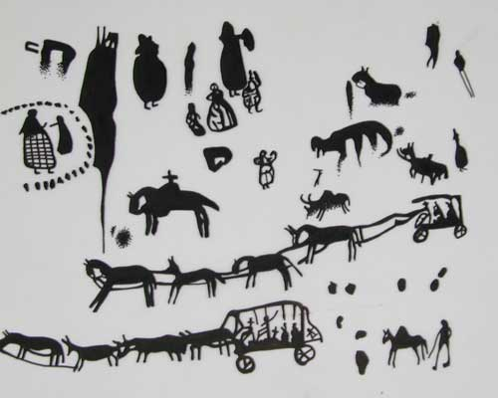

A panel from Stompiesfontein in the Western Cape illustrates numerous figures. Although none display typical posture in this panel the posture is painted for other figures at the site. These images are interpreted as European because of their costumes including hats, and through their association with horse-drawn wagons, as well as there being both male and female images. The scene includes several paint dots, possibly San 'finger dots' (Figure 6). The finger dots may have represented a multiplicity of iconic symbols in Bushman art; Lewis-Williams & Blundell argue that within the San cosmology of rock-art the dots were at the very least ‘implicated in the creation of socially situated meaning and thereby the reproduction and transformation of society’ (1997: 53).
Thus San art, already interpreted as shamanistic productions, seems to illustrate contact imagery in ways consistent with Bushmen cosmology. The constellation of European-style clothing, horses, wagons and female Europeans, seems like that seen in several regions of the world. Yet the typical stance may not always be used.

The conquistadors - Southwest United States

Figure 7
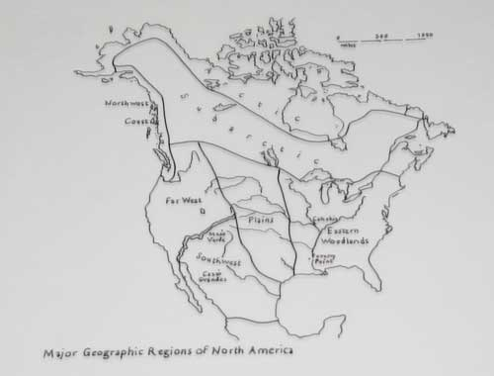

Rock-art images depicting Europeans are not unusual in the various groupings of rock-art around the United States; the focus in this section will be on the Southwest – western Texas, New Mexico and Arizona, and parts of Colorado and Utah (Figure 7). For the states of the Southwest the first European contact would have been with the Spanish. Yet this was not the first contact with ‘civilization’. In the era before Columbus much of the Southwest supported a complex cultural life based on a settled way of life and the cultivation of domesticated plants from central Mexico (Brown 1988: 34; Dutton 1975: 2–3). Cultural traditions that included pottery-making and weaving such the Mogollon, Hohokam and Anasazi led to settled towns with large populations at places like Chaco Canyon and Canyon de Chelly. These towns were later called ‘pueblos’ by the Spanish because of their settled life-style and structured habitations, and each was given saint’s name. Periodic droughts and shifts in settlements led the populations to move to the Rio Grande valley where most Pueblo peoples live today. The modern Hopi (Hopituh Shi-nu-mu = ‘the peaceful people’) still practise traditional farming that does not require permanent reservoirs of water (Brown 1988: 34–35). Pueblo societies were clan-based with elaborate ceremonial cycles (Brown 1988: 35–36); they participated in a complex trading system with Mesoamerica and southeastern native settlements (Dobyns 1988: 68). The way was paved for colonial conquest by the spread of Old World diseases such as smallpox. By 1620 the borderlands population between present-day United States and Mexico had gone from over 5 million to 250,000 (Dobyns 1988: 69).
In 1680 the Pueblos united and struck back at the Spaniards, killing 20 missionaries and 400 colonists. In response the Spaniards set up posts to protect against further uprisings (Dobyns 1988: 77–79). Apache bands (the term ‘Apache’ is believed to derive from the Zuni word for ‘enemy’ – apachu) on horses gained from the Spaniards pushed the remaining Pueblo horticulturalists further west. The historic Navajo (Dine’e = ‘the people’) emerged with a pastoralist life-style of combined sheep flocks and horses (Dobyns 1988: 76). Mexico gained its independence from Spain in 1821, and the Pueblo lands and inhabitants became Mexican citizens. In 1848 and then 1853 the US acquired the territory including the Pueblos, by the Treaty of Guadalupe Hidalgo and the Gadsden Purchase. When the lands of Arizona and New Mexico became states, the Indians of the Southwest were eventually granted citizenship status (Dutton 1975: 9–11). This was the European-contact history to which the Native Americans responded.

Figure 8
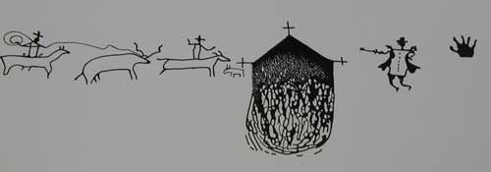

Just as the Bushmen drew their historiography in the contact art, so do the scenes painted and pecked throughout the Southwest display a native perspective. One example of colonial-contact art is the rock-art of the Despoblado, ‘the unpopulated zone’ of the Texas/Mexico border. These images have been described as ‘the only expression we have of the native Indians’ attitude toward their historical experience of the early Spanish and Anglo-America settlers' (Turpin 1988: 50). The earliest contact art represents late-16th-century interest in the presence of the Christian missions. Pressa Canyon along the Rio Grande in west Texas contains mission scenes showing white men and mission buildings (Figure 8). This panel includes hatted figures on horseback, one lassoing what appears to be a deer, a mission building; a pipe-smoking human, dressed European-style, with shoes and wearing a hat, stands with one hand on his hips: ‘This manner of painting white men derives from the fact that the hands on hips posture was and is one of their common bodily habits, but it was rare or absent among Indian tribes. The artist had only to show posture to convey the identity of the subject,’ explain Kirkland & Newcomb (1967: 200).

Figure 9
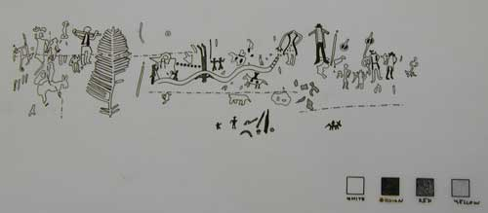

Other far west Texas images from Hueco Tanks include European styles of dress. In these, an 'hourglass' form to the torso is read as iconic for white men because white men wore belted garments; the depiction of hats or helmets is taken as a further costume-marker of white men (Figure 9). Some of the figures show the typical posture, and one of the males has two rows of buttons down the front of his waistcoat. This scene includes women dressed in European style as well; in one figure the hourglass form is particularly accentuated, and one hand is on her hip. Another scene from Castle Canyon in west Texas shows other examples of men with hats, posture and two with synched waists; there is a whole row of European-style women (Figure 10).

Figure 10
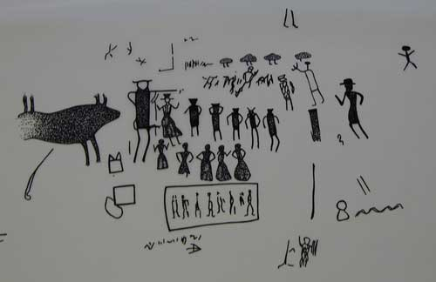
Figure 11
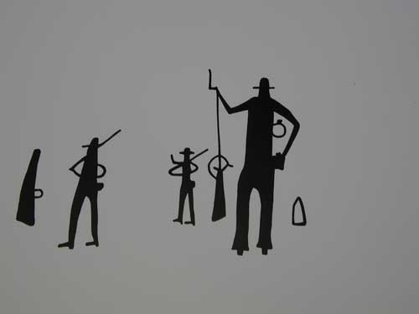
Elsewhere in the Southwest are additional depictions of white men presented in representational style. The Navajo painted numerous images of whites as well as engraving their presence on canyon walls. Pecked and painted images depict white men with hats and rifles, and with a hand on the hips (Figure 11).

Figure 12
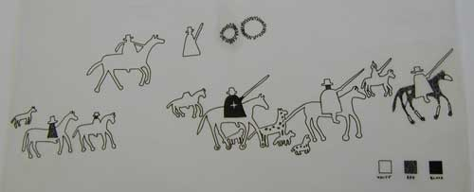

As the contact increasingly took on a tenor of warfare, the rock scenes displayed these events. In Canyon de Chelly, at Standing Cow Ruin in Canyon del Muerto, is a Navajo rock-art scene of Spanish horsemen. Of several interpretations, the narrative usually attached to it is of the Narbona Cavalcade (Patterson 1992: 118; figure 12 re-drawn from Grant 1967: colour plate). In 1804 Lt Antonio Narbona was sent north to take on the raiding Navajo. Word reached the Navajo, and the older men, women and children sought refuge in a high cave in Canyon del Muerto. Somehow the Spanish troops managed to locate the shelter and after a night-long assault, entered and killed all except one old man. The site is still riddled with hundreds of bullet holes; it also yielded the oldest example of Navajo weaving (Dutton 1975: 243). Lt Narbona, with his report describing the attack and the outcome, included 90 pairs of ears to account for those killed (Grant 1992: 84-89). The men in the cavalcade are drawn with capes, including one with a cross appliqué, and
hats; their horses display their hooves and possibly even their horseshoes.
The rock-art of the Southwest seems to conform to my model of depiction for the European: the distinctive style of clothing, hats and shoes as well as associations with horses, guns, wagons and European women. In addition there are many image associations with Spanish-style mission churches.

Wild time – Australia
Moving on from the theoretically secure ground of South Africa, and the familiar images of the Southwest, this section briefly examines rock-art images in Australia to see if the same holds for another group confronted with an invading outsider.

Figure 13
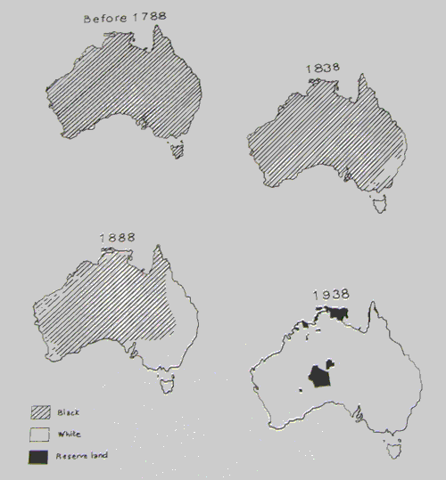

European contact with Australia began around the early 18th century as part of a mercantile trade system. Ships sailing from Macassar started visiting the northern coastline. Aboriginal cooperation aided resource gathering in exchange for food, alcohol, cloth, tobacco, axes and knives (Layton 1992: 89). The Macassans didn't colonise the coast; that was left to the arrival of the British colonists at Sydney Cove
in 1788. Within a year an epidemic had devastated the Aboriginal population and by 1791 venereal disease had been introduced (Layton 1992: 96).
The British definition of land titles, refined in its colonization of America, was expanded in Australia and the treatment of the Aboriginal inhabitants. The perspective was that European rights stemming from discovery superseded any native rights to land. Limitations on Aboriginal rights to land were based on the perception of the Aboriginal peoples as wandering hunter-gatherers (Perdue 1988: 138) (Figure 13). The discoverer had the right to possess the land when the Aboriginal peoples moved on.
European imagery is found widely in Aboriginal rock-art particularly in the Arnhem Land region of the Northern Territory. The production of rock-art continued beyond the time of initial colonization. Historic records from the late nineteenth century describe incidents of rock engravings depicting Europeans yet throughout Australia, Aboriginal resistance was fierce. Still the Aboriginal peoples’ understanding did not include the concept of territorial conquest (Layton 1992: 94). Instead, like the San, religion and ceremony were linked to the land - as was the production of rock-art. It may even be that the cessation of the production of rock-art was tied to the denial of the use of land (Layton 1992: 100).

Figure 14
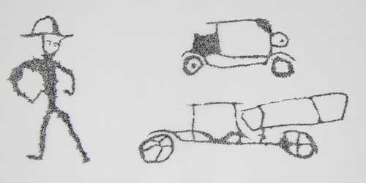

Figure 15
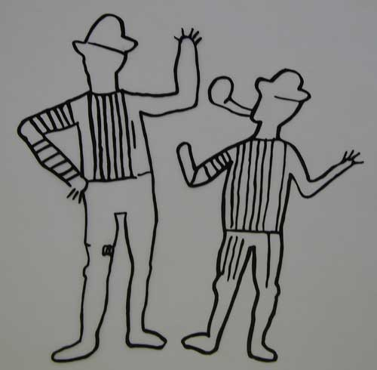

Representational figures rendered by the Aboriginal peoples range from pounded engravings of a hatted man with hands on hips and vehicles at the Granites (Northern Territory) (Figure 14) to a couple of European men with hats smoking clay pipes found in the Weliyn rock-shelter on Delamere station (Northern Territory) (Figure 15). The Delamere figures wear striped tops and wave hands; but there is otherwise no movement. These images reflect life on a cattle station in the early 20th century after the 'wild time', or of the beginning of colonial encounter (Trigger 1992: 17). They may reduce the European figures to a short-hand representation, but they
don't seem to illustrate any belief scheme.
An example of an effort to depict something strange is found in an early- contact narrative scene from the Alligator Rivers region. It is a line of horses, some with riders and some with pack-bells; it may show the figures of John McKinley's exploring party, which was lost in the region in 1865/6. The horses in the panel are drawn with wallaby-like, marsupial rear ends. The strangeness of horses to the artists led to their being drawn with a sloping back, large wallaby-shaped haunch, and angled rear legs rather than their true biological features (Figure 16; contact the author) (Chaloupka 1979; 1993: 195; Chippindale & Tacon 1998: 95).

Figure 17
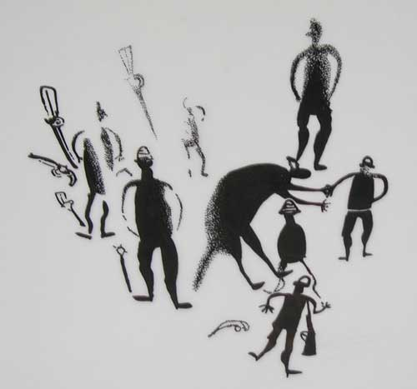
Another early scene from Wynbarra Rock-hole, Innesvale (Northern Territory), shows painted European men with rifles and revolvers associated with a kangaroo or wallaby, an iconic image depicted across much time and space in Australia. The human figures are presented in the aggressive stance with hands on the hips (Figure 17). The Aboriginal peoples viewed this as a European stance and thus by body language a marker of the race (Flood 1997: 314–18). Yet this posture may be symbolic: elsewhere Aboriginal people refer to the hands being in the pockets because the white man doesn’t work - he only issues orders (Jelinek 1989: 497).

Beyond the obvious
Attempts to interpret Bushmen images have explicated the social role of rock-art to include ‘violent clashes with other peoples’ (Lewis-Williams & Dowson 1994: 211). The contact art is now viewed not merely as representational or narrative but as depicting conflict, in all its permutations, between Bushmen and white colonists, and the resulting cultural negotiations of that conflict: ‘At first it was thought that this so-called “contact art” comprised cattle, shields, iron-bladed spears, black agropastoralists and white colonists. . . . [But the s]hamans and artists were engaged in a far more extensive, subtle and varied process of transmuting the circumstances in which they lived’ (Lewis-Williams & Dowson 1994: 220).
Images, at Beersheba, examined by Colin Campbell, Thomas Dowson and David Lewis-Williams delineate a fight between San cattle-raiders and a pursuing commando hatted, on horseback, discharging weapons (Figure 18; contact the author). David Lewis-Williams talks about the non-hallucinatory battle in Some aspects of rock art research in the politics of present-day South Africa, writing of Patricia Vinnicombe’s belief that the painting may depict a confrontation with Boers that took place between 1836 and 1845 (Lewis-Williams 1995: 327). Yet it has been suggested that the scene also depicts a 'hallucinatory battle' because of the presence

of the San figure to the right 'bleeding from the nose with two large, feather-like appendages issuing from the top of the head and a large feather-like tail’ (Campbell 1986: 262–263). ‘These details, nasal bleeding, feather-like appendages and dancing sticks, all signify aspects of trance belief and experience. . . . It is the medicine man’s responsibility to drive off harmful spirits, and a re-enaction of this hallucinatory battle’ is depicted (Campbell 1986: 264–265).
While an examination of the rock-art throughout the American Southwest and Australia shows numerous representational or narrative depictions both in the pictographs and petroglyphs, there is more to these than just that rendering of white Europeans. If we attempt to explain this art without reference to their cultural foundations and subsequent negotiations we risk false conclusions (Lips 1937: 40). The Australian scene described above (Figure 17) includes not only the typically clad, typically stanced Europeans associated with rifles and pistols; those are in association with a macropod figure which appears to have human feet. In San rock-art that image might be interpreted as shamanic.
Another pictograph along the Pecos River shows a mounted white figure, so interpreted because of his hat, who has been lanced (Turpin 1988: 55, 51) (Figure 19).

Figure 19
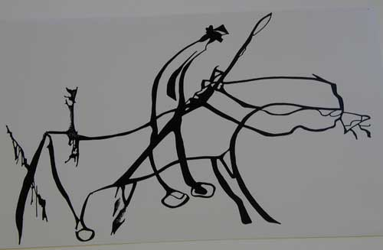

Such seeming antagonistic paintings are accompanied by many examples of symbolic imagery such as several depictions of Europeans and their designated icons.

Figure 20
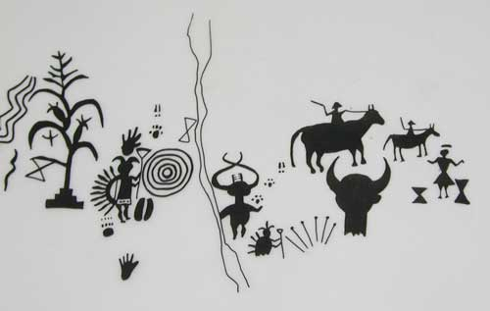

Another petroglyph scene from Largo Canyon (New Mexico) rendered by the Navajo shows hatted European figures on horseback in association with the Navajo Humpback God, Ghaanaskidi , traditionally employed to rid the people of sickness (Cole 1990: 204: Dutton 1975: 101). Also in association are a corn plant and the hourglass image representing Born-for-Water, the younger brother of Monster Slayer, the Navajo War Twins (Figure 20). The hourglass symbolizes the scalp-knot Born-for-Water tied after his brother ‘killed the monsters that plagued the Navajo after their emergence from the underworld’ (Patterson 1992: 119; Schaafsma 1992: 28–30). This linkage in Pueblo ideology can be additionally broadened to a linkage between enemy scalps and rain-making power; thus an enemy scalp "is transformed into a rain-bringing fetish" (Schaafsma 2000: 149).

Conclusion
The modest proposal outlined in the introduction has led, as theories often do, down

a slightly different path. Colonial-contact images should more accurately be called 'non-indigenous figures'. They are representational/narrative depictions employing choices of costume and posture that do not necessarily have a deep symbolic sub-text but do not necessarily show a complete uniform imagery of the contact figures either.
Nevertheless examining these contact images in rock-art scattered across the globe seems to confirm the similarity of the distinctive features of colonial period paintings.
The imagery often moves from the distinctive to include image depictions that may be interpreted as consistent with the native belief system prior to the ‘intrusive coming of the Europeans'. It thus also appears likely that the analysis and interpretation of the range of contact images painted and pecked in rock-art include the native historiography. Yet at the same time that native historiography contains the symbols, perhaps not shamanic but iconic. It is thus that the indigenous rock-art painter can be seen as engaging in a reductive reading of the encroaching other.
This leaves rock-art researchers of contact art with the following questions:
- Why are the features so similar?
- Are these features similar because they made an impact on the aboriginal?
- Or are these features rendered because they are distinctive or easy to draw?
As has already been pointed out for the Bushmen art, the term 'contact' may be misleading encouraging us to focus on images with identifiable features.
- Perhaps, finally, these features only seem distinctive because we, the non-native, can recognize them?
Maybe, in our vanity, we are drawn to and charmed by our recognition of our own appearance in an art with such an ancient legacy?

Acknowledgements
This research has been funded by the J. William Fulbright Foreign Scholarship Board
and supported by the University of Witwatersrand although neither entity is responsible for the results of such research.
I wish to thank my colleagues at the Rock Art Research Institute but especially Benjamin Smith for the loan of his books and slides and suggestions, Patricia Vinnicombe for the loan of slides and comments on the section on Australia and David Lewis-Williams, Meg Conkey and Dave Whitley for their suggestions and references. I owe a deep debt of gratitude to Chris Chippindale and Geoffrey Blundell for editorial guidance. In addition I would like to thank Ghilraen Laue, Olivia Tuchten, Justine Olofsson, and Robin Pickering for re-drawing efforts.

References
Alloula, Malek. 1987. The colonial harem. M. Godzich & W. Godzich (trans.). Manchester: Manchester University Press.
Brown, James A. 1988. America before Columbus, in F. Hoxie (ed.), Indians in American history: 19–45. Arlington Heights (IL): Harlan Davidson.
Campbell, Colin. 1986. Images of war: a problem in San rock art research, World Archaeology 18(2): 255–268.
Campbell, Colin. 1987. Art in crisis: contact period rock art in the southeastern mountains of southern Africa. Masters thesis, Department of Archaeology, University of Witwatersrand, Johannesburg.
Chaloupka, George. 1979. Pack-bells on the rock face: Aboriginal paintings of European contact in north-western Arnhem Land, Aboriginal History 3 (2): 92-5.
Chaloupka, George. 1993. Journey in time: the world’s longest continuing art tradition. Chatswood (NSW): Reed.
Chippindale, Christopher & Paul S.C. Taçon. 1998. The many ways of dating Arnhem Land rock-art, north Australia, in Christopher Chippindale & Paul S.C. Taçon (ed.), The archaeology of rock-art: 90–111. Cambridge: Cambridge
University Press.
Clegg, John. 1987. Human picturing behaviour and the study of prehistoric pictures, Rock Art Research 4(1): 29-35.
Cole, Sally. 1990. Legacy on stone: rock art of the Colorado Plateau and Four Corners region. Boulder (CO): Johnson Books.
Dobyns, Henry F. 1988. Indians in the Colonial Spanish borderlands, in F. Hoxie (ed.), Indians in American history: 67–93. Arlington Heights (IL): Harlan Davidson.
Dutton, Bertha P. 1975. Indians of the American Southwest. Englewood Cliffs (NJ): Prentice-Hall.
Flood, Josephine. 1997. Rock art of the Dreamtime: images of ancient Australia. Sydney: Angus & Robertson.
Grant, Campbell. 1967. Rock art of the American Indian. New York (NY): Thomas Y. Crowell.
Grant, Campbell. 1992. Canyon de Chelly: its people and rock art. Tucson (AZ): University of Arizona Press.
Jelinek, Jan. 1989. The great art of the early Australians: the study of the evolution and role of rock art in the society of Australian hunters and gatherers. Brno: Moravian Museum – Anthropos Institute.
Johnson, Townley, Hyme Rabinowitz & Percy Sieff. 1959. Rock-paintings of the South-west Cape. Cape Town: Nasionale Handelsdrukkery.
Kirkland, Forrest. & W. W. Newcomb. 1967. The rock art of Texas Indians. Austin (TX): University of Texas Press.
Layton, Robert. 1992. Australian rock art: a new synthesis. Cambridge: Cambridge University Press.
Lewis-Williams, J. David. 1981. Believing and seeing: symbolic meaning in San rock paintings. London: Academic Press.
Lewis-Williams, J. David. 1985. Testing the trance explanation of southern African rock art: depicting felines, Bollettino del Centro Camuno di Studi Preistorici 22:
47–62.
Lewis-Williams, J. David. 1986. The San: life, belief and Art, in T. Cameron & S. B. Spies (eds.), An illustrated history of South Africa: 31-36. Johannesburg: Jonathan Ball.
Lewis-Williams, J. David. 1995. Some aspects of rock art research in the politics of present-day South Africa, in K. Helskog & B. Olsen (ed.), Perceiving rock art: social and political perspectives: 317–337. Oslo: Instituttet for Sammenlignende Kulturforskning.
Lewis-Williams, J. David & Geoffrey Blundell. 1997. New light on finger-dots in southern African rock art: synesthesia, transformation and technique, South African Journal of Science 93: 51–54.
Lewis-Williams, J. David & Thomas A. Dowson, 1992. Rock paintings of the Natal Drakensberg. Pietermaritzburg: University of Natal Press.
Lewis-Williams, J. David & Thomas A. Dowson. 1994. Aspects of rock art research: a critical retrospective, in T.A. Dowson & J.D. Lewis-Williams (ed.), Contested images: diversity in southern African rock art research: 201–222. Johannesburg, Witwatersrand University Press.
Lips, Julius. 1937. The savage hits back or the white man through native eyes. London: Lovat Dickson Limited.
Middleton, John. (ed.). 1997. Encyclopedia of Africa south of the Sahara. New York (NY): Simon & Schuster.
Patterson, Alex. 1992. A field guide to rock art symbols of the Greater Southwest. Boulder (CO): Johnson Books.
Penn, Nigel. 1999. Rogues, rebels and runaways: eighteenth-century Cape characters. Cape Town: David Philip.
Perdue, Theda. 1988. Indians in Southern history, in F. Hoxie (ed.), Indians in American history: 137–157. Arlington Heights (IL): Harlan Davidson.
Sahlins, Marshall. 1995. How ‘natives’ think: about Captain Cook, for example. Chicago (IL): University of Chicago Press.

Schaafsma, Polly. 1992. Rock art in New Mexico. Santa Fe (NM): Museum of New Mexico Press.
Schaafsma, Polly. 2000. Warrior, shield and star: Imagery and ideology of Pueblo warfare. Santa Fe (NM): Western Edge Press.
Slifer, Dennis. 1998. Signs of life: rock art of the upper Rio Grande. Santa Fe (NM): Ancient City Press.
Smith, Benjamin. 1998. The tale of the chameleon and the platypus: limited and likely choices in making pictures, in Christopher Chippindale & Paul S.C. Taçon (ed.), The archaeology of rock-art: 212-228. Cambridge: Cambridge University Press.
Smith, Benjamin. In press. Kholomolumo’s Revenge.
Trigger, David S. 1992. Whitefella comin’. Cambridge: Cambridge University Press.
Turpin, Solveig. 1988. Rock art of the Despoblado, Archaeology (September/October): 50–55.
Vinnicombe, Patricia. 1976. People of the eland: rock-paintings of the Drakensberg Bushmen as a reflection of their life and thought. Pietermaritzburg: University of Natal Press.
Vogel, Joseph. 1997. Encyclopedia of precolonial Africa: Archaeology, history, languages, cultures, and environments . London: Sage Publications, Inc.

Figure 1. Map of Southern Africa at the time of contact.
Re-drawn from Middleton (1997: 145).
Figure 2. A scene of twelve soldiers from Cathcart, Eastern Cape, South Africa.
Neil Lee slide, RARI collection; contact the author.
Figure 3. A scene of European soldiers with eland from Bellevue, Eastern Cape, South Africa.
Patricia Vinnicombe slide, RARI collection; contact the author.

Figure 4. Scene of European couple with ostrich from Rouxville District, Free State, South Africa.
Re-drawn from RARI collection; contact the author.
Figure 5. European-style figures with felines and a baboon, from the Free State, South Africa.
Benjamin Smith slide RSA GEL 6 18, RARI collection; contact the author.
Figure 6. European figures with horse-drawn wagons from Stompiesfontein, the Western Cape, South Africa.
Re-drawn from Johnson et al. 1959: plate 11.
Figure 7. Map of the United States including the Southwest states of the states of Texas, New Mexico, Arizona, Colorado and Utah.
Re-drawn from Brown (1988: 22).

Figure 8. A European-style figure with European figures on horseback, Pressa Canyon, west Texas, USA.
Re-drawn from Kirkland & Newcomb (1967: plate 64).

Figure 9. European-style figures at Hueco Tanks, west Texas, USA.
Re-drawn from Kirkland 1967: Plate 124, 1-A.

Figure 10. European men and a row of European women figures found in Castle Canyon in west Texas, USA.
Re-drawn from Kirkland 1967: Plate 65, No. 1.
Figure 11. Navajo petroglyph of Spanish infantry in Slim Canyon, Canyon de Chelly.
After a drawing in Grant (1992: 88).
Figure 12. Narbona Cavalcade, Navajo depiction of Spanish horsemen found in Canyon de Chelly, Arizona, USA.
Re-drawn from Grant (1967:color plate).
Figure 13. Maps of Australia at the times of contact.
Re-drawn from Layton (1992: 18).
Figure 14. Pounded engravings at the Granites, Northern Territory, Australia.
Re-drawn from Flood (1997: 216).
Figure 15. European men smoking clay pipes, Weliyn rock-shelter on Delamere station, Northern Territory, Australia.
Re-drawn from Flood (1997: 319).
Figure 16. Close-up of a horse-rider from a line of horses found in the Alligator Rivers region, Northern Territory, Australia.
Benjamin Smith slide; contact the author.
Figure 17. European men with rifles and revolvers from Wynbarra Rock-hole, Innesvale, Northern Territory, Australia.
Re-drawn from Flood (1997: 315).
Figure 18. Painted scene from Beersheba, Eastern Cape, South Africa of a fight between Bushmen cattle-raiders and a pursuing commando. But note the presence of the red transforming figure in the center right-edge of the photo.
J. David Lewis-Williams slide RSA BEH 1 1, RARI collection; contact the author.
Figure 19. Painting of a mounted figure of a white man who has been lanced, Pecos River, west Texas, USA.
After a drawing in Turpin (1988:51).
Figure 20. Navajo petroglyph scene from Largo Canyon, New Mexico, USA showing European figures on horseback with the Humpback God and hourglass images of one of the Navajo War Twins.
Re-drawn from Slifer (1998: 48).

"Whitefella" was borrowed from a book by David Trigger cited below, where it refers to the white presence in Australia. It seems descriptive of the focus of this paper.
By ‘norm’ I refer to Clegg’s name for assumptions unstated but employed in rock-art depictions (Clegg 1987; Smith 1998:216).
As so described by President Thabo Mbeke of South Africa in his State of the Nation Address, 2 April 2000. See also the rock-art image in the new national coat-of-arms, this volume pages ----.

