Colloquial Cantonese
Spring 2010
Sponsored by Hong Kong Student Association
(Time/location to be announced)
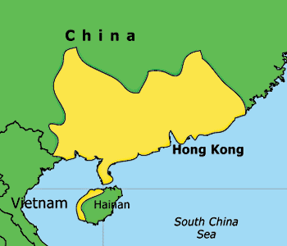

Course Description: This is a beginners’ language class that focuses on colloquial Cantonese for people who have no or little background. The class consists of eight lectures and also incorporates a variety of fun language-learning activities (e.g., movie watching, games). It is a must-take class for students who intend to visit/study in South China in the near future and a great learning experience for all students who are interested in Cantonese culture.
How to sign up:
Xihong (Valerie) Li, Cantonese Class Program organizer
Email: xl5@rice.edu (for all sign-ups, inquiries and suggestions)
Advisors:
Lily Lam (OISS), Steve Wong (CUHK)
Instructors:
Valerie Li (WRC, 12’), Norman Truong (Jones, 12’), Chris Chan (Jones, 13’), Jun Guan (Baker, 11’)

Syllabus
Week 1
Introduction to Cantonese
Greeting and introducing yourself
(The application of English vocabulary in Cantonese)

Week 2
Expressions for everyday use (Thanks...etc.)
Number System
Time and Date

Week 3
Asking for directions
Transportation in Hong Kong
Traveling in Hong Kong (sightseeing)

Week 4
Order Food
Dim Sum (food) in Hong Kong + a dim sum trip to China town

Week 5
Shopping in Hong Kong

Week 6
Introduction to Cantonese film/popular music

Week 7
Tradition/culture in Hong Kong

Week 8
Cantonese slang

Sign Up Sheets (Name: Email Addresses)

